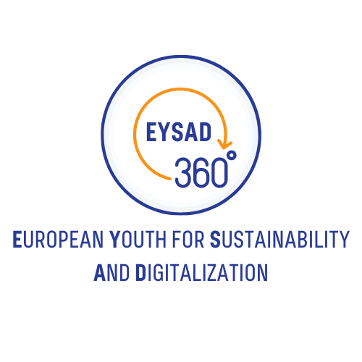

HandbOOK - “STRENGTHENING SUSTAINABILITY THROUGH DIGITAL MEDIA IN YOUTH WORK”

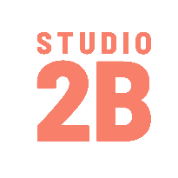
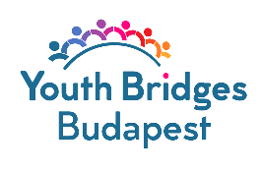
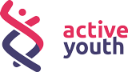

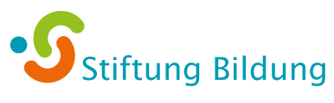
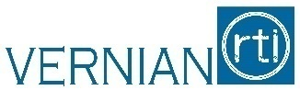
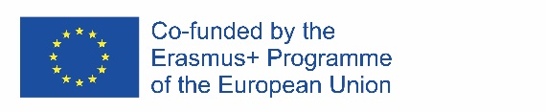
The European Commission's support for the production of this publication does not constitute an endorsement of the contents, which reflect the views only of the authors, and the Commission cannot be held responsible for any use which may be made of the information contained therein.

Table of Content
About the project 4
About the partners 5
Foreword 6
PART 1: Introduction 7
1. The big challenge: climate change 8
2. The term sustainability 10
2.1 Definitions and history 10
2.2 Three dimensions of sustainability 12
The ecological perspective 12
The economic perspective 14
The social perspective 16
2.3 Models of sustainability 17
The 3-overlapping-circles model (Venn diagram) 18
The three-nested-dependencies model (priority model) 18
Doughnut (economic model) 19
2.4 Sustainable development 20
PART 2: Roadmap to action 21
1. Background: The UN’s Agenda 2030 22
2. The Sustainable Development Goals 23
2.1 Why are the SDGs needed? 28
2.2 The World In 2050 Initiative (TWI2050) 28
2.3 SDGs for Business 29
3. Education for Sustainable Development (ESD) 30
3.1. What is ESD? 30
3.2. What skills are developed through ESD? 32
3.3. A systemic shift in education: ESD and Information Communication Technologies (ICTs) 34
PART 3: Non-formal educational activities on sustainability and digitalization with youth 36
How to design a workshop with young people? 37
Introduction 37
Target groups and needs assessment 37
Timeframe and resources 39
Impact and learning outcomes 42
Follow-up and interoperability 44
Workshop exercises toolkit 46
Energizers 46
Exercises 47
Evaluation practices and follow-up activities 55
Table of Figures 58
Sources 58

COPYRIGHT: This document and the accompanying templates were prepared by Studio2B, along with the valuable contribution from all of the project partners. This document is one of the intellectual outputs from the EYSAD Project, which is funded with the support of the European Commission. This document can be downloaded and used for free of charge under the terms of Erasmus+ programme. This document is subject to the licence:

Creative Commons Attribution NoDerivatives Version 4.0, by EYSAD-Project (CC-BY-ND, https://creativecommons.org/licenses/by-nd/4.0/legalcode): CC-BY-ND means in summary, that you are free to “Share” (copy and redistribute the material in any medium or format), but not modify the aforementioned text for any purpose, even commercially, if you comply with the following obligation: Attribution - you must give appropriate credit and provide a link to the licence. You may do so in any reasonable manner, but not in any way that suggests the licensor endorses you or your use. The images in the guide are not subject to the licence CC-BY-ND.

Image credits: All sources of the images are listed in detail in the “Table of Figures”.

LIABILITIES: The European Commission support for the production of this publication does not constitute an endorsement of the contents which reflects the views only of the authors, and the Commission cannot be held responsible for any use which may be made of the information contained therein. The authors who prepared this document bare no liabilities in relation to its use and implementation of the ideas, methods and advises contained therein.

CLARIFICATION OF TERMINOLOGY: The simultaneous use of male and female forms of speech has been avoided for reasons of better readability. All personal designations are equally applicable to both genders.

About the project

Sustainability and digitalisation are two central topics that move young generations in many nations. These subjects change and determine the future lifestyle of people. To meet these challenges, it is necessary to engage as society as a whole and from different levels. Particularly young people should be able to realize their overall potential. They have to be strengthened in their abilities in order to play an active role for a sustainable lifestyle in continuously digitalised societies. For this, new educational opportunities are needed that promote personal abilities like creativity, critical thinking and solution-oriented action according to a guiding principle of sustainable development. Additionally, a reflective manner with digital media is essential as these are important preconditions for social participation.

This is exactly the point where European Youth for Sustainability and Digitalization (EYSAD) starts. In the project, innovative learning and teaching opportunities for youth work will be developed, which support a reflective examination of sustainability by means of digital media. The project addresses both young people as well as youth workers and leaders and follows a participatory approach assisted by both target groups.

GOALS
- Awareness-raising for challenges in environmental and climate protection with reference to personal behaviour
- Acquisition of basic knowledge on sustainability and the 17 Sustainable Development Goals of the United Nations (17 SDGs) as well as their global interconnections -Strengthening of digital competences by means of using and developing digital media
- Promotion of further education of qualified employees within the field of youth work and/or education
- Support of young people and youth workers to become actors of change for a sustainable development

About the partners

Active Youth is a Lithuania-based for-purpose organisation that unites young leaders, thinkers and doers, those who seek change and those who make change. Their vision is to‌ ‌create‌ ‌opportunities‌ ‌for‌ ‌youth‌ ‌and‌ sustainable‌ ‌positive‌ ‌impact‌ ‌in‌ ‌the‌ ‌way‌ ‌we‌ ‌treat‌ ‌our‌ ‌planet,‌ ‌health,‌ vulnerable‌ ‌people‌ ‌&‌ ‌online‌ ‌community.‌

Youth Bridges Budapest is a Hungarian non-profit youth foundation established in 2019. It supports the European Solidarity Corps Quality Label and is an accredited organisation. Its aim is to help young people deal with the challenges of the 21st century. Young people should be supported in the first years of their adult lives to build a successful future and become active citizens, contributing to social development.

Vernian RTI is a Cypriot SME with a regional and European focus. It has many years of experience in various fields, including all areas of information and communication technology (ICT), digitalisation, information and cyber security. Vernian is also active in the development and delivery of vocational training. It recognises the challenges faced in today's complex and fast-moving environment and believes that by integrating research, technology and innovation into their strategy and operations, organisations of all sizes can increase their capacity to innovate, optimise their business model and value proposition,
improve their competitiveness and achieve sustainability. Sustainable organisations lead to sustainable economies and societies.

Stiftung Bildung is a German donor-funded Education Foundation. Its goal is to create the best educational opportunities for children and young people. It strengthens participation and diversity nationwide in the sense of education for sustainable development (ESD) and works at the grassroots level through the network of daycare and school development associations and promotes project ideas for sustainable development in many places.

Studio2B is a Berlin-based social enterprise. Studio2B has been developing innovative concepts and methods for career orientation and vocational training since 2012 with the aim of strengthening young people and adults in their competences and preparing them for entering or re-entering the workforce and supporting them in their further education. Studio2B combines target group-oriented presence formats with digital learning methods and methods of non-formal education. This includes the creation of e-learning courses, virtual company visits to numerous occupational profiles and dual study programmes using 360° videos and virtual reality (VR) as well as interactive and multimodular 360°- video training.

Abbreviations
ESD: Education for Sustainable Development
ESG: environmental, social and governance reporting
UNESCO: United Nations Educational, Scientific and Cultural Organisation
UN: United Nations
ICT: Information Communication Technology - the infrastructure and components that enable modern computing
WIA: Whole Institutional Approach

Foreword

Sustainability and digitalization - two topics that are highly relevant for young people and will decisively shape the future. Youth workers and teachers in all contexts are encouraged to bring these issues to the attention of young people. These are big topics that require a broad thematic and methodological understanding. Multi-perspectivity is of particular importance with these multi-layered issues. It is also a matter of finding the balance: Between communicating the urgency of social and ecological challenges and at the same time building motivation for action and interest in sustainable engagement. The following chapters aim to support youth workers in developing a scientific understanding of sustainability and sustainable development as a basis for outreach and for working with young people. The supplementary roadmap goes into more detail on practical approaches for working with individual sustainability goals. The document results from and draws on experiences with the ERASMUS+ EYSAD - European Youth for Sustainability and Digitalisation project. As a cooperation project between all EYSAD project partners, the different professional backgrounds (democracy education, IT business, youth work, etc.) of the partners inform this content.

The first chapter of this handbook is designed to provide basic knowledge and resources about climate change, sustainability, and sustainable development.

Having the SDGs as the beacon and guiding principles of our project, we want to support Europe contribute to developing a sustainable way of living on our planet. Each goal and its targets are presented in detail in Chapter 2 of this document.

A tool that connects all dimensions of sustainability that have been discussed above is education. Quality Education, is a stand alone SDG (4), and is the key for understanding and achieving the targets set by the 17 Sustainable Development Goals. In Chapter 2 it is explained why and how.

Chapter 3 provides information and practical tips for the concrete implementation of a practical training project with young people.
The following are the areas elaborated in Chapter 3:
- How do I plan a digital practical project on sustainability and what do I need to bear in mind?
- How do I make the best use of 360° Environmental Photo Tour?
- How do I create a VR-enabled environmental photo tour with and for young people?
- What materials and technology do I need?

PART 1: Introduction

“Climate change is the environmental challenge of this generation, and it is imperative that we act before it’s too late.”
- John Delaney

1. The big challenge: climate change

We start with the elephant in the room - the most obvious challenge of our times and the word that often comes into mind when it comes to sustainability: climate change. It is a term as well as a phenomenon we can no longer avoid. All over the world, politics, the economy and societies are confronted with the increasing challenges of climate change. But for many people the term is abstract, hardly tangible. We hear about rising temperatures and extreme weather. But what exactly does climate change mean? How can youth workers teach this? And why do we have a responsibility NOW to effectively address climate change to protect future generations? Let’s take a look.

What is climate change?
The United Nations explain the term of climate change on their website as follows:
“Climate change refers to long-term shifts in temperatures and weather patterns. These shifts may be natural, such as through variations in the solar cycle. But since the 1800s, human activities have been the main driver of climate change, primarily due to burning fossil fuels like coal, oil and gas.
Burning fossil fuels generates greenhouse gas emissions that act like a blanket wrapped around the Earth, trapping the sun’s heat and raising temperatures.
Examples of greenhouse gas emissions that are causing climate change include carbon dioxide and methane. These come from using gasoline for driving a car or coal for heating a building, for example. Clearing land and forests can also release carbon dioxide. Landfills for garbage are a major source of methane emissions. Energy, industry, transport, buildings, agriculture and land use are among the main emitters.” (UN 2023).

Climate change is only one part of global ecological system change. Species extinction (biodiversity loss) is described as the second natural disaster we are facing and in a two-way process both cause each other (European Union 1995-2023).

Causes and components
The United Nations environmental programme identifies five main drivers to the general nature crisis: changes in land and sea use, direct exploitation of natural resources, climate change, invasive species and pollution - especially the pollution of the world's oceans. All factors lead to an uncontrollable imbalance in the Earth's ecosystem balance. Every change in the natural eco-balance influences other factors. The interrelationships are therefore very complex.

Scientists have illustrated the complexity of the planetary system in the planetary boundaries model. It currently shows nine ecological boundaries of the Earth, the transgression of which endangers the stability of the Earth's ecosystem and consequently the existence of humanity.
The boundaries are intended to define a safe scope of action for humans. However, we have already crossed some boundaries (Fig.1). In 2022 we crossed the border of Green Water (PIK 2022).
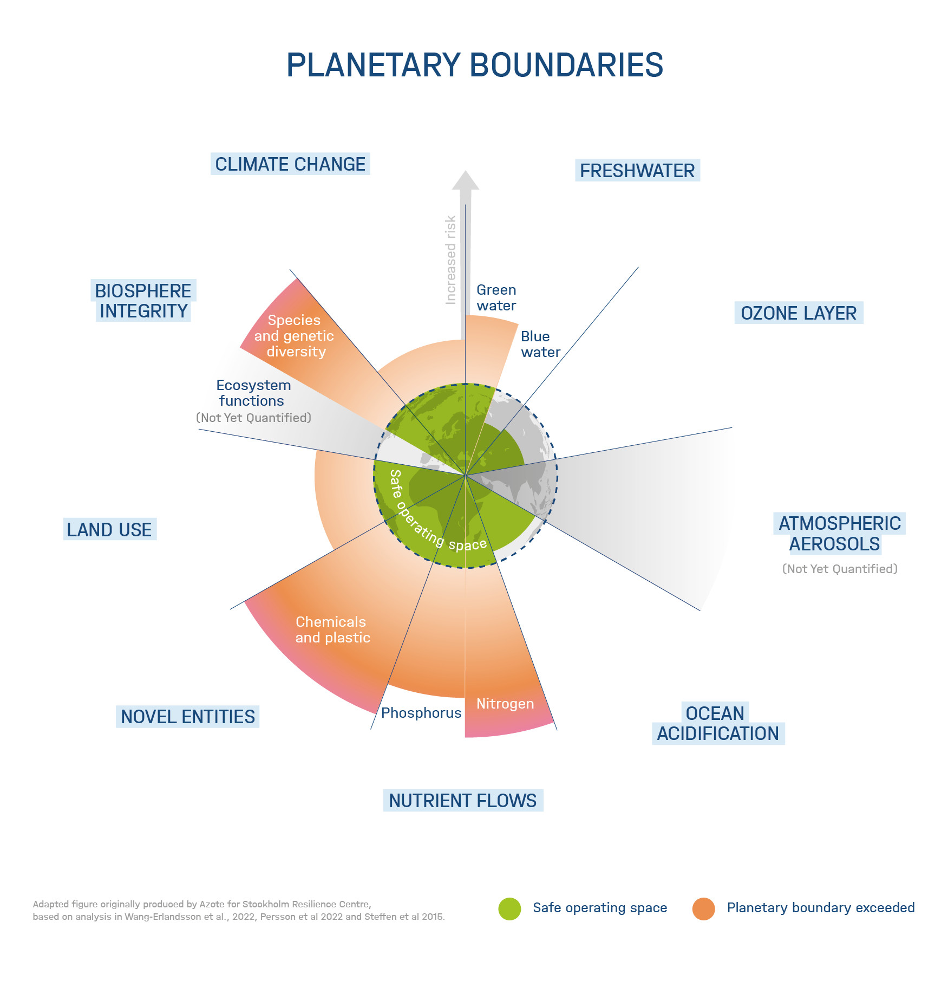
Figure 1 Adapted graph from Helmholtz Climate Initiative, originally by Azote for Stockholm Resilience Centre based on Wand-Erlandsson et al. 2022, Persson et al. 2022, and Steffen et al. (2015).

Impact
The Intergovernmental Panel on Climate Change (IPCC), the United Nations body for assessing the science related to climate change, regularly publishes reports on the current state of research in relation to climate change. The latest IPCC report 2022 highlights the extreme impacts of human-made climate change. For example, experts predict that the increase in global mean surface temperature (GST, "running average" over 20 years) compared to pre-industrial levels will probably reach 1.5°C by the early 2030s. The consequences of global warming include stronger and more frequent natural disasters and extreme weather, as well as changed precipitation patterns and also social conflicts. It makes clear: We need immediate climate action in the next few years.
Climate change is progressing extremely fast and already creates suffering for many people, especially in the most vulnerable countries of the global South and Asia. They are already highly affected, for example by droughts, floods, and extreme temperatures (IPCC 2022).

An Ipsos survey for the World Economic Forum shows that one in three globally brace themselves for being displaced from their home in the next 25 years (Ipsos 2022). Due to these facts, it is now often recommended to use the term "climate catastrophe" instead of "climate change", to make the importance of the issue clear. Mediums like The Guardian changed their terms in use already (DownToEarth 2019).

Working with climate change as a youth worker
A challenge for youth workers is that dealing with climate change can cause feelings of being overwhelmed, helplessness and resignation on the participants' side. If not dealt with properly, it can also trigger the phenomenon of climate anxiety.
From the experience of the EYSAD Project, we offer the following advice to address climate change:

- Solution-oriented approaches:
Do not talk too much about the problem - think about solutions and actions.
- Fact-based/scientific:
Stick to scientific knowledge:
Stay clear and name non-scientific theories, get them out of the way
- Interactive forms of work and a good atmosphere:
High participation in the choice and implementation of the programme.
- Creating social connections:
Projects that create social connections help to process the content better and keep motivation high.
- Strengthen empowerment and commitment:
ideas, visions and own projects are always welcomed.
- Addressing the interests and life experiences of young people:
Ask about and discuss topics that are of great concern to young people at the moment and relate them to climate change.
Climate change is often talked about in the context of sustainability. Sustainability offers great scope for solution-oriented forms of learning. In the next chapter, the meaning of sustainability will be discussed in detail.

2. The term sustainability

2.1 Definitions and history
Just googling the word sustainability results to more than 2,700,000,000 results. Although the use of the word sustainability has increased over the last few years, the concept of itself is not new. The word is derived from the Latin word sustinere (tenere, to hold; sub, under) which means "to sustain": to maintain, support, uphold, or endure.
While sustainability has many different dimensions, people usually focus on the environmental one. All dimensions will be complemented later on in this brochure - for now we will focus on the meaning of environmental sustainability: This concept is rooted in forestry and was linked to the regeneration of forests in relation to the cutting before. 'Don't cut the wood faster than it can grow back' is the basic motto and still applies today. In a simplified definition, environmental sustainability includes making sure that human consumption does not deplete natural resources, that ecological systems stay in balance and life on earth remains diverse, as biodiversity is largely responsible for making this planet habitable for humans at all (International Institute for Sustainable Development 2020).

Digression 1: Further historical background of sustainability
The last two centuries are of special importance for the development of our modern understanding of environmental sustainability. During the 18th century, where the Industrial Revolution took place, the world had experienced many changes: technological, economic, cultural and social. Historians divide the Industrial Revolution into two consecutive parts, the so called the first Industrial Revolution, which lasted from the mid-18th century to about 1830 and was mostly geographically confined to Britain and the second Industrial Revolution, which lasted from the mid-19th century until the early 20th century and is geographically positioned in Britain, continental Europe, North America, and Japan (Encyclopedia Britannica 2022).
The Industrial Revolution was characterized by the use of new energy sources and new materials in production, the invention of new machines, the introduction of the factory system and in addition significant developments in communication and transportation. All these led to a momentous increase in the use of natural resources so that the world could keep up with the needs of development and mass production.
Furthermore, the Industrial Revolution has led to many agricultural improvements which in turn helped the provision of food to a larger percentage of population and also to social changes such as the non-stop growth of cities since people were moving from urban areas to the cities to pursue better working opportunities. These changes resulted in overpopulated cities which eventually suffered from air and water pollution and bad living conditions.
Industries were powered by burning coal. This resulted in pumping vast quantities of pollution into the atmosphere which caused the appearance of respiratory illnesses and higher death rates. A study published by Abram, N., McGregor, H., Tierney, J. et al. (Early onset of industrial era warming across the oceans and continents. Nature 536, 411–418 (2016)) suggests that climate change driven by human activity began as early as the 1830.
The exponential industrial growth resulted in long-term consequences - referring to the forestry example: ‘humans cut the trees too fast’.

The importance of environmental sustainability
Today, our planet is constantly changing: the climate, oceans, land, and atmosphere of the planet. The difference in today’s changes of those of the past is the unusual scale and the pace as well as the factors that create these changes. The planet is now facing a new reality of extreme phenomena, such as heat waves and droughts and once in hundred-year storms and floods. Concerns about climate change, pollution and biodiversity losses are becoming more widespread. The world has started to embrace environmentally sustainable policies and practices and green technology investments to secure future growth opportunities, because human wellbeing is closely linked to the health of the environment. Environmental sustainability determines the future of the planet and humans, as it preserves natural resources and shields the ability of future generations to meet their needs.
According to the World Health Organization, 24% (WHO 2023) of deaths worldwide are linked to environmental factors, whereas between 2030 and 2050, climate change is expected to cause approximately 250.000 additional deaths per year. In addition, 3.2 million deaths per year are caused due to exposure to indoor smoke from cooking fuels and 4.2 million every year are a result of exposure to fine particulate matter. The direct damage costs to health are estimated to be between USD 2-4 billion per year by 2030.
The escalating amount of food, energy and human resources that is used daily in combination with the rapid population growth has resulted in an increase in technological needs and agriculture. Industrialization, global warming, unplanned urbanization, and natural disasters have led to deforestation, gas emissions and unsustainable use of energy. These environmental issues have reached global dimensions and started to threaten the planet. Both national and international regulations, policies and laws are needed for sustainability and the protection of the environmental balance. People need safe places to live, clean water to drink and clean air to breathe so the priority is planet first, people second and production third.
Over the years the term sustainability became more complex and diverse.
Environmental sustainability was complemented by other perspectives, which will be explored in more detail below. As a quick note to take away:

Sustainability includes:
- improving public health
- protecting biodiversity
- reducing water and air pollution
- conserving resources
- helping to achieve food security
- preventing the extinction of species
- bringing social inclusion and equality

2.2 Three dimensions of sustainability
Today, most sustainability concepts distinguish between three perspectives. Since we have already taken a deeper look at the ecological perspective, we will follow this up connected to practical approaches.

The ecological perspective
With the explanation of environmental sustainability, the ecological perspective became already clear. Ilić Krstić et al. (2018) state that “within ecological frameworks, sustainability refers to the capacity of biological systems to maintain their functions and processes over time. This perspective focuses on natural capital and often emphasizes the irreversibility of some natural resources and the rights of non-human beings.” The ecological dimension is often defined as the most important or the base of the other dimensions. The European Union has several strategies to guide action for ecological sustainable development.
Approaches of the EU - Climate action
The European Union is committed to support the achievement of the climate neutrality goal and the efforts of the United Nations.
In December 2019, the European Commission announced the European Green Deal, the strategy that will support Europe to achieve EU climate neutrality by 2050. The initiative was endorsed by all European leaders.
The goal of the European Green Deal is to both tackle the climate change threat while creating economic growth with better jobs and by enhancing human well-being.
The Green Deal includes measures such as:
- investing in environmentally friendly technologies,
- supporting innovation,
- helping the development of cleaner forms of transport,
- decarbonising the energy sector,
- ensuring buildings become more energy efficient,
- working internationally to improve standards around the world.
What is new about the European Union’s climate-neutrality goal and the Green Deal is that all economic sectors are required to take action, which means that climate and environmental considerations are integrated across all EU policy areas. This approach is known as climate mainstreaming (European Council 2022).
Preservation of biodiversity
To tackle the challenge of biodiversity loss, the European Union has adopted an EU Biodiversity Strategy for 2030 and an associated Action Plan (annex). On the Website of the European Environmental Agency it’s described as “a comprehensive, ambitious, long-term plan for protecting nature and reversing the degradation of ecosystems. It aims to put Europe's biodiversity on a path to recovery by 2030 with benefits for people, the climate and the planet. It aims to build our societies’ resilience to future threats such as climate change impacts, forest fires, food insecurity or disease outbreaks, including by protecting wildlife and fighting illegal wildlife trade.” The strategy is part of the Green Deal (European Union 2023).
On a larger scale, in 2010 the UN launched the UN Decade of Biological Diversity, which supports worldwide action to protect biodiversity. The successor is the UN Decade on Ecosystem Restoration, which runs until 2030. The UN Decades aim to empower stakeholders to take action and to raise a broader awareness within society.

Cross-cutting EU approaches
In addition to its own objectives and strategies, the EU has funding programmes to enable civil society and industry to take their own action.
With its two sub-programmes "Environment" and "Climate Policy", the EU funding programme LIFE offers support for projects for the protection of biodiversity and ecosystems. It aims to integrate climate and environmental activities in a societal context. Research-oriented projects on environmental topics can be applied for by research institutions, universities, companies and NGOs in the EU research programme HORIZONT Europe.

Up to that, environmental education programmes promote the teaching of ecological sustainability. This also includes educational programmes such as EYSAD. In addition, environmental education programmes promote the teaching of ecological sustainability. This also includes educational programmes such as EYSAD.

The economic perspective
From an economic point of view sustainability is linked to the goal, to create a (rising) society’s well-being over time. The concept of wellbeing is, in an economical sense, linked to consumption, which is enabled by economic production (income) (Ilić Krstić et al. 2018). One practical approach to reach this goal, is the concept ESG. In the following part, the concept is introduced as an example of sustainable business approaches.

In terms of working with young people, this perspective is particularly important if the target group is concerned with sustainable career choices. Studies suggest that young people are more willing than older generations to prioritize their sustainability related values when choosing a career path and are even willing to leave employers who do not act sustainably (Ro 2022). Supporting young people’s skill building in the field of sustainability, is thus very much in their own interest and their own ideas of their “dream job” can easily serve as an entry point for discussions or workshops about sustainability.
The ESG approach, which will be explained in detail in our digression 2, can be taught as a tool to inspire sustainable business management/ company choices. At the same time, this knowledge also sensitizes people to possible corruption structures or the commonly criticised PR method of greenwashing. Therefore, it is important for youth workers to have an understanding about sustainability in an economical sense.

Digression 2: Doing sustainable business – ESG
Sustainable development is becoming a global priority that mobilizes governments, businesses, and the society to take action and adopt new practices. The United Nations have established the Sustainable Development Goals (read more about the SDGs in Part 2) which led to a new understanding of the role companies have to take. The number of companies that start measuring and managing sustainable opportunities and risks is increasing daily.
Sustainability in this sector is often broken in three core pillars: Environmental, Social and Governance (ESG). ESG refers to environmental, social and corporate governance issues that can affect a company's ability to generate value in the long term. It is easily mixed up with the abbreviation CSR (Corporate Social Responsibility) and also with the general term “sustainability”. Even though all of the above are closely related, they do not mean the same thing.
While CSR is a loose framework for corporate behaviour to improve society and the environment, ESG is a quantifiable assessment of sustainability (Lutkevich 2022). It is important to understand that ESG has evolved from business sustainability. The main difference between ESG and sustainability is that ESG sets specific criteria to define environmental, social, and governance systems as sustainable (Corporate Finance Institute 2023).
ESG is a quantifiable assessment of sustainability and is defined as a strategic framework that identifies, assesses, and addresses an organization’s activities and objectives from the organization’s commitment to sustainability and carbon footprint to workplace culture and commitment to diversity and inclusion.
ESG dates back to 2006 and the United Nation’s Principles for Responsible Investment (PRI) report. The Principles for Responsible Investment (PRI) initiative is a network of international investors working together to put the six Principles for Responsible Investment into practice. The common view of the signatories is that environmental, social and governance (ESG) issues can affect the performance of investment portfolios and therefore must be given appropriate consideration by investors if they are to fulfil their fiduciary duty. It is additionally understood that by implementing the principles, signatories contribute to the development of a more sustainable global financial system (UN Global Compact 2023).
In 2004, the United Nations asked major financial institutions to collaborate with the United Nations and the International Finance Corporation in identifying ways to integrate environmental, social, and governance concerns into the capital markets. The resulting 2005 study “Who Cares Wins” marked the first use of the term ESG. In the paper it was stated that incorporating ESG drivers into investments would benefit companies and would also make good business sense (Perrone G. 2023).

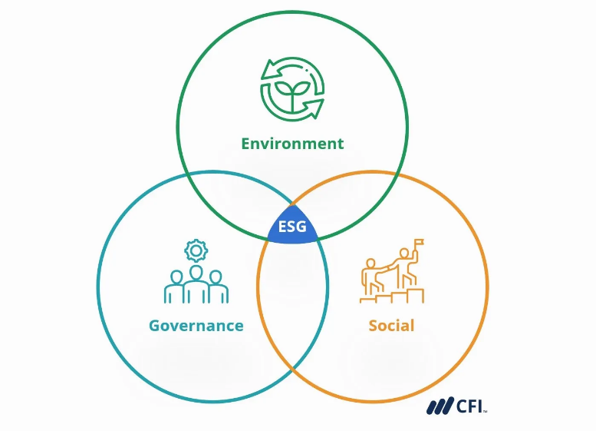
Figure 2 Adopted from the Corporate Finance Institute website (2023)
- Environmental Pillar
The main point of the environmental pillar is understanding that every company uses resources and energy, every company is affected by the environment and every company affects the environment.
The environmental pillar includes climate policies, waste, pollution, energy use and natural resource conservation, gas emissions and compliance to environmental regulations. It also includes whether a company uses virgin or recycled materials in its production processes and how a company ensures that the maximum material in their product is cycled back into the economy rather than ending up in a landfill.

- Social Pillar
Under the Social Pillar, companies report on how they manage their relationship with internal and external shareholders, how they manage their employee development and labour practices. They also report on safety and quality of their products as well as health and safety standards.

- Governance Pillar
The main topics under the Governance Pillar are board diversity, executive compensations, anti-competitive practices, corruption, transparent accounting methods, avoidance of conflict of interest in the choice of board members and the nonexistence of illegal conduct.
The adoption of ESG criteria in the selection of investment positions is a rapidly growing trend internationally. In general, ESG criteria refers to the three main factors measuring the ethical and environmental impact of an investment in a company. The ESG investment philosophy is adopted both by investors who, due to their values, wish to contribute to sustainable development with their investment behaviour and by Fund Managers who choose investment schemes that contribute to sustainability. They can also help investors avoid companies that may pose greater financial risk because of their environmental or other practices.

In the corporate world, sustainability promotes the circular economy model, reduces the global carbon footprint, and encourages responsible production. Sustainability policies can help a company reduce costs, increase productivity and operating profits, and create job opportunities.
It should be noted that the economic perspective on sustainability is criticised from various sides. The question of whether "green economic growth" in line with the 17 Sustainable Development Goals is possible has not been conclusively answered. The young generation bears a great responsibility in answering this question. Therefore, it is all the more important to raise awareness for a sustainable way of doing business.

The social perspective
Social sustainability, as one of the three pillars of sustainability, is intended to enable a stable society in which all members can participate and to ensure human dignity, as well as labour and human rights, for generations to come. This aspect focuses on people, society, and their needs. According to Mohamed and Paleologos (2021) it is defined as a measure of the human’s welfare. It is often strongly connected to economic issues.
For youth workers, social sustainability is an important pillar to be aware of, because they are taking direct action to reach connected targets when working with young people on topics of sustainability.

Sustainable Development Goals (SDGs) that focus especially on social sustainability:

Goal 1) Eradicate poverty
Goal 2 Address hunger and malnutrition
Goal 3) Health and well-being
Goal 4) Quality education
Goal 5) Gender equality
Goal 8) Decent work

Many of the SDGs can be viewed from several angles and cannot be assigned to any of the three dimensions alone. Nearly every goal contains social aspects as well. Values and principles that are often mentioned with the social sustainability goals are:
Equal opportunities and rights for social standards, Tolerance, Equality, Fair trade/Fair wages/Fair work, individuality of the human being.

The social challenges resulting from climate change, such as social unrest to wars, flight and hunger, also fall under the aspects of social sustainability and are Challenges addressed by the goals. In this sense, it encompasses all impacts of environmental degradation, biodiversity-, and climate crises on humans.

Consequently, intra-, and intergenerational justice become other important components of social sustainability. Intergenerational justice means that no damage is caused in the present time that is at the expense of future generations. Intragenerational justice aims at more justice of the generations living today (primarily between industrialized countries and countries mainly of the global south). In 2023 the UN decided that rich and less affected countries have to pay vulnerable countries, mainly in the global south, for climate change outcomes (loss-and-damage-fund) (UNFCCC 2022). This can be seen as a step towards the implementation of goals for social sustainability.

Access to quality education for all is another important component of social sustainability and is anchored in the SDGs with Goal 4). With regard to sustainable development, Education for Sustainable Development (ESD) is of particular importance here. ESD is clearly defined by UNESCO as Goal 4.7:

"By 2030, ensure that all learners acquire the knowledge and skills needed to promote sustainable development, including, among others, through education for sustainable development and sustainable lifestyles, human rights, gender equality, promotion of a culture of peace and non-violence, global citizenship and appreciation of cultural diversity and of culture’s contribution to sustainable development" (UNESCO 2020).

This target is also tackled by the ERASMUS+ youth exchange programmes, especially with the EYSAD project. The European Commission states on their European Education Area that “Education and training, like all sectors, must take action to respond to this planetary crisis.” The “knowledge, skills and attitudes needed for a greener and more sustainable economy and society” is therefore part of Quality Education.
ESD gives youth workers the tools and the base to teach and to work with sustainability on all levels. On European, as well as on national levels, UNESCO is engaged to support ESD projects.

2.3 Models of sustainability
The commonly used sustainability models show the three dimensions of sustainability (economic, social and environmental) mostly as pillars, embedded circles or in the popular Venn diagram, where the three circles are overlapping (IUCN, 2006). Each model focuses on different aspects and prioritizes differently.

The Venn Diagram and the embedded circles are showing the intersection between the three areas. They emphasize the need for interdisciplinary and transdisciplinary (e.g., 1217 Todorov and Marinova, Models of sustainability Marinova and McGrath, 2005) - an approach to understanding sustainability. They are created simply to be understood by a wide range of people.

Critical voices state their explanatory power is too weak in relation to the other four criteria put forward by Boulanger and Bréchet (2005).

The 3-overlapping-circles model (Venn diagram)
The overlapping-circles model of sustainability acknowledges the intersection of economic, environmental, and social factors. In this model each sector is building a component of sustainability.
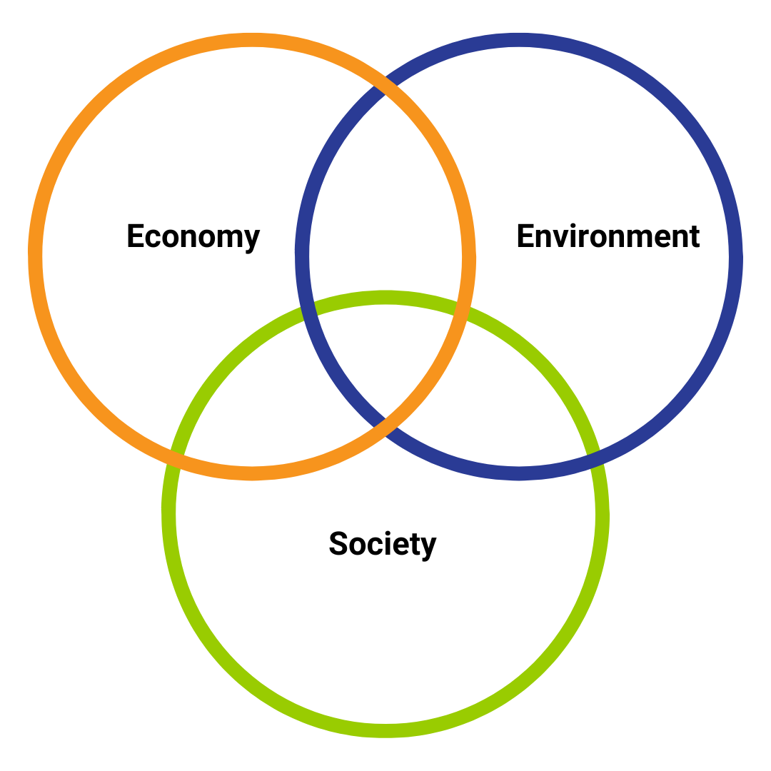
Figure 3 Venn Diagram of sustainability designed by the authors of this publication (2023)

It is possible to resize the circles to show that one factor is more dominant than the other two. The model is criticized due to the fact that every component is in the same amount dependent on the other. They argue that society depends on the environment and economy on both of them. From this point the 3-nested-dependencies model was developed (Todorov and Marinova 2008).

The three-nested-dependencies model (priority model)
The three-nested-dependencies model reflects this co-dependent reality. It shows that human society is a wholly owned subsidiary of the environment. Social and economic needs can only be fulfilled, if the environment is healthy and natural resources accessible (Herath and Rathnayake 2019). The model takes into account that without environmental sustainability we cannot live a sustainable economy or societal life. It’s also called the egg model (where we need both: a good egg white, but also a good yolk).
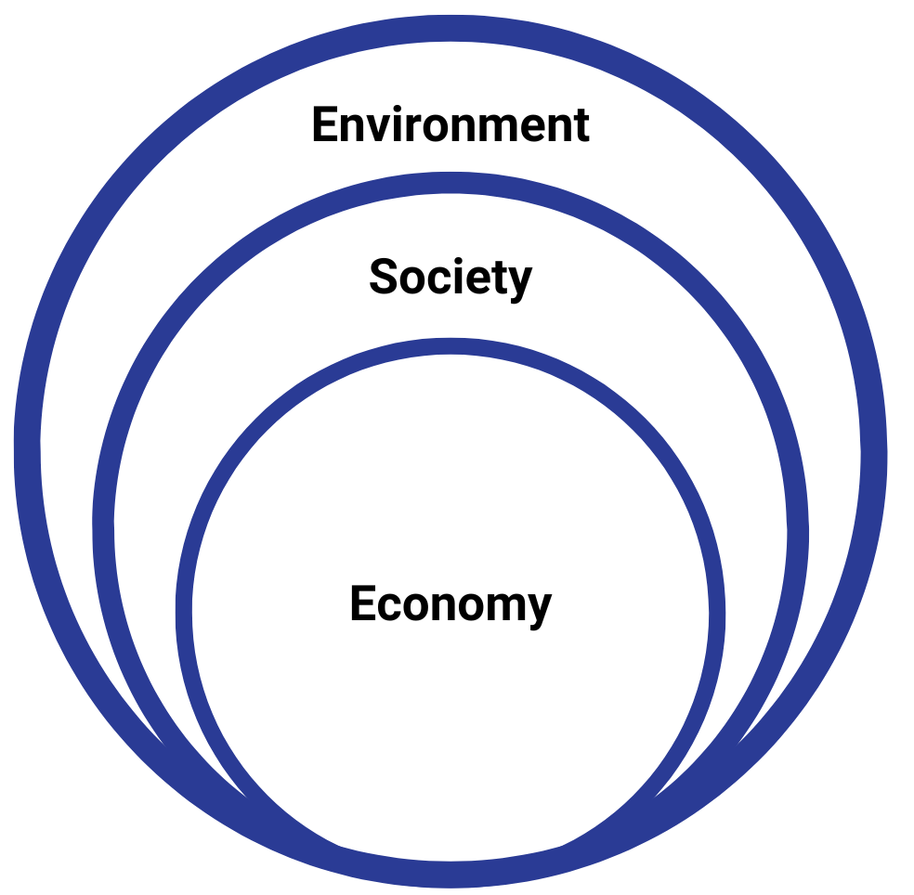
Figure 4 Three-nested-dependencies model of sustainability designed by the authors of this publication (2023)

Doughnut (economic model)
The Doughnut model was first introduced by Kate Raworth in 2017 in her book “Doughnut Economics”. The model works with a safe zone between social equity and environmental boundaries, our aim is to get human life into this zone. It is mainly used as an economic sustainability model. The idea is about an “era of the planetary household” where we manage our collective household in the context of inner and outer bounds. In a visual, these boundaries remind of the shape of a doughnut, hence the name.
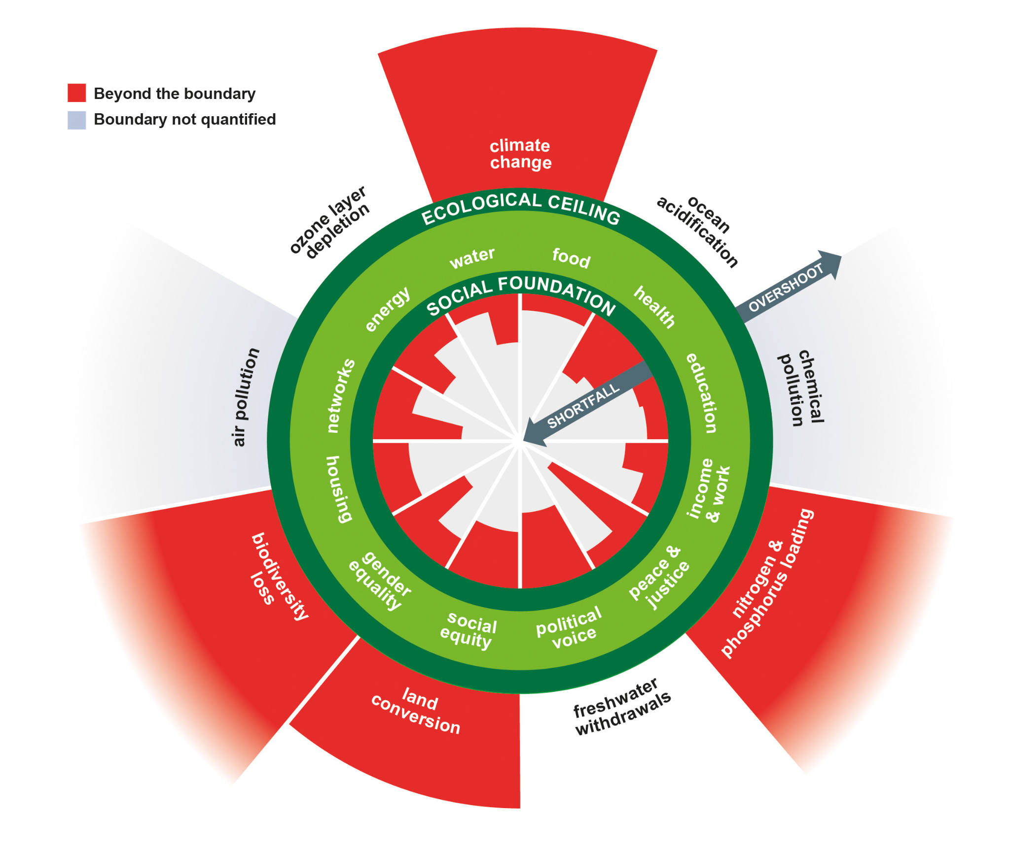
Figure 5 Shortfalls and overshoot in the Doughnut by Raworth (2017b)

2.4 Sustainable development
After diving deep into sustainability concepts, we take a closer look into the different term “Sustainable development”. The UNESCO distinguishes between sustainability and sustainable development: "Sustainability is often thought of as a long-term goal (i.e. a more sustainable world), while sustainable development refers to the many processes and pathways to achieve it."^{[7]} The concept is quite young: The use of the term was strongly influenced by the 1983 UN Commission on Environment and Development, also known as the Brundtland Commission. The World Commission on Environment and Development was developed by the United Nations in 1984 under Gro Harlem Brundtland, as a result of the increased environmental concerns by pressure groups to have countries pursue sustainable development together (IGI Global). In the commission's 1987 report, titled “Our Common Future” (also known as the Brundtland Report), sustainability is defined as “meeting the needs of the present without compromising the ability of future generations to meet their own needs”.
This led to our modern discussion about the topic (Brüggemeier 2012). Even though the Brundtland-Commission’s 1987 definition already includes the social and economical dimension, we tend to focus on the environmental dimension (SDG 13, 14, 15). According to Talan et al. (2020) this is starting to change. They state: "The social dimension of sustainability recently attained acceptance as an elemental component of sustainable development".
The UN’s 2030 Agenda commits the global community to “achieving sustainable development in its three dimensions—economic, social and environmental—in a balanced and integrated manner” (UN 2015).
The key to achieving the goals of the 2030 Agenda is often described as the integration of the economic, social and environmental dimensions of sustainable development (ESCAP 2015). Considering that sustainability itself has many different definitions, each dimension has its own perspective on sustainable development and the interpretation of it.

PART 2: roadmap to Action

“A man (sic!) cannot participate actively in history, society, in the transformation of his reality, if he is not helped to become aware of reality and his own capacity to transform it.”
- Freire, 1977

1. Background: The UN’s Agenda 2030
It was September of 2015 in New York, where the United Nations General Assembly made a historical decision that affected and will affect the lives of millions of people around the world. The decision, known as 2030 Agenda for Sustainable Development, is a global agreement, by which the State Members of the United Nations stated their commitment to sustainable development. The 2030 Agenda, among other guidelines and goals, contains 17 goals, known as “Sustainable Development Goals” (SDGs) or “Global Goals” with the primary objective to achieve decent lives and living conditions for all humankind on a healthy planet by 2030. The 17 SDGs and their 169 sub-goals create commitments for all countries, taking into consideration different national realities, levels of development, national policies, and priorities.
Participating in this global agreement, more than 190 leaders who represented almost all the planet, pledged to transform the world into a world without hunger, poverty, inequality, decent work and working conditions and good education for all. Leaders also pledged to a world without the threat of climate change, where through the principles and regulations of sustainable development, will care the needs not only of the current generation but also of future generations.
The 2030 Agenda and specifically the 17 SDGs are based on the below principles:
- universality – the Agenda applies to all countries, at all times, no matter their development rate
- “leaving no one behind” – it seeks to reach all people who are in need and to benefit all people whoever and wherever they are
- inclusiveness – the Agenda presumes that all people are included in the society and must participate in implementing the Agenda regardless their race, gender, ethnicity and identity
- interconnectedness and indivisibility – The 2030 Agenda rests on the interconnected and indivisible nature of its 17 SDGs
- Multi-Stakeholder Partnerships – The 2030 Agenda requires multi stakeholder partnerships to support the achievement of the Global Goals in all countries

2. The Sustainable Development Goals
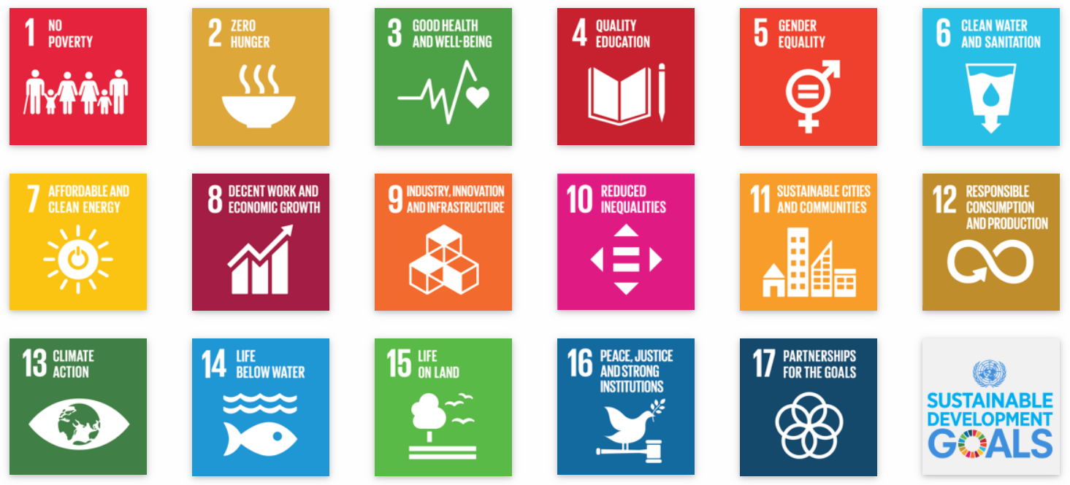
Figure 6 The Sustainable Development Goals, Adopted from the United Nations website (2023)

How to answer the immense challenges that result from the fast changes in the earth system? As major changes do not only affect nature, but all aspects of human existence (social and societal life, politics, power relations, economic structures, (food) security, etc.), a holistic approach is needed, which includes change and adaptation in all areas and at all levels.

In order to systematically meet this challenge, the United Nations have set 17 global Sustainable Development Goals, the SDGs. Through clear sub-goals, the SDGs provide guidance for actors to develop effective measures, programmes and actions to achieve sustainable transformation. The United Nations‘ 2030 Agenda names five core messages that precede the 17 SDGs principles guiding action: People, Planet, Prosperity, Peace and Partnership (UN 2015). The goals under the core topic “Planet” are mainly addressing the biggest environmental challenges global societies are facing: climate change, environmental pollution and biodiversity loss. The goals here are: 13) Climate Action 14) Life below water 15) Life on Land.

The 17 SDGs aim to create and provide an inclusive model of sustainable development for everyone regardless of their race, gender, ethnicity, culture, religion and disability. Hunger and poverty are considered the most crucial challenges of the world along with security, peace, freedom and human rights. Special attention is given to the underdeveloped countries and countries that face conflicts and war. In addition, special consideration is given to the management of natural resources through sustainable development and the climate change and global warming issues are perceived on a universal level (UN SGDS 2023).

GOAL 1: No Poverty – End poverty in all its forms everywhere
Goal 1 targets focus on eradicating extreme poverty for all people everywhere, the reduction of at least by half the proportion of people living in poverty in all its dimensions and the implementation of appropriate social protection systems and measures for all. In addition, by 2030, the Goal 1 aims to ensure that all people, especially the poor and the vulnerable have equal rights to economic resources, access to basic services, ownership and control over land and property, inheritance, natural resources, appropriate new technology and financial services.

GOAL 2: Zero Hunger – End hunger, achieve food security and improved nutrition and promote sustainable agriculture.
Goal 2 aims that hunger is ended by 2030 and that all people, especially the poor and those who live in vulnerable situations have access to safe, nutritious and sufficient food throughout the year. The Goal intends to end all forms of malnutrition and to double the agricultural productivity and incomes of small-scale food producers providing secure and equal access to land and other productive resources.

GOAL 3: Good Health and Well-being – Ensure healthy lives and promote well – being for all at all ages
Goal 3 focuses on reducing the global maternal mortality ratio to less than 70 per 100,000 live births and ending preventable deaths of new-borns and children under 5 years of age. Additionally, Goal 3 supports the research and development of vaccines and medicines, provides access to affordable medicines/vaccines, aims to end the epidemics of AIDS, tuberculosis and other diseases and tries to strengthen the prevention and treatment of substance abuse, including narcotic drug abuse and harmful use of alcohol. A major target is the provision of universal access to sexual and reproductive health-care services.

GOAL 4: Quality Education – Ensure inclusive and equitable quality education and promote lifelong learning opportunities for all
Free, equitable and quality education, access to pre-primary education, the elimination of gender disparities in education and the provision of equal access to all levels of education and vocational training for the vulnerable, including persons with disabilities, indigenous peoples and children in vulnerable situations are the main focus of Goal 4. Goal 4 aims to ensure that all learners acquire the knowledge and skills needed to promote sustainable development through the education for sustainable development and sustainable lifestyles, human rights, gender equality, promotion of a culture of peace and non-violence, global citizenship, and appreciation of cultural diversity and of culture’s contribution to sustainable development.

GOAL 5: Gender Equality – Achieve gender equality and empower all women and girls
All forms of discrimination, all forms of violence, all harmful practises against women and girls such as forced marriage and female genital mutilation everywhere must be ended. The Goal tries to ensure women’s full and effective participation and equal opportunities for leadership at all levels of decision-making in political, economic and public life and to adopt and strengthen sound policies and enforceable legislation for the promotion of gender equality and the empowerment of all women and girls at all levels.

GOAL 6: Clean Water and Sanitation – Ensure availability and sustainable management of water and sanitation for all
The Goal aims that by 2030, the water quality will be improved by reducing pollution, eliminating dumping and minimizing release of hazardous chemicals and materials. By 2020, to protect and restore water-related ecosystems, including mountains, forests, wetlands, rivers, aquifers and lakes and achieve universal and equitable access to safe and affordable drinking water for all.

GOAL 7: Affordable and Clean Energy – Ensure access to affordable, reliable, sustainable and modern energy for all
The Goal is aiming to improve international cooperation to facilitate access to clean energy research and technology and to promote investment in energy infrastructure and clean energy technology. In addition, to ensure universal access to affordable, reliable and modern energy services and to increase substantially the share of renewable energy in the global energy mix.

GOAL 8: Decent Work and Economic Growth – Promote sustained, inclusive, and sustainable economic growth, full and productive employment and decent work for all
The purpose of Goal 8 is to achieve higher levels of economic productivity through diversification, technological upgrading and innovation, to promote development-oriented policies that support productive activities, decent job creation, entrepreneurship, creativity and innovation, and encourage the formalization and growth of micro-, small- and medium-sized enterprises, including through access to financial services. Among other things, the goal aims to achieve full and productive employment and decent work for all women and men, including people with disabilities, and equal pay for work of equal value.

GOAL 9: Industry, Innovation and Infrastructure – Build resilient infrastructure, promote inclusive and sustainable industrialization and foster innovation
The main targets of Goal 9 is to make industries sustainable through upgrading infrastructure, increasing the efficient resource use and through the adoption of clean and environmentally friendly technologies and industrial processes. In addition, Goal 9 targets include the development of quality, reliable, sustainable and resilient infrastructure to support economic development and human well-being, with a focus on affordable and equitable access for all and to promote inclusive and sustainable industrialization.

GOAL 10: Reduced Inequality – Reduce inequality within and among countries
Some of the targets of Goal 10 is to empower and promote the social, economic and political inclusion of all, irrespective of age, sex, disability, race, ethnicity, origin, religion or economic or other status, to ensure equal opportunity and reduce inequalities of outcome and to promoting appropriate legislation, policies and action in this regard. Moreover, to ensure enhanced representation and voice for developing countries in decision-making in global international economic and financial institutions in order to deliver more effective, credible, accountable and legitimate institutions.

GOAL 11: Sustainable Cities and Communities – Make cities and human settlements inclusive, safe, resilient and sustainable
By 2030, all efforts must ensure access for all to adequate, safe and affordable housing and basic services, to provide access to safe, affordable, accessible and sustainable transport systems for all such as road safety, public transport. Efforts must be strengthened in order to protect and safeguard the world’s cultural and natural heritage. Furthermore, efforts must be made to reduce the number of deaths and the number of people affected and substantially decrease the direct economic losses relative to global gross domestic product caused by disasters, including water-related disasters, with a focus on protecting the poor and people in vulnerable situations.

GOAL 12: Responsible Consumption and Production – Ensure sustainable consumption and production patterns
The Goal aims to ensure that by 2030, people everywhere have the relevant information and awareness for sustainable development and lifestyles in harmony with nature. Moreover, all countries must implement the 10-Year Framework of Programmes on Sustainable Consumption and Production Patterns, all countries taking action, with developed countries taking the lead, taking into account the development and capabilities of developing countries so that by 2030 the sustainable management and efficient use of natural resources is achieved. Moreover by 2030, substantially reduce waste generation through prevention, reduction, recycling and reuse.

GOAL 13: Climate Action – Take urgent actions to combat climate change and its impact
Some of the targets of Goal 13 are:
- By 2030, ensure that people everywhere have the relevant information and awareness for sustainable development and lifestyles in harmony with nature
- Integrate climate change measures into national policies, strategies and planning
- Improve education, awareness-raising and human and institutional capacity on climate change mitigation, adaptation, impact reduction and early warning
- Promote mechanisms for raising capacity for effective climate change-related planning and management in least developed countries and small island developing States, including focusing on women, youth and local and marginalized communities

GOAL 14: Life Below Water – Conserve and sustainably use the oceans, seas and marine resources for sustainable development
The Goal’s first target is that by 2025, marine pollution of all kinds is prevented and significantly reduced from land-based activities. Furthermore, to minimize and address the impacts of ocean acidification and to increase scientific knowledge, develop research capacity and transfer marine technology, taking into account the Intergovernmental Oceanographic Commission Criteria and Guidelines on the Transfer of Marine Technology, in order to improve ocean health and to enhance the contribution of marine biodiversity to the development of developing countries, in particular small island developing States and least developed countries.

GOAL 15: Life on Land – Protect, restore and promote sustainable use of terrestrial ecosystems, sustainably manage forests, combat desertification and halt and reverse land degradation and halt biodiversity loss
Many of the targets of Goal 15 were due by 2020. Some targets that must be met by 2030 are to combat desertification, restore degraded land and soil and to strive to achieve a land degradation-neutral world. In addition, to promote fair and equitable sharing of the benefits arising from the utilization of genetic resources and promote appropriate access to such resources and to ensure the conservation of mountain ecosystems, including their biodiversity, in order to enhance their capacity to provide benefits that are essential for sustainable development.

GOAL 16: Peace and Justice Strong Institutions – Promote peaceful and inclusive societies for sustainable development, provide access to justice for all and build effective, accountable and inclusive institutions at all levels
Some of the targets of Goal 16 are:
- Significantly reduce all forms of violence and related death rates everywhere
- End abuse, exploitation, trafficking and all forms of violence against and torture of children
- Promote the rule of law at the national and international levels and ensure equal access to justice for all
- By 2030, significantly reduce illicit financial and arms flows, strengthen the recovery and return of stolen assets and combat all forms of organized crime
- By 2030, provide legal identity for all, including birth registration
- Ensure responsive, inclusive, participatory and representative decision-making at all levels
- Strengthen relevant national institutions, including through international cooperation, for building capacity at all levels, in particular in developing countries, to prevent violence and combat terrorism and crime

GOAL 17: Partnerships to achieve the Goal – Strengthen the means of implementation and revitalize the Global Partnership for Sustainable Development
Among other targets, the Goal 17 aims to:
- Strengthen domestic resource mobilization, including through international support to developing countries, to improve domestic capacity for tax and other revenue collection
- Mobilize additional financial resources for developing countries from multiple sources
- Assist developing countries in attaining long-term debt sustainability through coordinated policies aimed at fostering debt financing, debt relief and debt restructuring, as appropriate, and address the external debt of highly indebted poor countries to reduce debt distress
- Promote the development, transfer, dissemination and diffusion of environmentally sound technologies to developing countries on favourable terms, including on concessional and preferential terms, as mutually agreed
- Enhance international support for implementing effective and targeted capacity-building in developing countries to support national plans to implement all the Sustainable Development Goals, including through North-South, South-South and triangular cooperation

2.1 Why are the SDGs needed?
In the last few decades, the world is changing dramatically. Humans are causing more and more damage to the environment and the planet. People are living under extreme poverty and inequality amongst the countries is growing day by day. Some facts are:
- The last five years have been the hottest since records began.
- Sea levels are rising an average of 3 millimetres per year, at the fastest rate in 3,000 years.
- Global wildlife populations have declined by 60% in the last 40 years due to human intervention.
- A million plants and animal species will be extinct within the next decades.
- More than 20% of the Earth’s land area was degraded between 2000 and 2015.
- Eight million tons of plastic go into the oceans annually. By 2050 it is estimated that there will be more plastic in the oceans than fish unless action is taken.
- The world’s tropical forests are shrinking at an overwhelming rate, equal as 30 football pitches per minute.
- More than 800 million people suffer due to climate change impacts such as droughts, floods and extreme weather events.
- More than 700 million people are living in extreme poverty, on less than USD $2 per day.
- Today, 8 men have as much wealth as the bottom 3.5 billion poorest people
- There are more than 152 million cases of child labour globally.
- In 2017, more than 750 million people went to bed hungry every night and at the same time, there are approximately 2 billion people that are overweight or obese.
- Today, about 263 million children and youth are out of school, including 61 million children of primary school age.
- Currently, 49 countries have no laws specifically protecting women from domestic violence.
- In 2012 a least 1.8 billion people were exposed to drinking water that was contaminated.
All these will continue to escalate dramatically. The SDGs provide a starting plan, guidance, and direction to fight these challenges.

2.2 The World In 2050 Initiative (TWI2050)
The World in 2050 (TWI2050) was established by the International Institute for Applied Systems Analysis (IIASA) to provide scientific foundations for the 2030 Agenda and to develop pathways for the achievement of the 17 SDGs. The TWI2050 is based on the efforts of more than 60 authors from about 20 institutions and about 100 independent experts from different business sectors, governmental and non-governmental organizations from all around the world.
As mentioned to the TWI2050 report six transformations must be made to achieve the SDGs:
- Human capacity and demography - Substantial advances in human capacity are needed through further improvements of education and health care
- Consumption and production - Responsible consumption and production cut across several of the other transformations, allowing us to do more with less
- Decarbonization and energy - It is possible to decarbonize the energy system while providing clean and affordable energy for all
- Food, biosphere and water - Achieving access to nutritional food and clean water for all while protecting the biosphere and the oceans requires more efficient and sustainable food systems
- Smart cities - Transforming our cities will benefit the majority of the world population
- Digital revolution - Science, technology and innovations (STI) are a powerful driver but the direction of change needs to support sustainable development.
It is important for young people to be familiar with initiatives like TWI2050 which support a successful implementation of the UN 2030 Agenda.
The focus of the TWI2050 is to identify the interactions between and among the SDGs in order to answer questions such as:
- How do we meet the hunger, poverty, energy, growth goals while meeting the environmental goals?
- What are the synergies and trade-offs?
- What are the costs of pursuing social goals without meeting sustainability goals and the other way around?
In addition to the above, the TWI2050 Initiative will provides valued insights and projections about the future of the world, a reality young people will live in the decades to come. Young people must be aware of the consequences of the decisions made today and understand how they will shape their future and the challenges they will faced with.

2.3 SDGs for Business
By adopting the 2030 Agenda, the governments of all countries have assumed the responsibility of planning and implementing various initiatives and actions that will lead to the achievement of the 17 SDGs.
Governments are expected to draw up national plans, to take actions to prepare the environment for the adoption of these actions, as well as to inform society about the importance of implementing the Agenda.
The active participation of the business world through initiatives and actions for the Agenda is the key to the successful achievement of the objectives. Some of the actions that businesses can adopt are responsible business operations, the emergence of new business models as well as investments and collaborations with partners that promote sustainability. Focusing businesses on actions that promote the SDGs will create new business opportunities and strengthen the business environment.
According to the United Nations the SDGs present an opportunity for businesses to capitalize on a large number of benefits by pursuing social impact and engaging with the SDGs. Customers and societies are calling for greater transparency and accountability, which means companies can integrate purpose with their operations and develop a unique competitive advantage meeting the expectations of consumers, investors, and employees(https://www.undp.org/sdg-accelerator/business-and-sdgs).
Other international organisations like the World Bank and the OECD are also supporting the development of the Sustainable Development Goals.
At the European level the organisations like the European Investment Bank are also in support of the effort by co-financing projects linked to specific SDGs (https://www.eib.org/attachments/lucalli/eib_groups_contribution_to_sdg_2021.pdf).

There is a number of reasons why young people should be familiar with the approaches companies follow in supporting the achievement of the SDGs.
Holding companies accountable for their actions and monitoring their contribution towards achieving the SDGs is one of the reasons which combined with consumer power by supporting companies that have sustainability and the SDGs in their agenda, can force businesses to adopt more sustainable practices and contribute to the vision for positive social and environmental outcomes.

Business and entrepreneurship opportunities is another reason. Young people can engage with companies active in the sustainability area, share their ideas and perspectives, and collaborate to either develop new solutions or sell concepts and products that can address sustainability challenges.

Overall, by influencing the number of companies that are striving for a more sustainable world and for adopting SDGs young people can have a positive influence the future and contribute to the development of a more sustainable and equitable world.

3. Education for Sustainable Development (ESD)

3.1 What is ESD?
Education has many faces. Everybody, not only pupils can learn. We do not only learn in school, but everyday in life. So, education is, besides general knowledge, way more diverse than we might think at first. SDG 4 is one of the key goals within the collection of all 17 SDGs because it addresses the purpose and quality of education. It has several targets, which are reflecting the diversity of the goal. One of them is 4.7 - education for sustainable development. We are diving deeper in here, because ESD is an effective tool in reaching sustainability and a method frame for EYSAD as well.
The implementation of the 17 goals requires awareness, commitment and support from all parts of politics and civil society. Education for Sustainable development (ESD) is key to this process. ESD “empowers learners to take informed decisions and responsible actions for environmental integrity, economic viability and a just society, for present and future generations, while respecting cultural diversity. It is about lifelong learning and is an integral part of quality education” (UNESCO 2020, p.8).
The attendees of the 2021 UNESCO World Conference state in their Berlin Declaration: „We are confident that Education for Sustainable Development (ESD), anchored in SDG 4.7 and as an enabler for all 17 SDGs, is the foundation for the required transformation, providing everyone with the knowledge, skills, values and attitudes to become change agents for sustainable development“ (UNESCO 2022, p. 3).

The UN’s Roadmap for Education for Sustainable Development defines SDG 4.7’s main aims to „[…] ensure that all learners acquire the knowledge and skills needed to promote sustainable development, including, among others, through education for sustainable development and sustainable lifestyles, human rights, gender equality, promotion of a culture of peace and non-violence, global citizenship and appreciation of cultural diversity and of culture’s contribution to sustainable development“ (UNESCO 2020, p.20).
ESD is not only defined by specific sustainability topics as teaching content and the teaching of the necessary competencies to "recognize problems of unsustainable developments [and] to be able to effectively apply knowledge about sustainable development" (translated from German by the authors of this handbook; De Haan et al., 2008, p. 12), but also by didactic innovations and newly conceived learning environments.

ESD unites other, sometimes competing concepts (Schreiber 2005). It represents a development or elaboration of “environmental education” from the 1970s, but extends the then prevailing primacy of ecology with the conceptual and thus conceptual change to sustainability. In addition to ecology, which continues to be significant, social and economic aspects are added, which are assigned equal roles in interaction with the ecological aspects. Furthermore, ESD differs from environmental education, which is mainly focused on knowledge transfer, by being more competence-oriented. A competence orientation, on the other hand, is found in another root of ESD, “global learning”: global learning, which emerged from development education currents, initially addressed mainly the social and economic dimensions of ESD. Global learning shows itself rather as a complex of values, which as a background concept aims to promote the supra-subjective reflection of different topics in global contexts within the framework of teaching (Nagel, Kern & Schwarz, 2006; Schreiber, 2005).

While, as the University of Plymouth fittingly states, “there is no ‘correct’ pedagogy for sustainability education, [...] there is a broad consensus that it requires a shift towards active, participative, and experiential learning methods that engage the learner and make a real difference to their understanding, thinking and ability to act” (University of Plymouth 2023). Researchers and education practitioners have identified various ways of learning and teaching using the mindset of ESD. They can be applied to both, formal and non-formal, learning settings.

Brock and Grund (2020, p.10) include:

- situated learning
- deliberative learning through discussions
- project-based learning
- self-regulated learning
- lectures or frontal teaching, i.e., learning by instruction.

The University of Plymouth identified:
“1. Critical reflection – including the more traditional lecture, but also newer approaches such as reflexive accounts, learning journals, and discussion groups.
2. Systemic thinking and analysis – the use of real-world case studies and critical incidents, project-based learning, stimulus activities, and the use of the campus as a learning resource.
3. Participatory learning – with emphasis on group or peer learning, developing dialogue, experiential learning, action research/learning to act, and developing case studies with local community groups and business
4. Thinking creatively for future scenarios – by using role play, real-world inquiry, futures visioning, problem-based learning, and providing space for emergence.
5. Collaborative learning – including contributions from guest speakers, work-based learning, interdisciplinary/ multidisciplinary working, and collaborative learning and co-inquiry” (University of Plymouth 2023).
So while the way ESD is accomplished in non-formal and formal education may be similar, Brock and Grund point out that “non-formal learning settings contribute in a special way to sustainability-related educational processes for various reasons. Sustainability learning and non-formal learning overlap strongly in their thematic focus on lifeworld proximity and in their methodological repertoire, such as self-regulated, problem-oriented and situated, i.e. embedded in everyday contexts, forms of learning. Both, non-formal educational practice as well as ESD and related concepts, moreover, do not aim at single phases of life but at lifelong learning (Rogers 2019)" (translated from German by the authors of this handbook; Brock, Grund 2020, p.2). The different competencies ESD fosters are explained in the next section.

EYSAD itself is an example of ESD in action: The project aims to reach different targets among which some important ones are: educating youth about sustainability and sustainable development, promoting their sense of self-efficacy and encouraging interaction with both their immediate surroundings, peers from their own “bubble” as well as of other groups and interaction with technology at the same time. All of the above contribute to their ability to take an active part in shaping the world today and tomorrow.

3.2 What skills are developed through ESD?

Boeve-de Pauv et al. quantified the effectiveness of ESD for the first time in 2015. In their publication “The effectiveness of education for sustainable development” they came to the clear conclusion that ESD is strengthening the sustainability consciousness in students and is therefore a key tool for a sustainable future. EYSAD projects, especially the ones with a focus on SDGs like the "European youth for Sustainability and digitalization" Project are examples of an applied whole Institution approach of ESD. Not only participants are learning in a practical way of sustainability, also the trainers and involved organizations do. UNESCO published a useful toolbox for implementing ESD on a national level. It can be found here.

Within the German debate about ESD there is a strong focus on the learner’s abilities and competences. At Freie Universität Berlin Gerhard de Haan developed the concept of Gestaltungskompetenz which can be translated as the competence to shape and change one’s own surroundings and thus the future. The following passage including the text of Figure 1 is cited from De Haan (2010), p. 320:

“Gestaltungskompetenz means the specific capacity to act and solve problems. Those who possess this competence can help, through active participation, to modify and shape the future of society, and to guide its social, economic, technological and ecological changes along the lines of sustainable development. Gestaltungskompetenz (de Haan and Seitz 2001; de Haan 2003b; Working Group 2007; de Haan et al. 2009) means having the skills, competencies and knowledge to change economic, ecological and social behaviour without these changes merely being a reaction to existing problems.

Gestaltungskompetenz makes an open future possible that can be actively shaped and in which various options exist. Over the past four years, the concept of Gestaltungskompetenz has become more differentiated and enriched with examples of topics and methods. It now encompasses the following twelve sub-competencies.

Sub-competencies of Gestaltungskompetenz

Gestaltungskompetenz can be split into twelve sub-competencies, namely the ability to:
1. gather knowledge in a spirit of openness to the world, integrating new  perspectives;  2. think and act in a forward-looking manner;  3. acquire knowledge and acting in an interdisciplinary manner;  4. deal with incomplete and overly complex information;  5. co-operate in decision-making processes;  6. cope with individual dilemmatic situation of decision-making; | 7. participate in collective decision-making processes;  8. motivate oneself as well as others to become active;  9. reflect upon one’s own principles and those of others;  10. refer to the idea of equity in decision-making and planning actions;  11. plan and act autonomously; and  12. show empathy for and solidarity with the disadvantaged.”
Figure 7 Sub-competencies of Gestaltungskompetenz (de Haan 2010)
These skills correspond with the competence groups related to sustainability the European competence framework on sustainability (‘GreenComp') from January 2022 defines. The framework states they should be acquired by learners of all ages. Each competence has three sub-parts (Bianchi et al. 2022):

Embodying sustainability values  - valuing sustainability  - supporting fairness  - promoting nature | Embracing complexity in sustainability  - systems thinking  - critical thinking  - problem framing
Envisioning sustainable futures  - futures literacy  - adaptability  - exploratory thinking | Acting for sustainability  - political agency  - collective action  - individual initiative
Figure 8 European competence framework on sustainability: Competence groups related to sustainability and their sub-parts (Bianchi et al. 2022)

3.3. A systemic shift in education: ESD and Information Communication Technologies (ICTs)

Sustainability is a complex phenomenon which is defined in various ways. Inarguably the previous pages have proven that we need to act for change rather earlier than later, if we want it to matter that we defined the matter at all. It is our duty to ensure everybody can educate themselves about the impact their own actions have. The Global Goals are an attempt to include many aspects and provide us with a concept to work with.

We have to broaden the ways we have been looking at education: not only the curricula matter but the environment we learn in, the people we learn with and from and the methods that are utilized. It is important to introduce sustainability on all institutional levels of an organisation (this idea is referred to as the whole institutional approach (WIA). It is by seeing how sustainable solutions are brought into action in our immediate surroundings and bringing them into action ourselves with the help of others that we learn to comprehend and trust them.

The competences developed by ESD not only by youth but also in contexts of lifelong learning are invaluable. They build the base our societies can rely on in an uncertain future: Crisis management, empathy, democratic culture and problem solving by teamwork – to just name a few here.

“Why do it digitally?”, one might now ask. This question is easily answered as there are many advantages of digital tools when it comes to non-formal education as e.g., the European Commission’s Digital Education Action Plan 2021-2027 points out:

“Digital technology, when deployed skilfully, equitably and effectively by educators, can fully support the agenda of high quality and inclusive education and training for all learners. It can facilitate more personalised, flexible and student-centred learning, at all phases and stages of education and training. Technology can be a powerful and engaging tool for collaborative and creative learning. It can help learners and educators access, create and share digital content. It can also allow learning to take place beyond the walls of the lecture hall, classroom or workplace, providing more freedom from the constraints of physical location and timetable. Learning can happen in a fully online or a blended mode, at a time, place and pace suited to the needs of the individual learner.” (European Commission 2021, p.2)

Zachariou et al. (2020) state several lines of reflection and action regarding ESD and ICTs. Their work can help us take the next steps in our own projects:

„(...) ICTs have a range of potential applications that facilitate innovative pedagogies for learning about ESD. In this perspective, several lines of reflection and action can be envisaged:
1. Develop digital resources and tools to reinforce the current ICT potential by combining formal, non-formal and informal learning and to highlight their impact in the current educational scenario. This integration will encourage the design, creation and sharing among students, faculty and society so that knowledge can be combined and developed together.
2. Generalize e-learning and blended learning combining face-to-face training, conducive to learner-trainer interactions, and e-learning, which is an effective way to learn using immersive learning models.
3. Apply Learning Analytics and other artificial intelligence techniques to ESD to measure, collect, analyze and process data associated with learners and their environment, in order to understand and understand optimize learning and the conditions in which it occurs.
4. Develop social networks as a key instrument, knowing that these social networks are totally useless without an educational purpose and a judicious integration into a framework, a strategy or an itinerary.
5. Integrate an Open Science framework, as well as a practical implementation plan, to use, reuse, create and share open educational resources and best practices at all levels of training, including training of teachers and administrative staff” (Zachariou, Ricard, Burgos 2020).

PART 3: Non-formal educational activities on sustainability and digitalization with youth

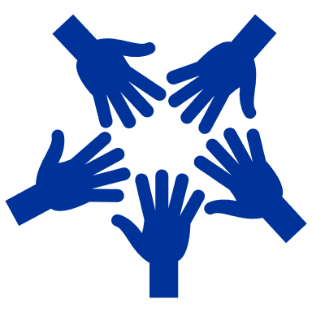

How to design a workshop with young people?

Introduction
The EYSAD project promotes the digital skills of trainers and learners and raises awareness of environmental topics. Hard and soft skills are trained and learned with this project.
How such a project can be approached is shown in this chapter. You can also see the finished product on the EYSAD website.
But first, let us see an example of how a regional environmental photo tour can be implemented:
Miguel lives in Southern France, where it has become continuously hotter in the past years. As he walks along the beach, he collects garbage, cigarette filters, plastic bottles, bottle lids, food wrappings, and plastic bags. All of these are things that need a very long to be decomposed. How long, actually? What happens if the garbage stays where it is? And where does it all come from? Do you also have all these questions? You can find the answers by clicking on different hotspots in the picture. When you select the hotspot on Miguel’s garbage treasures, you will see a picture of a table on which all those things lying that Miguel has collected during his walk. Next to the waste, textboxes appear that show how long it takes until, for example, a single cigarette filter is corroded. It takes approximately 400 years until such a filter is corroded. And what happens when garbage is not collected by people like Miguel but instead reaches the sea? When you go back to the last picture, you see further hotspots close to the sea, on the beach, and on Miguel himself. The hotspot in the sea leads you to a picture of sea animals that have plastic bags attached to them. There is also plastic in the fish’s belly. This is because when plastic wrappings corrode are, they give off microplastic that can reach algae and this way also into the food of animals. And what happens once the fish is on your plate? Would you want to eat it? (Picture of a fish garnished with plastic/wrapped in plastic). Miguel does not want to eat it either. And he wants to do something. When you click on the hotspot on Miguel, you see that some of his friends collect plastic on the beach and also in the park. You see treasures of plastic in the next picture and tools that Miguel and his friends use to collect garbage. For this, they are quite creative. And you see how they bring the garbage to a landfill, where the plastic is recycled. In a selfie video, Miguel explains how he has organised himself with his friends and now collects plastic once a week. He tells you how they create a game out of this by trying to collect as much as possible in as little as time. The one who has found the most is allowed to organise the meeting the next time.

Target groups and needs assessment
The target groups are:
- Young people. People aged 16-30 are interested in the topic of environment and/or digitalization.
- Youth workers. People whose main occupation is working with young people in various non-formal formats
Currently, our planet is experiencing a Climate crisis, which mostly affects the younger generation. This is mostly because they are the ones to inherit the Earth and make the best of their lives for many decades to come.
Of people ages 16 to 25, 84% expressed at least moderate worry about climate change in a 2021 global survey of 10,000 people. More than 56% believed “humanity is doomed,” and more than 45% said their feelings about climate change negatively affected their daily life and functioning (1). Not to mention that the Climate crisis will eventually touch on every aspect of our day-to-day lives, including economic, social, and political sectors. Therefore, it is so important to address these topics, including our target groups (1).
To achieve a positive outcome regarding the climate crisis, young people, as well as youth workers, must acquire such skills:
- Digitalization;
- Teamwork;
- Creativity;
- Psychological awareness;
- Public speaking, and communication;
- Argumentation;
- Critical thinking, and researching.
All of which correspond to the specific needs of future professionals of different parts of the climate crisis. Youth needs to be able to manage their stress regarding eco-anxiety and upcoming extreme weather events. At the same time, they will be the ones to make important decisions, so there is a need for them to be able to hold a discussion backed up by scientifically based arguments and to convey their opinion in influential ways. Critical thinking is also an important part of the puzzle because even though doing research and looking for information has never been this easy as in the XXI century, there is also an enormous amount of false information, which distorts the worldview of many communities, including the decision-makers.
Concerning the abilities mentioned above, youth workers are the bridges between the needed knowledge and the subject group. Therefore, they need to be trained and prepared accordingly to be able to convey these skills and expand the circle of people, capable of making a tangible contribution to this problem.
The EYSAD project gives a method for youth workers to react to these challenges and qualities needed in the future. Digitalization linked to the topic of the environment is the key concept here. Digitalization will play a big role in the future. Therefore, it is important that young people can find smart digital solutions for possible future problems that our planet might be facing. For this reason, EYSAD has the strategy of creating a digital product that includes environmental topics.
To reach the above-mentioned target group, it should first be considered which communication channels young people use in their respective regions. For example, Instagram or TikTok, but notice boards at universities can be used to make the target group aware of the project.

Needs assessment
Once a group of young people has been selected to create a 360° photo tour on the topic of the environment, it is important to first analyse who the participants are. For this, we have already given important impulses in the Trainer-the-Trainer guidebook (Module 1) on the basis of which factors this analysis can be made.
Furthermore, it is crucial for youth trainers and young people to make a needs analysis before starting with the creation of the photo tour, i.e., to become aware of the environmental and social spaces in which the young people move. Are there environmental initiatives or projects that are particularly concerned with their region? Are there environmental issues that can be addressed in this region? This research may already reveal exciting topics that can be looked at more closely in a photo tour. However, it is important to make a needs assessment that does not scare young people away and make them feel that they cannot make a difference. Trainers should pay special attention to the topic of eco-anxiety (DuLong 2022).
The assessment serves to determine the "actual state" and thus to do initial research on the topic of the environment.

Timeframe and resources

Timeframe
The EYSAD project with young people aims to promote the skills mentioned above. An example of how to set up the project concretely and how each process can be is shown here. Trainers should decide for themselves how intensively they want to support each activity. With older and well-organised groups, for example, it is only possible to check selectively at meetings (monitoring) how far the project research has progressed.
The time needed for the photo tour can vary depending on the topic and capacities. However, it is advisable to let the project run for at least two to four weeks, especially if it is not possible to work on it every day.
This list can be used as a checklist by trainers:
ACTIVITY | DESCRIPTION | TIME NEEDED | SKILL TRAINED
Need assessment | Young people research what relevant issues there are about the environment in their region. | Approx. 3-5 days | Research and critical thinking
Workshop (1):  Introduction to sustainability and SDG | Here, the young people learn the fundamental knowledge about sustainability and work concretely with the SDGs. Depending on the level of knowledge of the young people, the workshops can be adapted. | Approx. 1-2 days | Sustainability
Workshop (2):  Storytelling | To take a good 360° photo tour, the young people should learn about the principles and structure of storytelling. This way they can later tell a coherent story through the digital medium. | Approx. 1-2 days | Creativity, Script writing, argumentation
Workshop (3):  Technical instructions | The youngsters receive technical guidance on how to "build" the photo tour, create image and audio material. | Approx. 1-2 days | Technology and digitalization
Searching motivation and finding a topic | This point can be part of the workshop to find out together which topics the youngsters find exciting, what are they interested in?  At the end of this activity, they should know what theme they want to reflect in the photo tour. | Approx. 0,5 day | Curiosity and self-reflection
Write a timeline, milestones, and distribution of tasks | This step is optional and is especially recommended for groups who want to work remotely or are older. It consists of the groups thinking about how long each process step should be and defining concrete milestones in advance. At the same time, it can be decided whether the group wants to do everything together or divide tasks. | Approx. 0,5 day | Project management
Planning of the photo tour (1) | First, the photo tour should be roughly planned:  - Create a first draft of a script (what story do you want the photo tour to tell? Which pictures should be shown)  - Plan how many 360° photos to take and where.  - Plan the 2D material (e.g., whether to record audio and 2D video). | Approx. 3-5 days | Teamwork, script writing, creativity, visual understanding
Writing a script | Thanks to the previous point, the young people have a rough plan of what they want to show and how this should be represented visually. In this step, they now plan the concrete script. | Approx. 3-5 days | Teamwork, script writing, creativity, visual understanding
++++ Monitoring by the trainer: Here it is recommended to check at the latest in which direction the young people's work is going, whether there are difficulties and how well they are progressing. ++++
Scouting of the “photographing” locations (if necessary) | It is recommended that youngsters first look at the environments they want to photograph and take sample pictures. This can immediately identify possible difficulties and a solution can be sought together. | Approx. 1-2 days | Creativity, visual and photographic understanding, psychological awareness
Research | The youngsters research which sources they want to use, look for concrete material for the photo tour (e.g., videos, links, texts, etc.). It is important that in this step they strongly engage with the topic of the environment.  This is one of the most important phases in the project! | Approx. 3-5 days | Research, argumentation, critical and sustainable thinking
Shooting the 360° material, 2D videos and photos, and recording audios | This is where the material for the photo tour is created. As the group has written a script in advance, researched the topics and already scouted the places, the group is well prepared for this step.  If difficulties arise, such as the location looking different, the group can work together to find creative alternative solutions (such as taking a different angle).  In this step, you can not only record the 360° images, but also 2D videos and photos, as well as voiceovers. | Approx. 1-2 days | Digitalization, visual and photographic understanding
Create photo tour digitally | Using 360° virtual tour software, the young people can now compile their materials from the research and recordings here.  The different software available are mentioned in the Train-The-Trainer Guidebook - check it out! | Approx. 3-5 days | Digitalization, visual and photographic understanding
++++ Monitoring by the trainer: Here it is recommended to check again in which direction the young people's work is going, whether there are difficulties and how well they are progressing. ++++
Present the photo tour | When the group has finished the photo tour, be sure to present it so that feedback can be gathered, and the young people can present their ideas and work.  If several groups create different photo tours, they can give feedback to each other.  Here it is important that the young people are motivated and praised for their work! | Approx. 0,5 days | Public speaking, communication (receiving feedback) and argumentation
Improve the photo tour | This step is also optional. If the group has received feedback and suggestions for improvement, it can still enhance the photo tour here. | Approx. 0,5 days

Notes on the individual activities:
After finding a group of youngsters interested in the project, it is important to find a specific topic for the photo tour. Here trainers should give input to the youngsters and in this way support them. For example, when finding a topic, the trainers can ask the young people questions so that they specialize in the topic:
- Why this topic?
- What is the importance? And what exactly do you analyse?
- Where in your neighbourhood or region do you find this topic?
- How can it contribute to the environment and society?
Workshops 1-3 can be combined and organised on three subsequent days, for example. However, as they are divided thematically, they can be planned flexibly. However, it is recommended to plan at least one day per topic in order to give the young people enough insights and to be able to process new things.
When presenting the photo tour, it is important to encourage the group in what they are doing and to praise their work. If young people give feedback to each other, it is also important to explain the rules of feedback to them in advance (e.g., it should always be well-intentioned, constructive and respectful).
After the photo tour has been completed, the participants can decide together what to do with the product. For example, it can be published!

Resources
The advantage of the EYSAD project is that you can decide which resources to use depending on your budget. The project is set up in such a way that it is also possible to work with free software and with equipment that one usually already owns. This ensures accessibility. If you want to make the project more complex, you can also use special 360° cameras. More detailed technical information and explanations can be found in the Train-The-Trainer Guidebook.
- Internet access
- Smartphone with mobile data, tablet or 360° camera
- PC/laptop → Editing the photo tour (here possibly important a computer mouse)
- Optional Cardboard or VR glasses
- Room for workshop
If there are young people who do not have access to the internet, smartphones or computers, the youth organisations should make these devices available to the young people for the project.
For the project implementation, it is highly recommended to include digital tools (beyond the software to create the 360° material). In the hand- and guidebook of this project you will find examples like Miro, Kahoot!, Canva, etc. But there are many other interesting (free) software for each exercise:
- Project management (plan, create tasks and set deadlines): Asana, Trello, monday.com
- Video, photo editing and layout creation: Canva, vimeo, InShot
- Surveys (gather feedback or ask for information): Kahoot!, Mentimeter, SurveryMonkey
- Brainstorming and digital workshop facilitation: Miro, Mural
- Online meetings: Jisti, zoom, google meetings, BigBlueBotton
- Presentation: Prezi, Google Slides
It is important to encourage youngsters to use these interesting tools since they are often also used in different job categories.

Impact and learning outcomes
Learning outcomes are descriptions of the specific knowledge, skills or competence that the learner will gain from the activities and workshops. Learning outcomes are measurable achievements that the learner will be able to understand at the end of the learning process, which helps learners understand the value of the information and what they will gain from engaging in the learning activity.
When developing training, organizations need to appreciate that creating clear, actionable learning outcomes is critical. When designing training, it is necessary to set clear objectives: what the learners should understand after completing the learning path. What is Bloom's Taxonomy? For example, one tool to show how to define effective learning outcomes is Bloom's Taxonomy. There are 6 levels defined there that can be used to structure learning outcomes, instruction, and assessment of your course (Shabatura 2022):
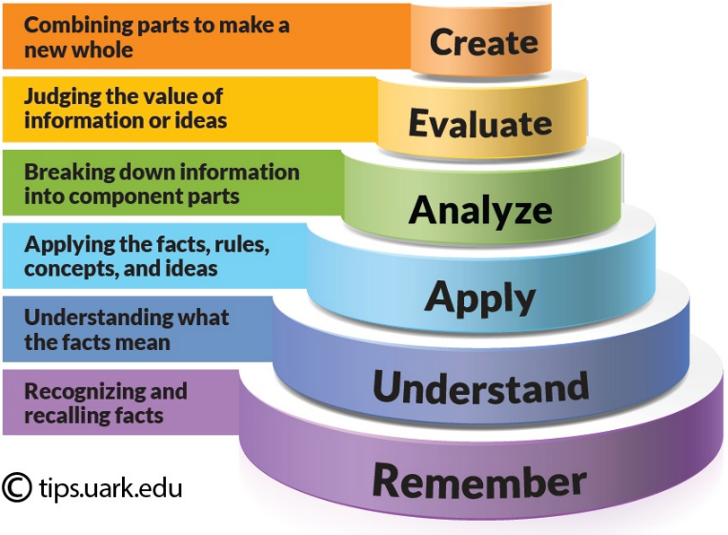
Figure 9 Bloom's Taxonomy (Jessica Shabatura 2022)
The concept can be applied as follows:
Bloom’s Level | Keywords | Example Learning Outcome with EYSAD
Create | design, formulate, build, invent, create, compose, generate, derive, modify, develop. | By the end of the project, the learners will be able to design and build a 360° photo tour based on story telling.
Evaluate | choose, support, relate, determine, defend, judge, grade, compare, contrast, argue, justify, support, convince, select, evaluate. | By the end of the project, learners will know how to select topics and examine them at a regional level.
Analyse | classify, break down, categorize, analyse, diagram, illustrate, criticize, simplify, associate. | By the end of the project, learners will understand how to prepare, research and analyse topics.
Apply | calculate, predict, apply, solve, illustrate, use, demonstrate, determine, model, perform, present. | By the end of the project, learners will have mastered how to implement environmental themes in a digital environment and will have presented these results.
Understand | describe, explain, paraphrase, restate, give original examples of, summarize, contrast, interpret, discuss. | By the end of the project, learners will have understood what environmental issues exist in their immediate environment and will discuss with others how they can be a part of the solution.
Remember | list, recite, outline, define, name, assign, cite, recall, identify, label, recognize. | By the end of the project, learners will recognize what possible solutions exist and will actively work on them. Furthermore, they will have gained an awareness of the environment.
Figure 10 Learning outcome examples adapted by the authors of this publication (Nelson Baker 2022)
The optimal effect of this project is that young people become aware of the environment and at the same time are digitally agile. The theory part helps individuals to educate themselves and learn new things. By working together in groups, they additionally learn what belongs to a good project and group work. The goal of the project is also that young people to become active in their environment.
For young people to become active in their regions it is recommended to show to the target group (and avoid eco-anxiety) regional environmental challenges (see example in the beginning).

Summary
Advantages of learning outcomes:
- It is a valuable component that sharpens focus and emphasises student learning.
- Makes students smarter, more efficient, and smarter
- Develops the ability to analyse and react to real situations
- Increases the overall value of education
- Educates the learner holistically, acquiring knowledge and values
- It inspires learners to create a much better society
- The key to writing effective learning outcomes
- Digitalization
- Awareness of sustainability

Follow-up and interoperability
Even the best program will be pointless if we don't use the momentum that comes after the workout. If you are the person leading the workshop, it is up to you to take care of the follow-up.
Below are some tips to help you get the results you want (Coward 2016):
1. The workshops and the creation of the photo tour are parts of a larger process. The days of the workshops are an important event – getting the right people together, making sure the discussions are productive and everyone is engaged – so a lot of time is spent on this process. But the workshops are a part of a larger project to take it to the next stage. After it, even more, efforts must be made to realize the ideas born during the seminar. The workshops are the foundation for the success of the photo tour, so it is important here to motivate the group.
2. Plan the next steps when creating the workshop. Once you start organizing the workshop, think about what needs to happen after the workshop to facilitate the final project. Consider what to do with the workshop content. Perhaps you can share discussion questions, and prepare a report, presentation, or report.
3. Actions and next steps. End the project with an opportunity for everyone to reflect and share their next steps to create a sense of commitment and direction. You can also get suggestions on what they think should happen next, as they may have good ideas on how to keep the momentum going. By involving participants in the plans for subsequent workshops, they will be more engaged and motivated.
4. Keep communicating. You can share common files with participants, e.g., Google Doc is perfect for this. Invite participants to correct and comment. You can ask them some open-ended questions that will encourage them to include any ideas they may have had after the project. It would be ideal if the young people stay in contact after the project and organize with each other to help their region with environmental issues.
5. Plan the dissemination of the project. The project has the aim to motivate youngsters and have a positive impact in their actions. Therefore, it is important that the young people disseminate their work and that the project is published. Social media channels can be used for this purpose or a presentation in front of other youngsters, for example. The group or the trainers can decide what the publication of the results should look like.
TIP: You can use the following questions:
- What was the purpose of this project? Do you think it achieved that goal?
- Has your skill level changed? If so, how?
- Which activity did you find most useful? Which were the most enjoyable?
- How can we improve the projects process for better learning in the future?
It is helpful to keep these surveys anonymous. A secret identity will allow your guests to be more honest with their criticism. It can be harsh, but constructive criticism is necessary to improve the workshop.
To maintain the energy of a great workshop, think of it as three phases – before (preparation and design), during (support) and after (workshop follow-up) – and give them equal importance.

Workshop exercises toolkit

Energizers

These energizers were used during the EYSAD youth mobility in Budapest, Hungary, May 2022, held by the participants. Of course, they are only examples, any energising exercise can be used. It is strongly recommended to have an energizer at the beginning of the day and after lunch break. It is usually a great idea to give the floor to the participants and encourage them to bring and hold the energizers themselves.

Cross the pillow
Number of participants: 8-30 (it can be more but the more participants, the longer the game lasts)
Aim: develop group dynamics, activation, moving
Duration: 5-10 minutes
Materials needed: two pillows (or balls)
Description: the group forms a circle. Every second participant belongs to the group 2. Each group has a pillow (or ball) which start from opposing participants. The pillow should be passed around the group as quickly as possible. The team whose pillow crosses that of the other team wins.

Dodgeball
Number of participants: 8-30 (it can be more but the more participants, the longer the game lasts)
Aim: energizer, activation, moving
Duration: 10-30 minutes (depending on the participants)
Materials needed: tape, balls
Preparation: using the adhesive tape to divide the training room into two equal parts, pack away the fragile items
Description: the group is divided into two equal parts. The objective of dodgeball is to eliminate all players of the opposing team by throwing one of four game balls and hitting the opposing player below the shoulders on the fly. If the participant catches the ball, he does not fall out. Each team starts with one ball and then there are two balls evenly spread on the centre line at the beginning of each game. The team with the last man left on the pitch wins.
Tips: it can be a great exercise before a less active session, e.g., before a presentation.

He-Ha-Ho
Number of participants: at least 10 (otherwise it is finished too soon) - no upper limit
Aim: develop group dynamics
Duration: 5-10 minutes
Description: group is in the circle and one player begin with the play. There are three different words in connection with three different movements. First player pronounces HE and with joined palms waves from the top of the head down – as they has a sword in their hands, like they wants someone to cut in half. A person who is halved pronounced HA and raise their palms from down to up over the head. Two persons beside pronounced HO and then sweep also with connected hands to the stomach of the “HA” person, also like they cut him with the sword. Afterwards that “HA” person continues to play with pronouncing HO, and “cutting” somebody else in the circle.

Grab the finger
Number of participants: at least 10 (otherwise it is finished too soon) - no upper limit
Aim: develop group dynamics
Duration: 5-10 minutes
Materials needed: fingers and hands
Description: the group stands in the circle, and everyone puts their right index finger in the air touching the underside of the flat left hand of their neighbour. At a sign of the facilitator, the left hands (on top) try to catch the right-hand index fingers. The index fingers of course try not to get caught. The fingers that are caught leave the circle - the remainder plays again and again until only 2 are left over.

Group map
Number of participants: no lower or upper limit
Aim: icebreaking, developing group dynamics
Duration: 5-10 minutes
Materials needed: map, pins in two different colours
Can be implemented online with Miro or other online board.
Description: A map is shown, where everyone can make a pin regarding two questions: Where were you last on vacation? Where would you like to go? Afterwards, there is a round in which everyone says their name and explains where they have placed their pin.

Exercises
These exercises were implemented in the EYSAD youth mobility in Budapest, Hungary, May 2022. All of them are suitable for international groups as well as working with national teams of young people. Some of them can be easily implemented online too.

Norms, expectations, contributions
Number of participants: no lower or upper limit
Aim: laying the foundations for the learning process, setting learning objectives, involve participants in the learning process
Duration: 60 minutes
Materials needed: flipchart papers, sticky notes, stationery items
Preparation: write the titles to the flipchart papers: ‘Norms’ (it stays in the flipchart), ‘Contributions’ (put it to the wall) and ‘Expectations’ (put it to the wall as well and draw a large tree).
Can be implemented online with Miro or other online board.
Description: first we ask the participants to think about the norms and rules they want to apply for the learning environment. We can give them some examples like “no phone unless it is for work” or “do not interrupt each other”. We collect their suggestions on the flipchart. When it is ready, every participant formally signs it as an agreement for the whole group. Then we can proceed with the ‘Expectation Tree’ and contributions. We give sticky notes and pens to every participant and ask them to collect their expectations – what do they want to learn and how, what they want to do in this training; and their possible contributions – what they can do for achieving these aims. Participants put their expectations to the roots of the tree and contributions to the flipchart paper.
Tips: this can be the first exercise of the workshop, after some team building.

How much do you know about…?
Number of participants: 5-36
Aim: laying the foundations for the learning process, setting learning objectives, involve participants in the learning process
Duration: 5-15 minutes depending on the group’s size
Materials needed: flipchart, markers, “How much I already know about” reference system (Annex 1)
Preparation: draw the reference system to the flipchart paper.
Can be implemented online with Miro or other online board.
Description: This is a short introductory exercise to assess the existing knowledge of the participants on sustainability and digitalisation. Shortly present the reference system to the participants and ask them to think about their knowledge on these two topics. When they are ready, they can go to the flipchart and mark their position in the reference system. After each participant has positioned themselves in the system, offer the opportunity to share what they already know.
Tips: this exercise is especially useful if we do not really know the group and their preparedness is useful information for us in the rest of the training.

Our Sustainable City
Number of participants: 6-36
Aim: thinking about sustainable development from different perspectives, brainstorming on possible solutions for the SDG challenges
Duration: 95 minutes
Materials needed: flipchart with the rules and steps of the game, worksheets (Annex 2)
Preparation: prepare the flipchart with the rules and steps of the game in advance.
Can be implemented online with breakout rooms.
Description: We tell the participants that we live in an imaginary city. Dedicate a few minutes to think about it – what size is it, how it is called, what geographical area is it in, etc. Then form 4 small groups and present them their profiles:
- Leaders of a big Sports Club
- Members of a self-driven urban community
- Staff members of a local community centre
- Board of management of a big food-producing company
Participants should come up with genuine ideas on how to operate more sustainably, create interest among citizens about sustainable lifestyle (involve more and more people). Rules for the small group work are strive to teamwork, detail the ideas, build on the 17 SDGs, and be as creative as possible. The worksheet should include the name of the project, project details, length, budget, benefits, risks. The small groups present their ideas to the whole group. If you can, create a jury by involving some of your colleagues. They give feedback for each project idea and may give financial support from a predefined theoretical budget. If you want to add some fun parts, you can complement this exercise with a quiz game with Kahoot (the group that wins, receives extra resources).
Tips: involve actual decision makers from the local government, if you can, it will be a huge added value for this exercise.

Your life story
Number of participants: 6-36
Aim: getting to know the bases of storytelling, developing creativity
Duration: 45 minutes
Materials needed: papers, pencils, colour pencils, markers
Can be implemented online with breakout rooms.
Description: As participants to take a paper and some pencils, markers and draw the river of their life. They should think of 3 important events that has happened to them. Try to draw them in the river: a waterfall, a dried section, a junction, calm water, etc. The group forms two circles one inside and one outside, thus creating pairs. Participants show their drawings to their partners and talk about these important events. After a couple of minutes, they change. After some another minutes, participants in the inner circle sit one to the right and form new pairs. Can be repeated for as long as you like, for small groups the full circle can be done. Finally, we ask participants: why do we talk about stories? Collect their ideas on a flipchart. Some hints for ideas:
- Stories work better than facts.
- We remember stories easier. Our brain is made for remembering stories.
- Facts address us as rational beings, while stories address us as rational, emotional and social beings.
- Stories give us orientation.
- Stories can connect us: if we are alone with our problem, we feel alone.

Video analysis
Number of participants: 6-36
Aim: getting to know the bases of storytelling, developing creativity
Duration: 30 minutes
Materials needed: laptop or smartphone, projector, speakers
Can be implemented online with breakout rooms.
Description: form small groups of 4-6 people. They will discuss their impressions about videos with helping questions:
- Which elements aim you as a rational being?
- Which elements aim your emotions?
- Which elements help to create a connection between you and the hero or topic?
- How did you like the structure of the story? (Suspense, pace, music, ending, etc.)
The suggested videos are:
- Video 1 - Three Plastic Bottles: https://www.youtube.com/watch?v=_6xlNyWPpB8
- Video 2 - A Whales Tale: https://www.youtube.com/watch?v=xFPoIU5iiYQ
- Video 3 - Reduce, Reuse, Recycle: https://www.youtube.com/watch?v=OasbYWF4_S8
- Video 4 - Organic & Sustainable Farming: https://www.youtube.com/watch?v=5SzJkL7czI0
- Video 5 - How to take care of the environment: https://www.youtube.com/watch?v=X2YgM1Zw4_E
- Video 6 - Why we need to stop plastic pollution: https://www.youtube.com/watch?v=Yomf5pBN8dY
At the end, participants can share their thoughts, highlights with the whole group.

Fighting eco-anxiety
Number of participants: 5-36
Aim: understanding the term of eco-anxiety and the emotions behind, building positive attitude
Duration: 30 minutes
Materials needed: laptop, projector, speaker
Can be implemented online.
Description: we introduce the phenomenon of eco-anxiety to the group and watch together this video: https://www.youtube.com/watch?v=x5d7auTlUyE. Lead a conversation with the group about eco-anxiety, collect together the feelings behind and emphasize the dangers of anxiety and powerlessness. Highlight that action helps to overcome negative feelings.

Salt painting
Number of participants: 12-36
Aim: meditation, artwork together to discover a new way of storytelling, developing creativity, finding inner peace
Duration: 90 minutes
Materials needed: papers, pencils, glasses, salt, alcohol free markers, blindfold materials, intro (Annex 3)
Preparation: darken the training room and ask participants to stay outside. Prepare tables depending on the group size, one for 4 people and put coloured markers, papers and pencils on them. Fill the glasses half full of salt and place them in the middle of the tables.
Description: form pairs, blindfold participants and lead them, holding hands, into the room and place them around the tables – separate the original pairs and lead them to different tables. The room has only weak, mood lighting. Ask participants to stay silent and tell the intro. Then, participants can remove the blindfold and start to draw their house. When they are ready, ask them to open the markers and stir the glass of salt with it until it becomes coloured. We add a bit more light and ask them to start to colour their drawings but only a little bit. Then all groups change the table and continue colour others’ drawings. Repeat rotation until a full circle (or with smaller groups, every participant visited every table) with continuously rising the light in the room. At the end, we put together all the tables with the drawings (be careful with them!), give some time to view them and find their own and sit in a circle around them. A facilitated discussion closes the exercise, where the facilitator asks participants how they felt in the dark, in the silent environment, what the house and the nature around meant to them, how was it to colour their own house and others’, how did they feel when they got back to their house (which was probably changed significantly), what stories can be behind these houses, etc.
Tips: ideal practice for an optional evening programme. We can play with the light with lamps or natural light and dimmer.

Storytime!
Number of participants: 12-36
Aim: practicing storytelling and get a deeper understanding on it
Duration: 30 minutes
Materials needed: topic cards (Annex 4) for each pair
Can be implemented online with breakout rooms.
Description: after forming pairs, we ask participants to choose one topic from the handout (topic cards) and tell a story to each other. It may be a true or an imagined one. Remind participants to rely on the skills and knowledge learned before and give constructive feedback to each other.
Tips: this exercise is recommended at a later stage of the training, when participants are more immersed in the topics and methods.

Positive gossip
Number of participants: between 5-60
Aim: strengthening group dynamics, positive attitude and feedback. This activity contributes to the group cohesion too and strengthens human relationships, which are more likely to be maintained after the training.
Duration: 30 minutes
Materials needed: timepiece (smartphone or watch), an object for smooth sound effect (e.g. a singing bowl)
Can be implemented online.
Description: we break the group into equal-sized groups of people, and you can use the same room or a clean space outside in nature. We explain that: You should use sentences as if the listening group member was not present in the circle; refer to them as “she”, “he” or “they” or by their name. / There is no given order in who is gossiping, you can even gossip at the same time / each person who is receiving positive gossip gets 2 minutes. So, the encouragement for the gossipers is to speak and talk and gossip as much as they can fit into this short time. / Gossiping can be anything about this one person, the only condition is, that these can only be a positive things, such as:
- what you like about this person (characteristics, behaviour, attitude)
- what situation you saw with this person that made a positive impact on you
- why you are fascinated by them
- what you are proud of in this person, you can even use your imagination - you have a strong belief this person can be good at....
We ask one group member in each group to turn his/her/their back on their group mates, so only “their ears” participate in the circle, but the other members cannot see their face. When all groups are ready the facilitator makes a sound that signals the beginning, and the participants start to heavily gossip about one person. (2 min each) We signal that the time is up, and a new person has a turn and a new gossip round starts. The signal is repeated to start and to stop every 2 minutes until everybody receives his/her/their gossip round. We gather the group in a circle to share and reflect on the experience of the activity.
Tips: it is worth having this exercise towards the end of the workshop, as it facilitates later contact between participants.

Getting to know the 360° photo tour app
Number of participants: no lower or upper limit
Aim: give technical knowledge on 360° photo tours, showing an application and its features for 360° photo tours creation
Duration: 20-30 minutes
Materials needed: laptop, projector, smartphones, strong internet connection
Preparation: prepare a presentation about the application
Can be implemented online.
Description: Ask participants to download and install the Theasys application to their smartphones. They can follow your presentation by trying the features you are presenting. There are two ways to present the application: connect your smartphone to the projector and show the steps and features of the 360-degree photo tour directly or prepare a presentation with pictures in advance. For the technical preparation, use the EYSAD Trainers’ Training Handbook. Encourage participants to ask their questions. After the presentation, create small groups (3-6 participants; small groups can be skipped if you work with a really large group), and give challenges to them based on the app features.

Study visit
Number of participants: it depends on the capacity of the host, recommended for smaller groups
Aim: food for thought, practice-oriented learning, getting to know SDGs better, bring the SDGs closer to the participants
Duration: 1-4 hours + travel
Description: It is always great to have an insight to the practical side of sustainable development goals. If the timeframe allows, organise a study visit to an NGO or governmental institute where sustainability is addressed. Participants can go places they would not necessarily have gone on their own and meet people they would not otherwise have met. Study visits can include environmental bodies and NGOs, schools and educational institutions, museums, health institutions, social services, refugee shelter, urban community gardens, etc. Youngsters usually love study visits, especially on a longer training or exchange. Recommendations for the visit:
- Carefully prepare your host what they can expect, what the timeframe is, what the group characteristics are. Discuss with them the possible topics and activities. Avoid long lectures. If there is an activity in which your group can participate (e.g., litter picking), ask your host to organise it.
- Let and encourage participants to ask their questions and share their opinions.
- Build on local strengths! If there is a seasonal programme, feel free to take this advantage, it can be a unique experience for the group.
- Make sure that participants reflect on the study visit and on their newly acquired knowledge and skills during the workshop, otherwise it will be only an excursion.

Social aspect of sustainability
Number of participants: 6-36
Aim: get to know the SDGs better, view on the social aspect of sustainable development
Duration: 90 minutes
Materials needed: flipchart papers, markers, sticky notes, coloured papers, glue, smartphones, laptop, projector, speaker etc., the better is the more materials they have
Can be implemented online with breakout rooms and online tools like Kahoot quiz game.
Description: create small groups of 4-6 people (or pairs in smaller groups). Every group select one or two SGDs. The first step is a discussion about the following questions:
- About the SDGs: what they mean in reality? What are their most problematic aspects? What are the taboos in them?
- What issues are in the participant’s environments related to these SDGs? How participants see these problems?
The second step is creating a short session (15-20 minutes) for the rest of the group. It can be anything like game, quiz, debate, performance, visuals, etc., any creative ideas are welcome. The short sessions are implemented. The last step is a feedback circle.

World café – project ideas
Number of participants: between 12-35
Aim: sharing ideas, developing the sense of initiative, encourage collaboration, access to “collective intelligence”, laying down the bases of a certain photo tour
Duration: 2-3,5 hours
Materials needed: flipchart papers, pens, markers
Can be implemented online with breakout rooms and Miro or other online boards.
Description: Based on the SDGs, we ask participants to share if they have project ideas around a certain topic. We collect them in the flipchart as a word cloud, grouped by theme and jointly choose 3-5 for the further work. Prepare one flipchart paper for each topic and put in on a table. We create as many small groups (or pairs) as topics and every group has 20-30 minutes by every table to share their ideas, collect keywords, draft one or more photo tour projects.
Some Café recommendations:
- Focus on what matters
- Contribute your thinking
- Speak your minds and hearts
- Listen to understand
- Speak with intention, listen with attention
- Link and connect ideas
- Go deeper instead of wider
After the last round, participants have some free space and time to view the final flipcharts, discover how and by whom was their idea further developed and possibly create teams for a photo tour.
Tips: this can be a quite long exercise; therefore, coffee break should be literally included. It is even better to have coffee, tea, and snacks in the training room or hold this activity at the coffee break venue. We can even create a real Café atmosphere.

Script writing
Number of participants: 6-36
Aim: starting to plan a 360° photo tour, finding common topics, putting into practice what they have learned
Duration: 90 minutes
Materials needed: flipchart papers, markers, sticky notes, coloured papers, glue
Can be implemented online with breakout rooms and Miro or other online boards.
Description: participants work in pairs or in small groups. (For international groups, it is recommended to work in national groups in case the photo tour will be implemented in the home countries of the participants.) They have some time and space to plan an actual 360° photo tour. Helping questions:
- What is the problem you would like to address?
- What approach do you want to take, what will you show?
- Which locations will the photo tour cover?
- What additional information will you add, in what order?
- Outline the main elements of the story, its key points!
- What will be the punch line, what can the viewer learn from it?
The small groups prepare a flipchart poster about their script and present it to each other.

Evaluation practices and follow-up activities

Reflection pairs/groups
Number of participants: no lower or upper limit
Duration: 10-30 minutes
Can be implemented online with breakout rooms.
Description: form pairs of groups of 3-4 people. Ask participants to evaluate the exercises and shortly reflect their learning process: what was new for them? Is there an area where you have deepened your existing knowledge? Was there anything you did not find useful at all? How did you feel during the exercises? Encourage them to be active listeners for peer-support of the learning process. If the training lasts more than one day, repeat the reflection groups at the closing of each day, keeping the same pairs/groups.

Dixit
Number of participants: 5-36
Duration: 10-30 minutes, depending on the group size
Materials needed: Dixit cards (the more the better)
Can be implemented online with online cards: https://ro.pinterest.com/evamelinda11/dixit-cards/
Description: this evaluation exercise is suitable for the full group feedback, including larger groups. The participants sit in a circle, the dixit cards are cast in the middle. We ask them to choose 1-3 cards that symbolizes their learning path and outcomes and tell a few sentences about it.

Exchange of experiences
Number of participants: 6-36
Duration: 10 minutes
Can be implemented online with breakout rooms.
Description: form small groups (or create breakout rooms in online environment) and ask participant to share their thoughts about these questions:
- How did we feel about creating the photo tour?
- What was easy, what was difficult?
- What tips would you give to someone who has never worked with this technology before and is asked to create a photo tour?
In plenary, one person shares the highlights (e.g., one point per question).

Photo tours presentation
Number of participants: 6-36
Duration: 5-10 minutes for each presentation
Materials needed: laptop, projector
Can be implemented online.
Description: each group present their photo tour: first summarising the questions of the previous task (how was the implementation, what difficulties were there, what was good/easy?). In the second step they share their screens and show their created photo tours (briefly the "rooms"/panorama pictures and 2-3 highlights). After a Q&A session, other participants can give short feedback. For this, it is recommended to dedicate some time to talk about giving constructive feedback with the participants.

Tracking the learning curve
Number of participants: 6-36
Duration: 25 minutes
Materials needed: flipchart papers, pens, sticky notes
Can be implemented online with Miro or other online board.
Description: what will participants take away from the experience? Different categories will be featured on flipchart papers (or Miro board):
- Sustainability
- European cooperation
- Digitalization
- Storytelling
- Maybe also: Others (referring a “free” category). What else do you want to share with us?
Participants fill in the different categories with post-its (10 min). After that, each person says their most important point in a category.

The compliment shower
Number of participants: 6-36
Duration: 5-10 minutes
Materials needed: pens, sticky notes
Description: The task is for everyone to write at least one positive point for each person and hangs it on their back or shoulder (in online environment: participants have a "frame" with their name). Activity is not commented, participants bring home these compliments.

Youthpass
Youthpass is a European recognition instrument for identifying and documenting learning outcomes that are acquired in projects under the Erasmus+ Youth and the European Solidarity Corps programmes.
- Youthpass promotes individual reflection and awareness about learning and helps to make learning outcomes visible for the learners themselves as well as for others.
- It aims to reinforce reflective practices in youth work and solidarity activities, thereby enhancing their quality and recognition.
- It also supports the continued pathways of young people and youth workers, and...
- raises visibility of the value of European engagement.
If the training or exchange is part of an Erasmus+ or European Solidarity Corps project, the coordinator can issue a certificate for the participants, and it also includes a self-reflection tool to reflect on the learning process and raise awareness on the learning outcomes.
More information: https://www.youthpass.eu/en/

Table of Figures
Figure 1 Adapted graph from Helmholtz Climate Initiative, originally by Azote for Stockholm Resilience Centre based on Wand-Erlandsson et al. 2022, Persson et al. 2022, and Steffen et al. (2015). 9
Figure 2 Adopted from the Corporate Finance Institute website (2023) (https://corporatefinanceinstitute.com/resources/esg/esg-environmental-social-governance/) 15
Figure 3 Venn Diagram of sustainability designed by the authors of this publication (2023) 18
Figure 4 Three-nested-dependencies model of sustainability designed by the authors of this publication (2023) 19
Figure 5 Shortfalls and overshoot in the Doughnut by Raworth (2017b) 19
Figure 6 The Sustainable Development Goals, Adopted from the United Nations website (2023) 23
Figure 7 Sub-competencies of Gestaltungskompetenz (de Haan 2010) 33
Figure 8 European competence framework on sustainability: Competence groups related to sustainability and their sub-parts (Bianchi et al. 2022) 33
Figure 9 Bloom's Taxonomy (Jessica Shabatura 2022) 43
Figure 10 Learning outcome examples adapted by the authors of this publication (Nelson Baker 2022) 44

Sources
Bianchi, G., Pisiotis, U. and Cabrera Giraldez, M., GreenComp The European sustainability competence framework, Punie, Y. and Bacigalupo, M. editor(s), EUR 30955 EN, Publications Office of the European Union, Luxembourg, 2022, ISBN 978-92-76-53201-9, doi:10.2760/821058, JRC128040.

Boeve-de Pauw, Jelle & Gericke, Niklas & Olsson, Daniel & Berglund, Teresa. (2015). The Effectiveness of Education for Sustainable Development. Sustainability. 2015. 15693-15717. 10.3390/su71115693.

Brock, A. & Grund, J. (2020): Non-formale Bildung für nachhaltige Entwicklung: Divers, volatil und dabei feste Säulen der Nachhaltigkeitstransformation. Berlin. Online access: https://www.ewi-psy.fu-berlin.de/einrichtungen/weitere/institut-futur/Projekte/Dateien/Brock_-A__-Grund_-J__2020__Non-formale_BNE_Divers_volatil_und_dabei_feste1.pdf

Brüggemeier, Franz-Josef (2012): Nachhaltigkeit- Ein historischer Überblick. Online access: https://library.fes.de/pdf-files/akademie/online/09118.pdf

Corporate Finance Institute (2023). ESG (Environmental, Social and Governance). Online access: https://corporatefinanceinstitute.com/resources/esg/esg-environmental-social-governance/

Coward, Alison (2016). 5 tips for better workshop follow-up – Bracket. Online access: https://bracketcreative.co.uk/workshop-follow-up/

De Haan, G., Kamp, G., Lerch, A., Martignon, L., Müller-Christ, G. & Nutzinger, H. G. (2008). Nachhaltigkeit und Gerechtigkeit (Bd. 33). Berlin, Heidelberg: Springer Berlin Heidelberg. Onlince access: https://doi.org/10.1007/978-3-540-85492-0

De Haan (2010): The development of ESD-related competencies in supportive institutional
frameworks. Article in International Review of Education June 2010
DOI: 10.1007/s11159-010-9157-9. Online access: https://www.researchgate.net/publication/225773272_The_development_of_ESD-related_competencies_in_supportive_institutional_frameworks

DownToEarth (2019): 'Climate catastrophe' and not 'Climate change'. Online access: https://www.downtoearth.org.in/blog/climate-change/-climate-catastrophe-and-not-climate-change--64728

Encyclopedia Britannica. "Industrial Revolution". Online access: https://www.britannica.com/event/Industrial-Revolution

European Union (1995-2023): Climate Change and biodiversity loss should be tackled together. Article in: EU Horizon magazine. Online access: ec.europa.eu/research-and-innovation/en/horizon-magazine/climate-change-and-biodiversity-loss-should-be-tackled-together#:~:text=In%20a%20two%2Dway%20process,and%20increasing%20vulnerability%20to%20it.

European Council (2022). 5 facts about the EU’s goal of climate neutrality. Online access: https://www.consilium.europa.eu/en/5-facts-eu-climate-neutrality/

DuLong, Jessica (2022). Do you have ‘eco-anxiety’? Here’s how to find out. Online access: https://edition.cnn.com/2022/08/12/health/eco-anxiety-harmful-for-health-wellness/index.html

European Commission (2021): Digital Education Action Plan 2021-2027. Resetting education and training for the digital age. Online access: https://education.ec.europa.eu/sites/default/files/document-library-docs/deap-communication-sept2020_en.pdf

Herath, H.M. Thakshila Ruvini and Rathnayake, R.M Prabodha Subhashini (2019): A Criticial Approach towards Sustainability models - A Review. Online access: https://scholar.google.pt/scholar_url?url=https://ijair.org/administrator/components/com_jresearch/files/publications/IJAIR_2975_FINAL.pdf&hl=de&sa=X&ei=o__WY_-uCpKzmAGksYPACw&scisig=AAGBfm1OWnzSSAxxW2VYPkz9EET1G34fOg&oi=scholarr
Holst, J. (2022): Towards coherence on sustainability in education: a systematic review of Whole Institution Approaches. Sustain Sci (2022). Online access: https://doi.org/10.1007/s11625-022-01226-8
IGI Global (n.d.). What is The Brundtland Commission. Online access: https://www.igi-global.com/dictionary/the-brundtland-commission/55619

Ipsos (2022): Majority across 34 countries describe effects of climate change in their community as severe. Online access: https://www.ipsos.com/en/climate-change-effects-displacements-global-survey-2022

Ilic-Krstic, Ivana, Ilic, Alexander, Avramović, Danijela (2018): THE THREE DIMENSIONS OF SUSTAINABLE DEVELOPMENT: ENVIRONMENT, ECONOMY AND SOCIETY. Conference paper for The 18th Conference of the series Man and Working Environment. Niš, Serbia. Online access: https://www.researchgate.net/publication/329611140_THE_THREE_DIMENSIONS_OF_SUSTAINABLE_DEVELOPMENT_ENVIRONMENT_ECONOMY_AND_SOCIETY

IUCN (2002) Education and Sustainability: Responding to the Global Challenge. Chapter: Education for sustainable development – an international perspective : https://books.google.de/books?hl=de&lr=&id=q18nBgAAQBAJ&oi=fnd&pg=PA13&dq=education+for+sustainable+development&ots=Kog6G4ieZF&sig=Xv_TaZPPIG_ymnYQZiCP3bcnNZI&redir_esc=y#v=onepage&q=education%20for%20sustainable%20development&f=false

International Institute for Sustainable Development (2020): Biological Diversity: Protecting the variety of life on Earth. Online access: https://www.iisd.org/articles/deep-dive/biological-diversity-protecting-variety-life-earth

Lutkevich, Ben (2022): ESG vs. CSR vs. sustainability: What's the difference? Corporate sustainability is gaining increased attention due to a growing focus on climate change and new regulation proposals. Online access: https://www.google.com/url?q=https://www.techtarget.com/whatis/feature/ESG-vs-CSR-vs-sustainability-Whats-the-difference&sa=D&source=docs&ust=1678138274044729&usg=AOvVaw1t2H9G0j3ErXeI9e-aNno3

Mohamed, Abdel-Mohsen O. Paleologos, Evan K. Howari, Fares M. (Editors) (2021): Chapter 1 - Sustainable pollution assessment practices. In: Pollution Assessment for Sustainable Practices in Applied Sciences and Engineering, Butterworth-Heinemann, Pages 3-42, ISBN 9780128095829, https://doi.org/10.1016/B978-0-12-809582-9.00001-3.
Nagel, U., Kern, W. & Schwarz, V. (2006). Schlussbericht. Beiträge zur Festlegung von Kompetenzen und Standards für die Bildung für Nachhaltige Entwicklung – unter den Aspekten Umweltbildung, Gesundheitsbildung und Globales Lernen. Pädagogische Hochschule Zürich.
Perrone, G. (2022). The story behind the term ESG. Twenty Now. Online access: https://www.twentynow.com/sustainability-initiatives/people/the-story-behind-the-term-esg/

Purvis, Ben. Mao, Yong. Robbinson, Darren (2018): Three pillars of sustainability: In search of the origins. Article in: Sustainability science (2019) 14:681-695. Springer Verlag. Online access: https://link.springer.com/content/pdf/10.1007/s11625-018-0627-5.pdf?pdf=button

Potsdam Institut für Klimafolgenforschung (2022): https://www.pik-potsdam.de/de/aktuelles/nachrichten/update-planetare-grenzen-suesswassergrenze-ueberschritten

Raworth, Kate (2017a): Doughnut economics: seven ways to think like a 21st century economist. White River Junction, Vermont, Chelsea Green Publishing.

Ro, Christine (2022): How climate change is re-shaping the way Gen Z works. Online access: https://www.bbc.com/worklife/article/20220225-how-climate-change-is-re-shaping-the-way-gen-z-works
Rogers, Alan (2019). Second-generation non-formal education and the sustainable development goals: operationalising the SDGs through community learning centres. In: International Journal of Lifelong Education 38 (5), S. 515–526. DOI: 10.1080/02601370.2019.1636893.

Raworth, Kate (2017b): A Doughnut for the Anthropocene: humanity's compass in the 21st century In: The Lancet Planetary Health, Volume 1, ISSUE 2, e48-e49, May 2017 DOI: https://doi.org/10.1016/S2542-5196(17)30028-1

Schreiber, J.-R. (2005). Kompetenzen und Konvergenzen. Globales Lernen im Rahmen der UN-Dekade 'Bildung für Nachhaltige Entwicklung'. Zeitschrift für internationale Bildungsforschung und Entwicklungspädagogik (ZEP), 28(2), 19–25.
Shabatura, Jessica (2022). Using Bloom’s Taxonomy to Write Effective Learning Outcomes: Online access: https://tips.uark.edu/using-blooms-taxonomy/

Talan, Anita, Tyagi, R.D., Surampalli, Rao Y. (2020): Social Dimensions of Sustainability. Chapter 9. Online access: https://onlinelibrary.wiley.com/doi/abs/10.1002/9781119434016.ch9

Todorov, V.I. and Marinova, D. (2008): Models of Sustainability. Online access:https://www.mssanz.org.au/modsim09/D2/todorov_D2a.pdf

United Nations (2015): Transforming our world: the 2030 Agenda for Sustainable Development: Resolution adopted by the General Assembly on 25 September 2015. Online access:
https://documents-dds-ny.un.org/doc/UNDOC/GEN/N15/291/89/PDF/N1529189.pdf?OpenElement
United Nations (2023). What is climate change? Online access: https://www.un.org/en/climatechange/what-is-climate-change

United Nations (2023): Academic impact: Sustainability. Online access: https://www.un.org/en/academic-impact/sustainability
United Nations (n.d.). THE 17 GOALS | Sustainable Development. Online access: https://sdgs.un.org/goals

UN ESCAP 2015: Integrating the three dimensions of sustainable development: A framework and tools. Online access: https://www.unescap.org/sites/default/files/Integrating%20the%20three%20dimensions%20of%20sustainable%20development%20A%20framework.pdf

UNESCO (2020): Education for Sustainable Development. A Roadmap. Online access: https://unesdoc.unesco.org/in/documentViewer.xhtml?v=2.1.196&id=p::usmarcdef_0000374802&highlight=esd%20roadmap&file=/in/rest/annotationSVC/DownloadWatermarkedAttachment/attach_import_99ceff12-2c27-4841-b420-37d0ed2bc01d%3F_%3D374802eng.pdf&locale=en&multi=true&ark=/ark:/48223/pf0000374802/PDF/374802eng.pdf#381_20_ED_EN_ESD_Roadmap.indd%3A.55292%3A98

UNESCO (2022): Berlin Declaration on Education for Sustainable Development. Learn for our planet: Act for sustainability. 19 May 2021, Online access: https://unesdoc.unesco.org/ark:/48223/pf0000381228?posInSet=2&queryId=N-EXPLORE-34188c8c-5d40-4853-8869-35c2152633fa

UNESCO (2023): Education for sustainable development Online access: https://www.unesco.org/en/education/sustainable-development

UNFCCC (2022): COP27 Reaches Breakthrough Agreement on New “Loss and Damage” Fund for Vulnerable Countries. Online access: https://unfccc.int/news/cop27-reaches-breakthrough-agreement-on-new-loss-and-damage-fund-for-vulnerable-countries

UN Global Compact (2023). Integrate the Principles for Responsible Investment. Online access: https://www.unglobalcompact.org/take-action/action/responsible-investment

University of Plymouth (2023): What is Education for Sustainable Development? Enabling every human being to acquire the knowledge, skills, attitudes and values necessary to shape a sustainable future. Online access: https://www.plymouth.ac.uk/students-and-family/sustainability/sustainability-education/esd

World Health Organisation (2023). Public health and environment. Online access: https://www.who.int/data/gho/data/themes/public-health-and-environment#:~:text=WHO%20global%20strategy%20on%20health,deaths)%2C%20and...

Zachariou, Ricard, Burgos (2020): Digital education, information and communication technology and education for sustainable development. Presentation held at 14th Meeting of ?, May 3rd 2020 Online access: https://unece.org/fileadmin/DAM/env/esd/14thMeet_SC/Doc/Presentations/STRAND_3_Digital_educ_presentaiton___comments.pdf p.3

