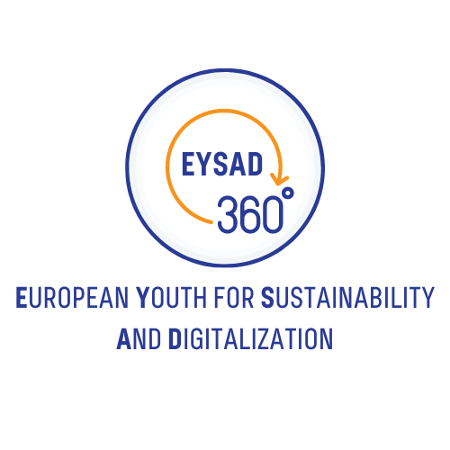

Train-the-Trainer Guidebook
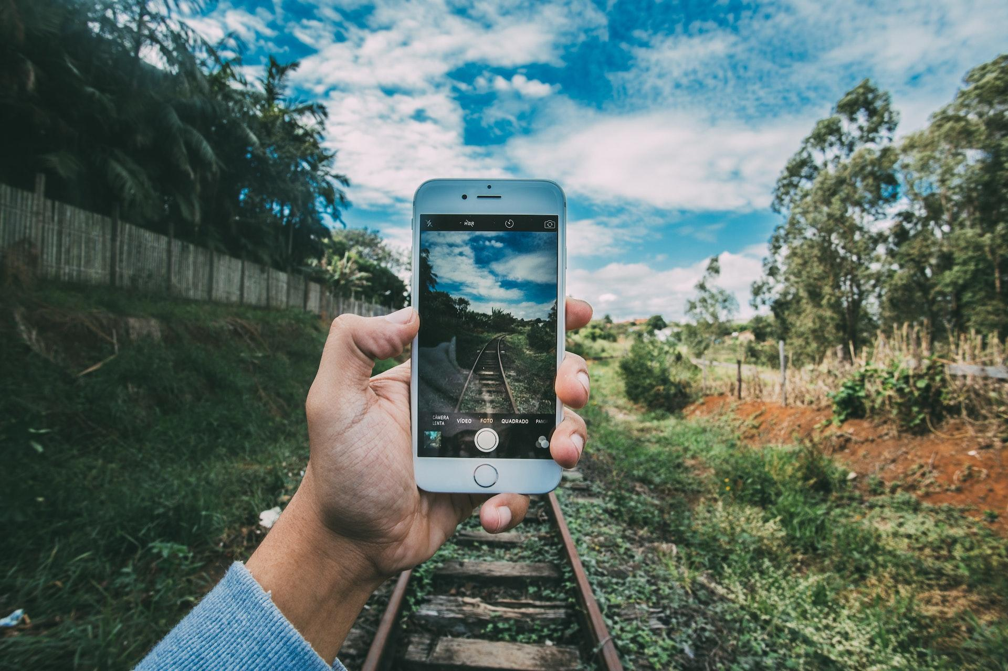

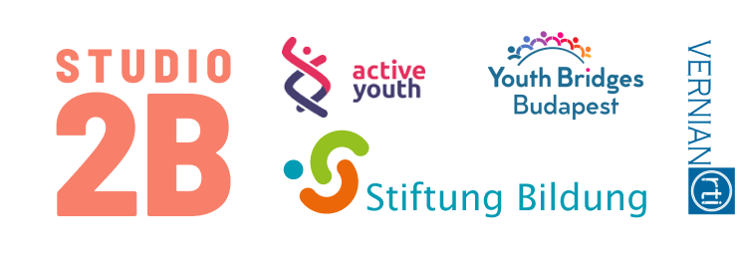

The European Commission's support for the production of this publication does not constitute an endorsement of the contents, which reflect the views only of the authors, and the Commission cannot be held responsible for any use which may be made of the information contained therein.

Table of content
About the project EYSAD 4
About the partners 4
Introduction to the Train-the-trainer Guidebook 6
Module 1 - Methodological competence 8
Introduction 9
Designing & conveying target group-oriented content for a practical project with young people 9
Introduction to sustainability and Sustainable Development Goals (SDGs) 11
How to introduce SDG’s to young people? 12
How to keep people motivated 14
Learning progress monitoring 15
How to give & receive feedback 17
Dealing with the conflicts 18
Module 2 – Creation of a 360° environmental photo tour 19
Introduction 20
What is a photo tour? 20
What makes a 360° photo tour special? 20
Photo tours and script writing 23
Storytelling 24
The necessary background 27
The process of script writing 27
Module 3 – Technology 29
Introduction 30
Virtual Reality 30
Creation of 360° content and photo tours 34
Possibilities for producing 360° pictures and videos 34
Instructions for creating 360° images with google street view 36
Create photo tours in 360° 39
Plan a photo tour (technically) and implement it successfully 44
Tips and Tricks 46
Milestone plan 47
Plan of measures 47
RCI Matrix 48
Tips and tricks list 49
Conclusion 50

Image directory 51
Module 1 51
Module 2 51
Module 3 51
Sources 52
Module 1 52
Module 2 52
Module 3 52
Annex 52
Annex: Puzzle Sdgs and targets 53

COPYRIGHT: This document and the accompanying templates were prepared by Active Youth, along with the valuable contribution from all of the project partners. This document is one of the intellectual outputs from the EYSAD Project, which is funded with the support of the European Commission. This document can be downloaded and used for free of charge under the terms of Erasmus+ programme.

This document is subject to the licence:

Creative Commons Attribution 4.0, International by EYSAD (CC BY 4.0, https://creativecommons.org/licenses/by/4.0/legalcode): CC BY 4.0 means in summary, that you are free to “Share” (copy and redistribute the material in any medium or format) and “Adapt” (remix, transform, and build upon the material).
The images in the guide are not subject to the licence CC BY 4.0.
Image credits: All images are from stock images database of Word.

LIABILITIES: The European Commission support for the production of this publication does not constitute an endorsement of the contents which reflects the views only of the authors, and the Commission cannot be held responsible for any use which may be made of the information contained.

About the project EYSAD

Sustainability and digitalisation are two central topics that move young generations in many nations. These subjects change and determine the future lifestyle of people. To meet these challenges, it is necessary to engage as society as a whole and from different levels. Particularly young people should be able to realize their overall potential. They have to be strengthened in their abilities in order to play an active role for a sustainable lifestyle in continuously digitalised societies. For this, new educational opportunities are needed that promote personal abilities like creativity, critical thinking and solution-oriented action according to a guiding principle of sustainable development. Additionally, a reflective manner with digital media is essential as these are important preconditions for social participation.

This is exactly the point where European Youth for Sustainability and Digitalization (EYSAD) starts. In the project, innovative learning and teaching opportunities for youth work will be developed, which support a reflective examination of sustainability by means of digital media. The project addresses both young people as well as youth workers and leaders and follows a participatory approach assisted by both target groups.

GOALS
- Awareness-raising for challenges in environmental and climate protection with reference to personal behaviour
- Acquisition of basic knowledge on sustainability and the 17 Sustainable Development Goals of the United Nations (17 SDGs) as well as their global interconnections -Strengthening of digital competences by means of using and developing digital media
- Promotion of further education of qualified employees within the field of youth work and/or education
- Support of young people and youth workers to become actors of change for a sustainable development

About the partners

Active Youth is a Lithuania-based for-purpose organisation that unites young leaders, thinkers and doers, those who seek change and those who make change. Their vision is to‌ ‌create‌ ‌opportunities‌ ‌for‌ ‌youth‌ ‌and‌ sustainable‌ ‌positive‌ ‌impact‌ ‌in‌ ‌the‌ ‌way‌ ‌we‌ ‌treat‌ ‌our‌ ‌planet,‌ ‌health,‌ vulnerable‌ ‌people‌ ‌&‌ ‌online‌ ‌community.‌

Youth Bridges Budapest is a Hungarian non-profit youth foundation established in 2019. It supports the European Solidarity Corps Quality Label and is an accredited organisation. Its aim is to help young people deal with the challenges of the 21st century. Young people should be supported in the first years of their adult lives to build a successful future and become active citizens, contributing to social development.

Vernian RTI is a Cypriot SME with a regional and European focus. It has many years of experience in various fields, including all areas of information and communication technology (ICT), digitalisation, information and cyber security. Vernian is also active in the development and delivery of vocational training. It recognises the challenges faced in today's complex and fast-moving environment and believes that by integrating research, technology and innovation into their strategy and operations, organisations of all sizes can increase their capacity to innovate, optimise their business model and value proposition,

improve their competitiveness and achieve sustainability. Sustainable organisations lead to sustainable economies and societies.

Stiftung Bildung is a German donor-funded Education Foundation. Its goal is to create the best educational opportunities for children and young people. It strengthens participation and diversity nationwide in the sense of education for sustainable development (ESD) and works at the grassroots level through the network of daycare and school development associations and promotes project ideas for sustainable development in many places.

Studio2B is a Berlin-based social enterprise. Studio2B has been developing innovative concepts and methods for career orientation and vocational training since 2012 with the aim of strengthening young people and adults in their competences and preparing them for entering or re-entering the workforce and supporting them in their further education. Studio2B combines target group-oriented presence formats with digital learning methods and methods of non-formal education. This includes the creation of e-learning courses, virtual company visits to numerous occupational profiles and dual study programmes using 360° videos and virtual reality (VR) as well as interactive and multimodular 360°- video training.

Introduction to the Train-the-trainer Guidebook

The purpose of creating our 360° photo tour is to enable youngsters to use digitalisation tools to recognise sustainability and the approaches in their immediate environment.

On the educators’ side, trainers should have the skills to stimulate trainees towards the concepts of digitalisation and sustainability. This means that EYSAD trainers need to understand how to react to various situations and be prepared to support young people/students in their training journey.

The programme is divided into the following modules:
- Module 1 - Methodological competence,
- Module 2 - Creation of a 360° environmental photo tour,
- Module 3 - Technology,
- Tips & tricks useful links/tasks.

If we consider training as the process of helping someone learn something new or acquire a new skill or competency, then our trainers should be able to perform this task efficiently and effectively. It is important to point out that in a train-the-trainer programme, the focus is on the trainer, who must become a subject matter expert and an efficient trainer, rather than on the learner.

Train-the-trainer programmes are considered important for developing a pool of competent trainers who will then teach the material to other trainers and, subsequently, other learners. Instead of having just one trainer who will teach the EYSAD course, the train-the-trainer course will develop several trainers teaching the course and multiply the number of learners. Train-the-trainer programmes additionally give consistency to what is taught and how it is taught by all trainers as they provide tailored content to future trainers. In the whole process the trainers are always learners too.

- EYSAD Concept Capacity building:

Our train-the-trainer programme is about preparing both new and inexperienced, as well as experienced trainers, to properly deliver the EYSAD course. Trainers are firstly provided with the necessary training elements and knowledge that will help them develop their capacity on the issues of digitalisation and sustainability and grasp the EYSAD concept.

Subject matter expertise is crucial for trainers. Therefore, mastering the EYSAD concept is essential to develop competent trainers that successfully, efficiently and effectively deliver a training program or digitalisation project.

Our train-the-trainer programme is designed to support trainers acquire the skills and competencies required to demonstrate the highest level of competence related to the EYSAD concept.

To this end, the EYSAD training content accompanying this train-the-trainer program is of high quality, well-structured and easy for trainers to comprehend. The program is additionally focused on the training objectives and the needs of the target groups.

The training content is designed to develop subject matter experts that will then transfer their knowledge to other trainers.

- Trainer capacity building:

Training is different from traditional didactic teaching; trainers must focus on the needs and objectives of each training group or individual learner rather than delivering a lecture from a textbook or a manual.
Trainers must see themselves as facilitators striving to support learners achieve their learning objectives. For a good facilitator, listening and engaging learners is more important than talking and delivering a course. Facilitators mostly focus on getting the group to learn through engagement, interaction and the sharing of knowledge and experiences, rather than teaching.

The main difference between the training and facilitation models is the overall approach followed. In the training model the learning process is established on the typical hierarchical model and the relation between a teacher and a student, while in the facilitation process, learning is established based on collaboration and by providing the tools, the energy and flow that will guide the group to learn. Combining training and facilitation skills will allow us to support our learners developing an open mindset for learning new skills through listening but also sharing their own skills, knowledge and experiences. Trainers create a safe facilitated space where peer-to-peer learning can take place.

In addition to mastering the EYSAD concept, trainers must be able to communicate the subject matter knowledge they will acquire to their audience, other trainers who will then train the project’s target groups.

The train-the-trainer programme will therefore develop experts, not only trainers and will provide them with the knowledge and skills that will enable them to become good trainers and train others with the EYSAD concept, in our case, mainly youngsters.

The best trainers share several personality traits that enable them to become efficient trainers. Some personality traits can be taught, while other traits cannot be taught.

Being a lifelong and continuous learner is a trait that cannot be taught, as it is up to each individual to be open to learning new things and developing a continuous habit of learning. Trainers must be open to learning new subject matters and new and innovative training methods, something extremely important in our digital age, where trainers must combine physical, face-to-face, and online training techniques.

On the other hand, several other traits are equally important to becoming a great trainer, like being flexible to class dynamics and the profile of each training group, being well organised and preparing in advance for each training session, being a non-judging listener and having non-violent communication as well as presentation skills. Being able to think strategically, and managing time efficiently, are traits that can be developed, improved and enhanced through practice. A moderation that is aware of the needs of the individuals, balances speech proportions and gives each participant the opportunity to contribute in an individual way on an equal footing is an important part of the trainer's task.

Delivering a training course with transparency is another important characteristic of great trainers which requires preparing well for each training session, having a map of the training modules and even anticipating some of the questions that may emerge from each training group, which means you must know and study your training group.

Great trainers must also be passionate and enthusiastic about the subject they are delivering and be patient with their learners who are new to the subject matter of the training.
The train-the-trainer programme is designed to help our trainers develop these skills and make them part of their training DNA.

Module 1 - Methodological competence

Introduction
A 360° photo tour with young people is, on one hand, for youngsters to use digitalisation tools to recognise what sustainability means and what approaches exist in their close environments. On the other hand, trainers should also feel prepared to give impetus to digitalisation and sustainability. This module explains what trainers should know when they want to organise a digitalisation and sustainability project with young people. Trainers must understand how to react to certain possible situations to be prepared for the project and to help and support young people/students in this way.

The following chapters allow trainers to gain insight into topics such as SDGs, motivation, monitoring, feedback and how to deal with conflicts.

Designing & conveying target group-oriented content for a practical project with young people

When working on projects involving people, it is essential to know with whom you will be working. This way, you can adapt the concept, content, activities and numerous other factors accordingly. That will help build a stronger connection between you and learners, a sense of trust and, most importantly, accommodate to get and keep their attention and, later on, provide a clearer view of achieving the change you are looking for.

In order to achieve the desired outcomes on how to effectively train learners to create a 360° environmental photo tour, it is crucial to describe the target group (learners) as precisely as possible. You can use the following questions to determine your target group a guide:
- Who are these people? Create an imaginary profile of one of them as an example.
  - What is their peer group?
  - What geographic area do they come from (a particular city neighbourhood, a rural district)? Are they local?
  - What are their hobbies, interests?
  - What is their education status?
  - What experiences do they already have in the field?
  - What problems are the target group facing?
  - What development opportunities does the target group have? What strengths, talents, and resources do its members possess?
  - What are target group members’ wishes and hopes?

These questions are especially sensitive when dealing with young people with different backgrounds. It is essential to respond to the problems or challenges of the group but also of the individuals in advance so that people feel comfortable implementing the photo tour and working together. Trainers should be aware of the differences to adapt the digitalisation-themed project in a way that all participants have the same conditions (e.g. access to smartphones, internet and pc’s). An example could be that one person in the group has older technology than the rest of the group. In this case, a conversation should be sought with this person before and during the project to ensure that the person is doing well. Youth organisations could also have basic equipment, e.g. technology, for the project so that the group does not have to use private equipment.

- What are the aims of your project, and what similarities can we find between them and the needs/hopes of the target group? Define the impact you want to have on the target audience/output.
- How will you get through to the audience based on their background and the goal you want to reach? Use your chosen technique to get their attention and keep them involved. The answers to the first question may help you define your audience's needs and wants. Some different examples of ways to present/teach information:
  - Workshop
  - Lecture
  - Written material
  - Individual tasks
  - Game
  - Video lesson/podcast

All things considered, which one will work for you the best? Maybe you have an original idea? On the one hand, you have to stay flexible with a group. It's important to be open to the group and not have a fixed image. Would prefer to find "softer words" "you can use different methods, and if one especially works well for your (target) group, feel free to use it more often. you can also ask the group for their needs/wishes. On the other hand, you have to be clear:
- Set specific target numbers you want to achieve (reach, dates, deadlines, results, etc.).
- What is the existing knowledge the group or certain people already have? If the group already knows a lot about digitalisation and sustainability, the project can be adapted to be thematically more complex. The trainers can give concrete impulses and ask the learners to deal with, e.g. political or social issues around sustainability. If the group is not yet familiar with the topics, the project can also be used to give a first introduction to the topic. Trainers should therefore ask how well-informed their learners are about the topics in order to adapt the project.

Nonetheless, when considering target group-oriented content, don't forget that if you want to implement a project successfully, all relevant groups with influence, institutions and persons must be involved from the outset. These are your stakeholders! For that, you can use a stakeholder analysis, by which you’ll be able to determine:
- which internal and external stakeholders are relevant to your project,
- what their expectations, hopes and fears are,
- and the degree to which they can positively or negatively influence the project.

Stakeholder analysis is the process of identifying these individuals before the start of the project, classifying them based on their levels of involvement, interest, and impact, and figuring out the best ways to involve and interact with each stakeholder group throughout. Every project needs many different persons' involvement, direction, and permission.

Any of these stakeholders could hinder the project's achievement if they don't comprehend or concur with its goals or strategy for execution. For example, when working with young people, their parents (family) can be an important stakeholder for your project's success. If a family can’t afford to give a youngster some tools needed to participate in a learning process, they can forbid the learner to come to the training courses, not wanting their children to feel inferior to others. Therefore, you should identify your

stakeholders, group and prioritise them, and figure out how to communicate with and win buy-in from each type of stakeholder.

In summary, trainers should be informed about their participants or learners before they start the project. All of the information listed above can help you understand your target group, i.e. the young people and prepare you, as a trainer, for meeting the young learners on a thematic and emotional level.

Introduction to sustainability and Sustainable Development Goals (SDGs)

The creation of the 360° photo tour is not only about the technical implementation but, above all, about getting to topics of sustainability through digitalisation. For this reason, the trainers should be prepared in terms of content to teach the learners this topic and to support them with questions. For this reason, the following is a brief introduction to the topic of sustainability.

In recent years sustainability and Sustainable Development Goals have been one of the most important topics worldwide. Therefore, it is vital to know more about this concept and its related themes. In the broadest sense, sustainability describes the ability to maintain or support a process over time continuously. In business and political contexts, sustainability aims to prevent the depletion of natural or material resources so that they can be used in the long term. Sustainability means „meeting the needs of the present without compromising the ability of future generations to meet their own needs. “ Therefore sustainability is not just environmentalism; it's also economical and social. These three pillars of sustainability are known informally as planet, profits and people.

As concerns about climate change, pollution and biodiversity loss have increased in recent years, several measures have been taken to address these challenges through sustainability practices and green technologies. For instance, some electricity companies set goals for generating energy from sustainable sources, such as solar, wind and hydropower. But all of these goals fall under the 2030 Agenda for Sustainable Development, produced by the United Nations, where 17 Sustainable Development Goals (SDGs) were established. These goals are a big step towards achieving a better, more sustainable future for generations to come.

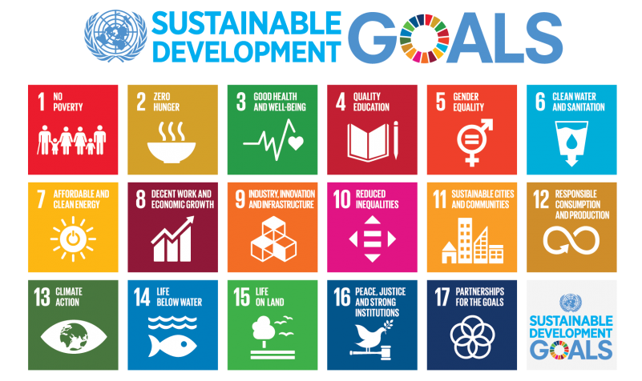
Picture 1: all SDGs, https://sdgs.un.org

All in all, Sustainable Development Goals fits right in with virtual tours, as it can be used as a tool to show youngsters the connection between several SDGs, give them more information about each goal or even give them an introduction to sustainability as a whole. Therefore, it is vital for trainers to have enough information about sustainability and SDGs so that they can be prepared to answer any questions related to it. In addition, the trainer needs to keep in mind about eco-anxiety and have some tricks on how to introduce SDGs in a way that is not exhausting. For example, the trainer should create a safe environment and inform learners that the learning session they are a part of is a safe space where learners can express their emotions freely and could connect with other like-minded people.

How to introduce SDG’s to young people?

There are many different approaches to teaching youngsters about the SDGs. Nowadays, you can find a lot of visual and simply explained information, like videos or infographics. It is advisable to choose an approach that is interactive, so that young people experience the "vitality" of the topic and their interest increases. Interactive methods can be, for example, games that are played in groups. In this way, young people get into conversation and discuss the topic at the same time.

An example of such a game is a SDG'S puzzle, where the pictures of the goals are on one side (as in the picture below), and the targets are written out separately. Learners can work together in groups of 2-4 people to find all the targets and solve the puzzle. This method is independent of age and can also be used by/for trainers. You can find the game in the annex.

For example:
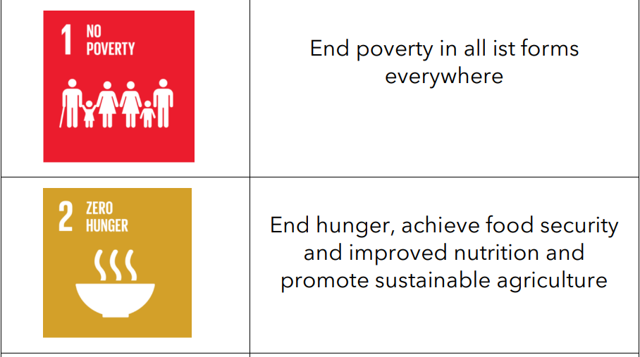
Picture 2: SDG examples, https://sdgs.un.org

You can also play the game „Know Your Goals!“. This game is built on a quiz that asks five questions about each objective, focusing on the circumstances that emphasise the goal's significance and the remedies that would aid in achieving the goal. Individual players or teams of 2-3-4 players can compete against one another in this game. The individual or a group with the most right answers wins the game. You can find the game questions in the annexe.
The example could be:
Picture 3: Know your Goals! game

You can also find online games such as “https://gamethegoals.com/” or YouTube videos to educate yourself or youngsters about this topic.

Examples for online material

- What is sustainable development?
https://www.youtube.com/watch?v=7V8oFI4GYMY

- UN Sustainable Development Goals - Overview
https://www.youtube.com/watch?v=M-iJM02m_Hg

- How We Can Make the World a Better Place by 2030 | Michael Green | TED Talks
https://www.youtube.com/watch?v=o08ykAqLOxk

- 'We The People' for The Global Goals | Global Goals
https://www.youtube.com/watch?v=RpqVmvMCmp0&t=45s

- Global Goals Posters | Comics
https://www.yumpu.com/xx/document/read/55730350/1-page-goals-comics-full-set-pd

How to keep people motivated

Motivating people to participate in various activities can be challenging, especially for youngsters. There can be a lot of reasons for this: 1) people do not believe that their efforts will improve their performance; 2) the structure and allocation of rewards demotivate them; 3) they have other priorities that compete for their time and attention; 4) they may suffer from physical, mental, or other personal problems that affect motivation; etc. Therefore, trainers need to know tips and tricks to keep learners interested in participating in a project and keep them motivated during a long period of the photo tour creation, especially youngsters. Here is some advice on how to keep them motivated:

- Always be prepared
The more prepared you are, the better you will be able to answer questions. Make sure you research your material thoroughly. Arrive early to get used to and familiarise yourself with your surroundings before each meeting.
At the beginning of your first teaching session, plan to provide your learners with some background information about yourself and the topic you will be training on. Outline the day, answer initial questions, and do a quick icebreaker - as simple as asking everyone for their name, favourite activity or favourite food. Icebreakers are a great way to make things easier for everyone right from the start.
When you read the teaching material, and people start asking questions, please do your best to answer them as clearly and accurately as possible. If you don't know the answer, be honest with them and assure them that you will find the answer to their question and get back to them promptly.

- Use hands-on approach
One of the quickest ways to disengage your learners is to have them listen to your lectures for hours on end. It is important to do your training as interactive and hands-on as possible. Everyone learns differently, whether through observations, videos, scenarios or games. Hands-on training provides real-world applications that make it easier for learners to understand what they're learning because they can practise independently. It also leads to excellent retention rates. When people are forced to do something, they engage in active learning. They practise critical thinking skills and test their knowledge. Most importantly, this form of education allows people to actively create knowledge rather than passively consume it.

- Introduce gamification
Keeping learning fresh and fun is essential and bringing gamification into the learning environment is a great way to increase learner engagement. Setting goals, challenging and rewarding youngsters will get them excited about the material.
Divide your learners into small groups and let them pick a name for their team. Build team leaderboards based on correct answers to see how each team ranks relative to their peers and give them an idea of how far they need to go to overtake the next team. This will motivate your learners to collaborate, have fun, and truly invest in their learning.

- Reward learners for engagement
As mentioned before, gamification boosts learners' motivation to engage in learning actively, but gamification also has a reward system. Leaderboards, badges, and certificates are simple but effective ways to incorporate reward cycles into learning experiences.
Offering a badge for each task or piece of content completed is one strategy for increasing learner engagement. Another is to highlight high achievers using a leaderboard. The most effective incentive for people to learn is a certificate because they want to improve their skills and have something to show for it. Think about how certificates can be used to recognize achievement and completion. Have certifications signed by a representative of authority, if practicable.

- Create open communication channels
A lot of the typical learning obstacles can be overcome with better communication. Make sure that open communication channels are prioritised while designing courses and that learners know how to use them. For example, to promote learner engagement, online communication can involve casual group discussions about how to improve photo tours, guided peer learning or informal spaces for asking questions. So for that, communication channels can be informal question and answer forums, personalised emails, in-person contact, instant messaging, etc. Make it apparent that each opinion is cherished and considered when creating these channels so that comments and thoughts can be expressed.

There can be a lot of reasons why young people could feel demotivated in the process of a project, e.g. they can feel frustrated because something doesn’t work technically and fear of a failure. It is completely normal, especially when a project takes a long period of time. The trainer should be the first to notice and take action when this problem occurs. Talk to the youngsters – learn why they are feeling demotivated. Make sure that achievements are rewarded – even if it’s just with a pat on the back. Don't punish failure – when learners are struggling because something doesn’t work, don't punish them – instead, encourage them to try again and say that it’s worth it. The group dynamic often hits a "motivation hole" in the middle of longer projects and that's often not about individuals.

Learning progress monitoring

To know the success of a project and the progress of learning how to create a photo tour, it is essential to do the monitoring. Progress monitoring, which is frequently used with both individual learners and small groups, is used to analyse learners' academic and social-emotional behaviour (SEB) progress, study the rate of improvement, and assess the efficacy of instruction or intervention. This approach is used to judge whether instructional practices and interventions should be maintained, adjusted, or increased to guarantee that learners are obtaining resources and guidance that push their development and fulfil their needs. Monitoring is also important because it helps the trainer to make informed decisions. Without tracking the learner’s performance, you can only make educated guesses about their aptitude. These assumptions are speculative and might or might not be correct. When you evaluate a learner's performance, you can objectively see what they know and don't know. Making judgments about a youngster's learning progress is much easier once you know how they are doing. Therefore monitoring is essential to evaluate the project's progress, make well-informed decisions, and make modifications, if needed, about what is the best way to create a photo tour. For instance, as a trainer during the first learning course, inform the young people how the progress monitoring will be pursued. You can meet with the group once or twice a week (either in-person or online) to check the state of a project and learn the challenges young people encounter. It could also be a good way to check on a youngster's motivation!
Tipp

There are many ways how to monitor progress, for example:
- Forming tiny groupings.
- Intervention planning.
- Identifying gaps or possible growth areas.
- Peer-to-peer learning.
- Questioning is tailored to the learner's development.
- Making plans for daily mini-lessons/instruction.
- Learner reflection.
- Summarising.

It is also essential to know exactly „what“ the measurement is measuring, which you could categorise thus:
- Attainment: what can be done / what can you do / what do you know?
- Achievement: what has been done?
- Potential: what could be done / what should be done about it?
- Progress: what positive change has been made / what distance has been travelled?
- Effort: what work has been put in?
- Ingenuity/enterprise: what solutions have been found to challenges given available resources?
- Environment: what are the circumstances in which the learner is trying to progress?

Online learning is also worth mentioning. Online learning is slowly becoming one of the world's most popular study forms. While there are plenty of benefits to online learning, there are also a few challenges that learners and trainers face. For example, it becomes much harder to track and monitor the progress of the youngsters. But there is always a solution. For instance, technology, tools, and apps, such as instant messaging apps, can be used by trainers to communicate with youngsters. WhatsApp, Messenger or Viber can be used to discuss work with learners. As a youth worker, you should ask questions that would help you track the progress, such as „How did you find this project that you are taking part in?“ or „Do you encounter any difficulties in absorbing the material provided during the creation of a photo tour?“ Also, tracking your learners' development using Q&A sessions is ideal. This gives learners the chance to ask any questions they may have about any areas of the assigned task. Further, you will be able to identify the areas in which they are struggling and those in which they are not.
In a nutshell, learning progress monitoring is essential to a successful project. It is important not just to you as a trainer, but also to young people to express their challenges and understand the learning material more effectively. It could also increase the learner’s motivation!

How to give & receive feedback

Feedback has been known to be an essential part of the learning process. It provides an excellent opportunity to develop skills and identify areas you and your learners need to improve. Whether you receive or give feedback, it is vital for every person's growth. Feedback can improve engagement, give people purpose and nurture meaningful relationships. By letting learners know where they are right now and what they need to focus on to reach their objective, practical feedback functions as a map to lead them. Without constructive criticism, young people could hold misconceptions they were unaware of when learning the information and might wander in the direction of a goal without knowing how to get there. Therefore giving feedback to the young learners during the process of a project is essential because, for example, they can improve their understanding of what is a virtual tour, enhance producing certain things, like photos or videos. The feedback could be given after every step of a photo tour creation, and the steps could be introduced at the start of a learning/teaching session.

If you are giving feedback, it needs to:
- Be specific - for development, learners need clear guidance.
- Focus on being constructive - always strike a balance between what you want to say and what you think will be helpful when delivering feedback. Limit your criticism to three encouraging areas and perhaps one or two suggestions for improvement.
- Ask questions - you bring the other person into the debate by posing a question at the beginning of the exchange. By trying them, you can ascertain their comprehension of the situation and learn about their point of view.
- Be timely - feedback is most useful when you give it as soon as possible after a specific behaviour occurs.
- Focus on behaviour and not the person - feedback should target behaviours and not how someone looks, thinks, who they are or what they believe.

If you are receiving feedback, here are some tips on how to take them:
- Listen and don’t interrupt - while you are receiving feedback, try not to contest, explain, or interrupt. Keep an open mind while you listen and take notes on what is stated.
- Put it into action - you must act positively in response to the criticism. Consider the changes you will make in light of your feedback.
- Own your mistakes and move forward - to succeed, you must also learn from your failures. Recognize your mistakes, forgive yourself too and resolve to proceed with caution in the future.
- Be thankful - to demonstrate that you not only listened and comprehended what they said but also accepted it, thank the individual who provided you with the feedback.

All in all, giving and receiving feedback in the creation process of a photo tour is important because when young people groups work together, they need to know how to give constructive feedback to each other to avoid arguing and prevent disagreements from escalating into major conflicts. This is the reason why trainers should inform and teach learners how they can deal with feedback. As it was mentioned before, it can be introduced in the first session before any group work begins and an extra learning session on this matter can be provided during the process of a project so it can be checked how it is working out for the group.

Dealing with the conflicts

There is no surprise that in a learning process where different people with different ideas come together, conflicts may arise. But they are fundamental to human nature and are necessary for moral and emotional development. In a learning process, disagreements may occur between learners or between trainers and learners. For instance, there could be disagreements in a group of learners, because they don’t have a structure on who will take over which tasks during the creation of a photo tour or youngsters have different opinions on how to implement certain things. Therefore the trainer could suggest at the beginning of a session that each participant takes on a specific task. This is a situation where the knowledge of how to give and receive feedback is important, because when young people know how to do it respectively and constructively, the rise of the conflict can be dealt with better. Keep in mind that conflicts are unavoidable, but harmony and respect should coexist in a learning environment, and disputes shouldn't negatively impact how youngsters are taught or how they learn. Therefore, how these conflicts are handled makes disagreements positive or negative. There are some strategies and advises on how to handle a conflict, so it doesn't harm the learning process:
- Don't let it bother you - learners in conflict situations may feel agitated, threatened, frustrated, and/or enraged. These negative emotional responses can make it difficult for you to respond helpfully.
- Decide where and when to address the issue - it shows that you know your learner’s needs. It enforces your expectations for their behaviour when you respond immediately to their worries, anguish, and improper conduct.
- Pay attention to the learner - when talking to them, use a friendly tone and open-ended inquiries to show that you are interested in learning about their viewpoints.
- Validate your perception - mainly, if they are acting in any way emotionally, it is pretty simple to misinterpret someone. You can ensure you comprehend your learners' accounts by articulating your understanding to them and asking them to clarify any misunderstandings or provide more information on any confusing points.
- Decide on a position and justify it - you are in an excellent place to choose a course of action now that you understand the situation better. Make sure the action you select is consistent with the course's learning objectives.
- Discuss the following steps and record your choice - after outlining your decision, you can talk to the learners about potential next actions.

Hint

Conflict can be both beneficial and destructive. A complete lack of conflict might result in apathy and passivity. On the other hand, a moderate amount of functional conflict can energise behaviour, encourage healthy rivalry, and spark new ideas. Disputes should be handled so that they result in more benefits than harm. The best method is to engage the parties to the disagreement in a dialogue where each will have a fair opportunity to present their point of view.

Module 2 – Creation of a 360° environmental photo tour

Introduction

The following section explains why 360° photo tours are interesting, what photo tours are, where they are used, and why they are effective to learn new things. This includes not only digital skills, but also skills such as writing a story that is enjoyable and effective at the same time. For this reason, this module explains what storytelling is and gives examples and exercises about how to explain it to learners.

What is a photo tour?

A photo tour can be used as a learning tool that leads interactively through different specific regions and shows with the help of photos, videos and audio materials, concerning topics such as environmental protection, climate change, wildlife, different industrial processes, landscapes etc.. A photo tour starts with a broad picture about the topic, and from that point the user can navigate through different sections of the tour via icons such as arrows. The pictures are presented in a 360° degree form.

Photo tours can be considered as stories. They are telling information about regional/national/global challenges, approaches and solutions. It is about taking photos within a theme, around a location, for a special event, to showcase a beautiful holiday location. It is about making many photos within a topic, thus they are connected to each other. Some examples for photo tours: Budapest architecture photo tour, night photo tour in Berlin, summer photo tour in Lithuania, glacier photo tour in Iceland, etc.. There is a huge business (see the example video) behind photo tours, they are mostly led by expert photographers, who know the area and the best places to make shots. But as we present here, this tool can be used and created by anyone.

What makes a 360° photo tour special?

A photo tour is a chance to step into a virtual reality and have the ability to move around and discover elements on your own. This is why it makes it such an interesting tool for youngsters: it's interactive and informative at the same time! They have a specific purpose, which is in most cases to provide information, educate, highlight the importance of something, or show an area for someone who can’t be at that place. It is different from videos, because they are more static, while photo tours have more flexible navigation and options.

The definition of photo tour: “A 360 Virtual Tour is a collection of 360-degree panoramic rotating images, “stitched” together to form a full, 360° view of a location. Special cameras, lenses, technology, and methods are used to bring a tour together into a visual experience for the viewer.”
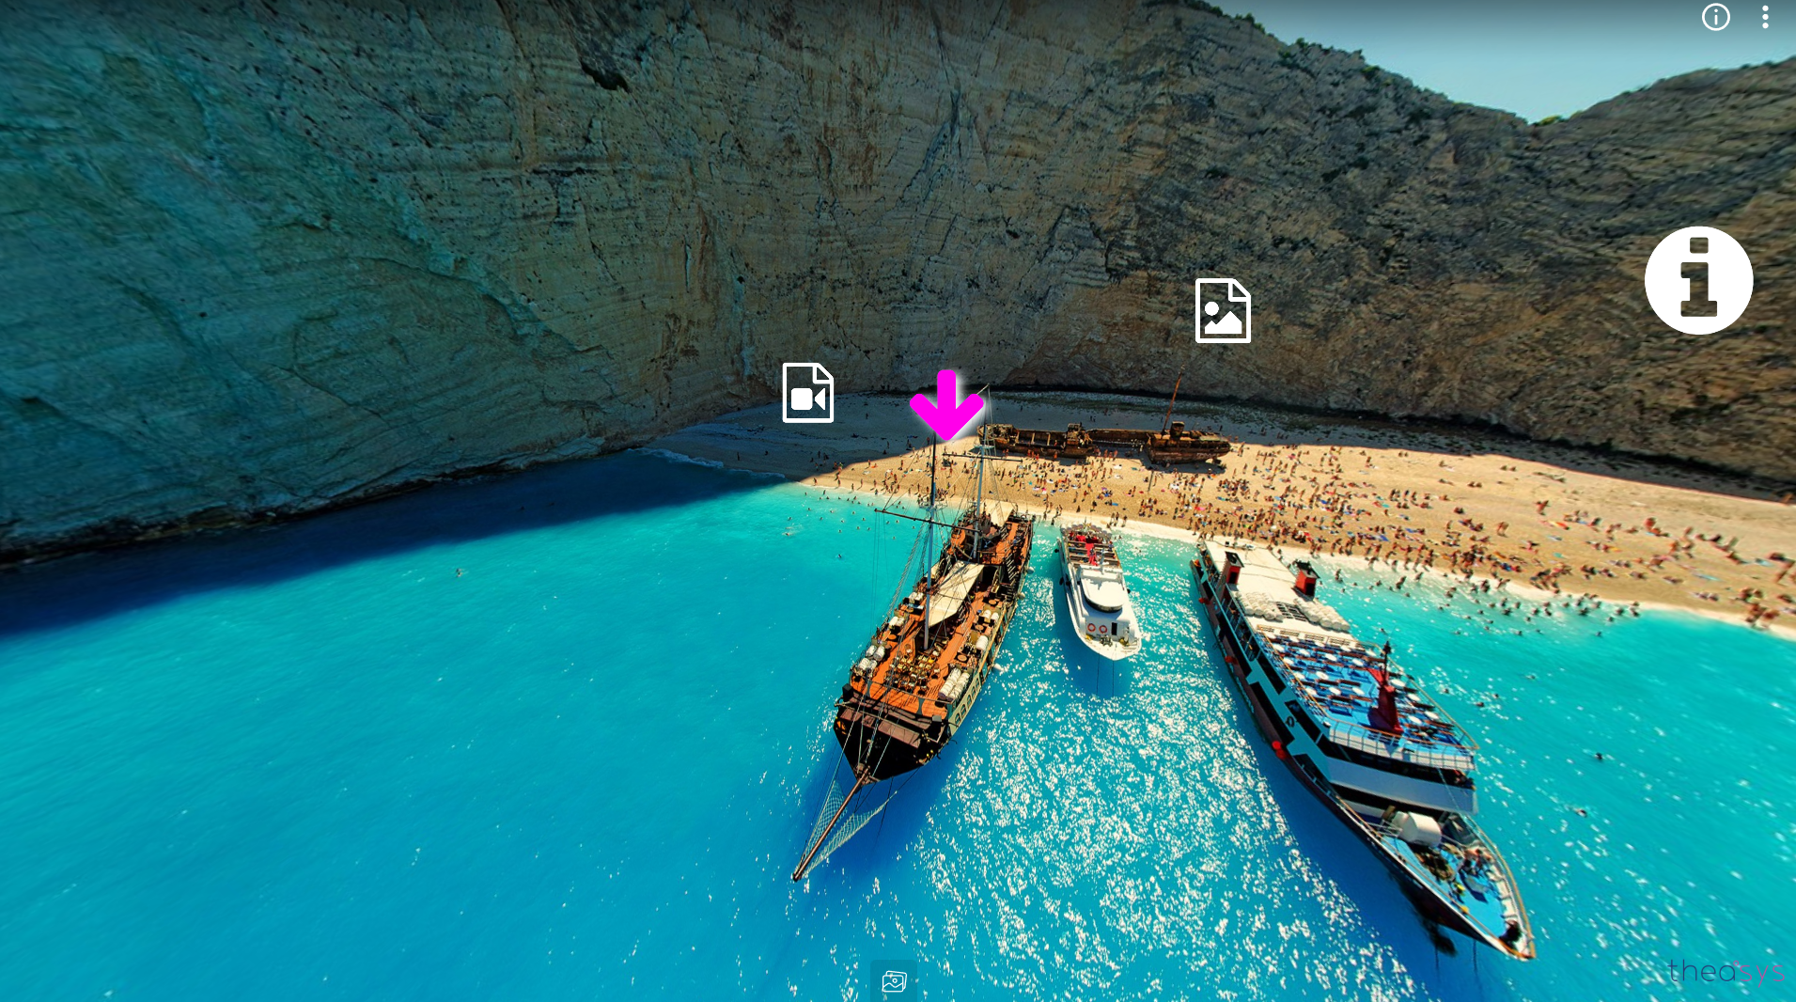
Picture 4: Landscape photo tour sample, https://www.theasys.io/samples/

In a 360° photo tour you have control over what you want to see. A very important detail about these virtual tours is high-quality pictures, because the user experience is highly related to the quality of images put together. It’s a fun way to get to know more about a place or an area, and also learn something new within a given topic (for example environmental issues that are related to a location).

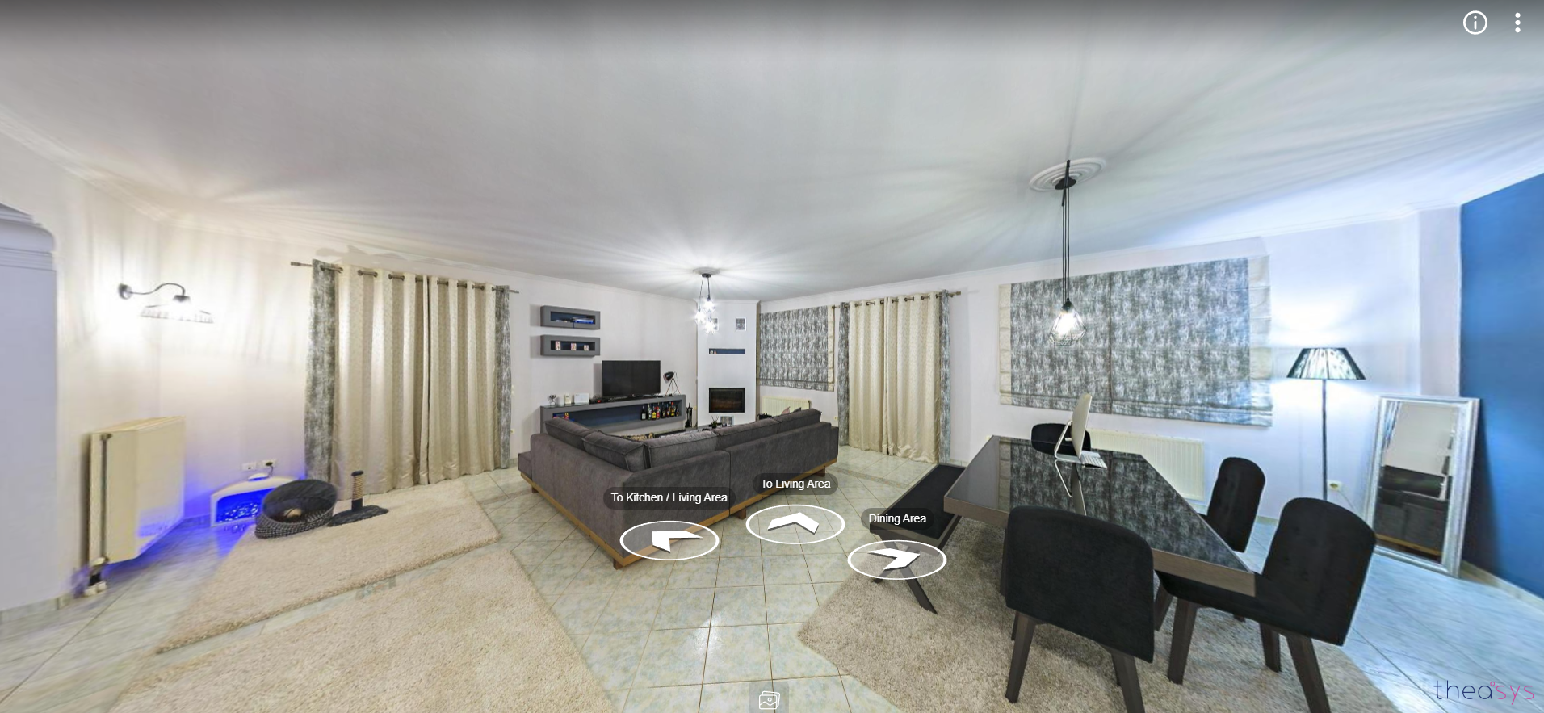
Picture 5: Real estate photo tour sample, https://www.theasys.io/samples/

These photo tours/ virtual tours are mainly used as a marketing tool. They provide a virtual reality feeling, having a much bigger impact on customers than regular images. A very common usage of photo tours is to show a house from inside, where you can choose which room to go by clicking on arrows. You can find examples on this website: https://www.theasys.io/samples/
Other common uses of 360° photo tours: restaurants, bars, holiday destinations, hotels. Google street view is a very similar experience. These photo tours are more interactive, they are entertaining, they provide a lot of information, and help to make decisions.
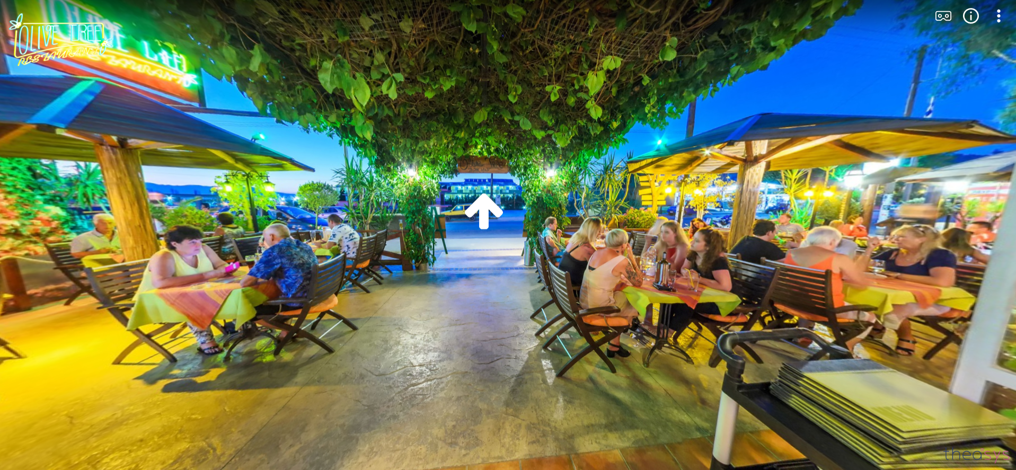
Picture 6: Commercial photo tour sample, https://www.theasys.io/samples/

A 360° picture doesn’t really look good on it’s own:
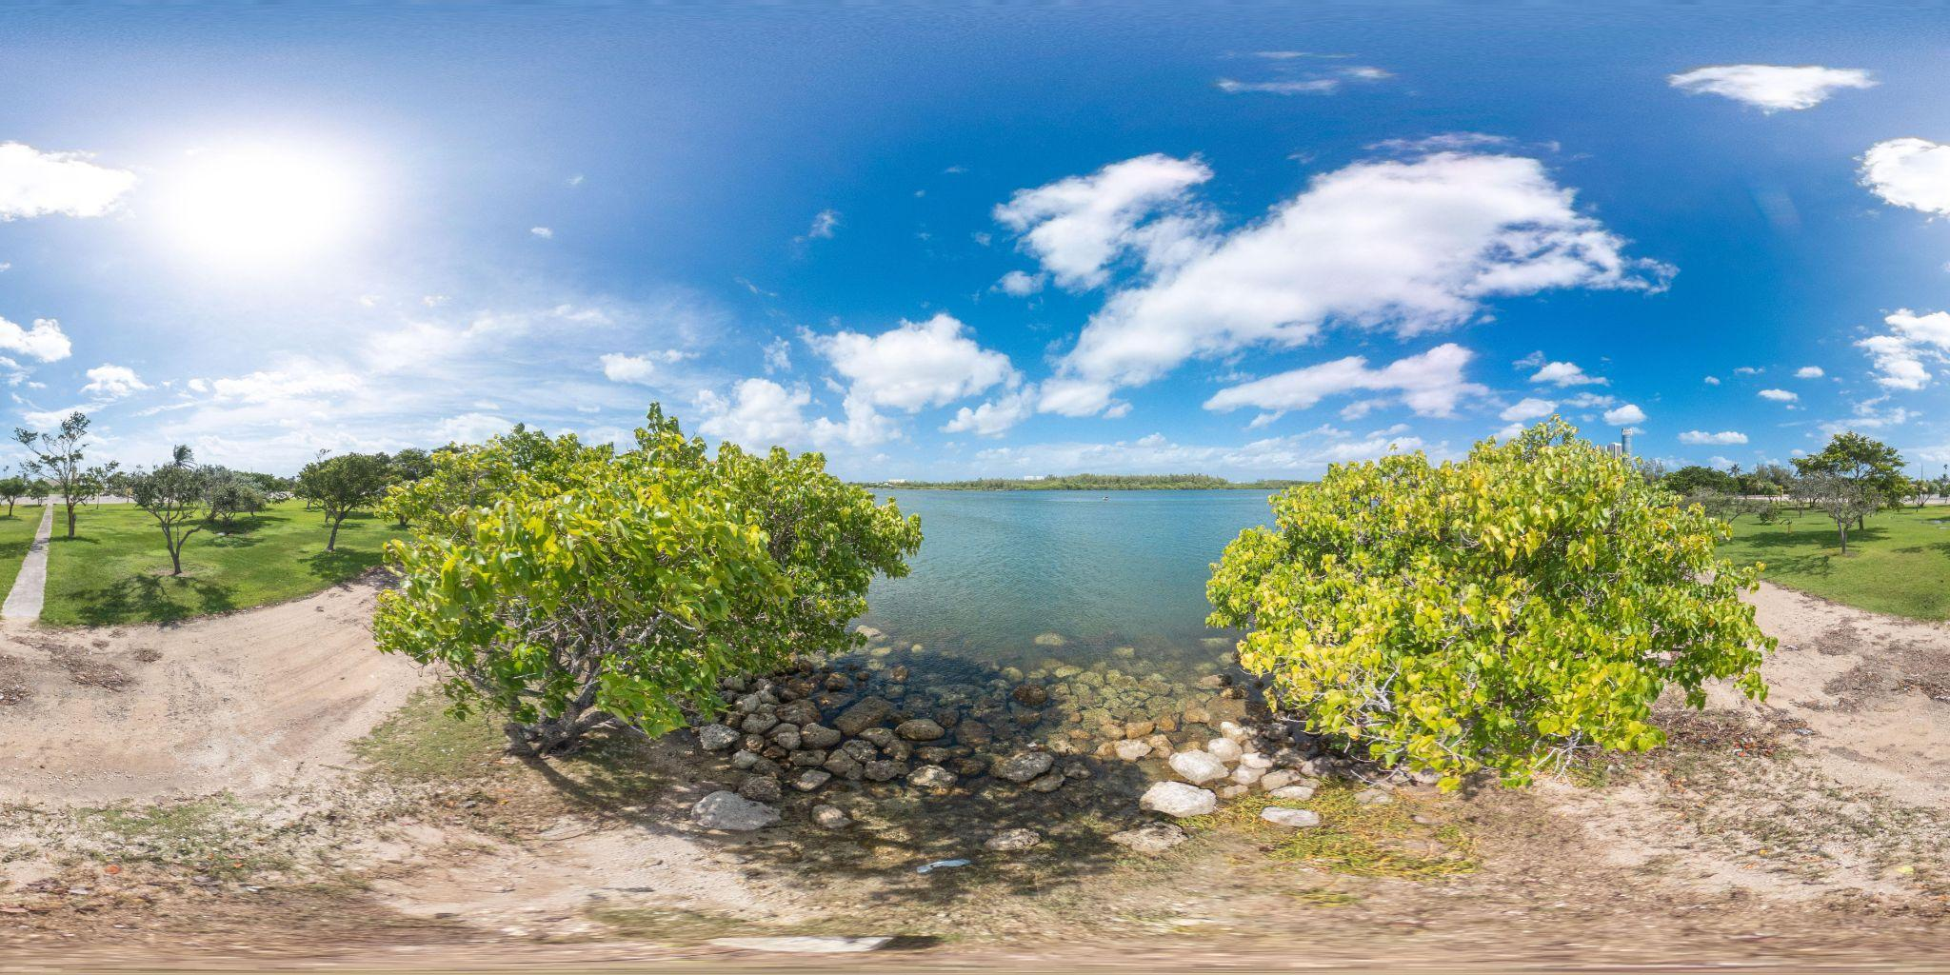
Picture 7: Panorama shore 360° photo, https://pixexid.com/image/sb0criu-360-panorama-shore

But these images are only the “covers” of an actual photo tour. We need an application, a website, a tool to open and see around the area. For example on this website we can see a collection of 360° pictures/photo tours: https://pixexid.com/search/360-panoramic.

The photo tours are used to showcase places, to convince the viewer from a distance. It can be a real place, in that case the pictures are taken at that location. The photo tour can also be made of many different locations connected together.

Another option is to create a virtual idea, which doesn’t exist in real life. They use this for arts, and mainly in architecture. For example, this is a 360° picture of a spaceship:
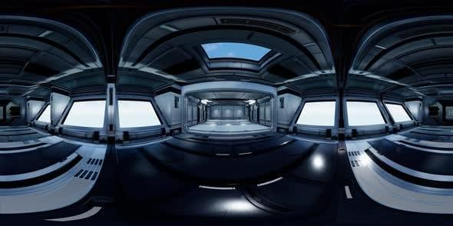
Picture 8: Spaceship 360° photo, https://pixexid.com/image/30g7d8y4-spaceship-on-space-360

To create a 360° photo tour a very handy application is Theasys. You can upload your 360° photos, put them together, and use the application’s tools to create a spectacular photo tour. You can add links, arrows that lead from one place to another, videos, downloadable materials etc.. For this you need a good quality camera, it can be a mobile’s camera as well if it takes good quality pictures (see more in Module 3).

More information about Theasys

This online software is basically free of charge! With a free account you can upload up to five 360° images there.
For larger projects (more than five images) you can upgrade your account. This costs about 19.99 US dollars a month.
You can find the prices here: https://www.theasys.io/pricing/

Theasys is only one of many online software for creating virtual photo tours. Other software programmes are listed under Module 3.

Photo tours and script writing

Script writing by definition is: “the process of writing stories in the screenplay medium. Script writing is writing down the movement, actions, expression and dialogue of the characters in screenplay, in screenplay format. The process of writing a novel, a poem, or essay, is entirely different from script writing. In order to express yourself effectively for the screen, particular formatting methods are required. Screenplay format is used to express the story visually. Scriptwriters or screenwriters write for film, television, video games, and now even online web series. Script writing can be done for hire or on speculation in hopes to sell their screenplay or find an agent.”
In our case the writing doesn't happen for a movie or play, it happens for a photo tour. Script writing is about creating a story. The stories have always played an important role in people’s life, it makes plain information more interesting, it can teach, educate, help to grow. When we are young, our parents tell us bedtime stories, which develops our fantasy. The necessary skills for writing a good story is in everybody, they just have to use it!

When working with young people, photo tours should be connected with stories. It makes the process easier, more fun and interesting. A good photo tour tells a story, which also contains valuable information about something we want to tell.

The process of script writing before creating the tour makes the actual creation a very easy process. When they know which point is coming exactly after another, they can just put together the pieces and see all the different parts as a whole story.

Storytelling

Storytelling can be used to generate feelings in the viewer/listener. It makes some topics easier to process, and to get the idea behind it.

Storytelling - Why stories?

- Stories work better than facts
- We remember stories
- Our brain is made for remembering stories
- Facts address us as rational beings
- Stories address us as rational, emotional, and social beings
- Stories give us orientation

Examples
This video about a whale highlights the importance of conscious treat of trash we produce: | https://www.youtube.com/watch?v=xFPoIU5iiYQ&ab_channel=CBCKids
This video explains the “life” of plastic bottles. It can also be included in a photo tour about environmental issues: | https://www.youtube.com/watch?v=_6xlNyWPpB8&ab_channel=TED-Ed
In this video we can see why organic farming is worth dealing with: | https://www.youtube.com/watch?v=5SzJkL7czI0&ab_channel=WholisticMatters

As the examples show, we can use many existing materials in a photo tour. These materials are short stories that can make a bigger story, if used well.

The viewer of the tour needs to have a clear idea about what he/she is seeing.
- The story has to start somewhere: the first scene is usually an overall picture of the area, of a very obvious (for example if it’s a park, many trees and a lake)
- It has to continue, go into details: the following steps should be more and more specific, giving detailed information about the topic, it’s issues (use numbers and graphs, relevant sources)
- It needs to have a solution: in the end, the viewer has to know what he/she can do. Examples:
  - Where is the venue exactly? (show a map)
  - What are the ticket prices? (use illustrations or link the website)

The following example of the story Hänsel and Gretel shows how tales and stories are built up. It reflects on the photo tours: overall picture, details, resolution.

Storytelling - Typical structure of a story: Hänsel and Gretel
- Hänsel & Gretel live in a poor family  - They are abandoned in a forest  - They find a house made of gingerbread  - The witch keeps them imprisoned (wants to eat them)  - With special tricks they dupe the witch and escape together | Hero / heroes  Initial situation  Conflict / problem / danger  Arc of suspense (here: danger to life)  Solution / happy end

Storytelling exercise

To better understand how storytelling is structured, here we show an exercise that can be done with groups (regardless of the age of the group). Use the videos, and follow the instructions:
- Create groups (e.g. 4 people each)
- Watch the different short movies (see list below)
- For each video, complete the sheet with the elements / techniques of storytelling used by the producers. Discuss in group

Picture 9: Storytelling exercise

List of videos:

- Video Intro - The Fog:
https://www.youtube.com/watch?v=wxQktFNOMAg

- Video 1 - Three Plastic Bottles:
https://www.youtube.com/watch?v=_6xlNyWPpB8

- Video 2 - A Whales Tale (→ negative example):
https://www.youtube.com/watch?v=xFPoIU5iiYQ

- Video 3 - Reduce, Reuse, Recycle:
https://www.youtube.com/watch?v=OasbYWF4_S8

- Video 4 - Organic & Sustainable Farming:
https://www.youtube.com/watch?v=5SzJkL7czI0

- Video 5 - How to take care of the environment:
https://www.youtube.com/watch?v=X2YgM1Zw4_E

- Video 6 - Why we need to stop plastic pollution:
https://www.youtube.com/watch?v=Yomf5pBN8dY

Assignment

Watch the different short movies and complete the table with the elements / techniques of storytelling used by the producers. None of the movies are “perfect examples”. But they show different elements, some have positive and others negative effects. Discuss the answers in group.

Questions | Answer of the group
Which elements help to reach the spectator as a
rational being?
What helps to motivate the spectator to reflect
the topic more deeply?
Which elements help to evoke an emotional
reaction in the spectator?
Which elements help to create a connection between the spectator and the hero or topic?
Which techniques /elements help to give the
spectator realistic information about the
situation of our planet without generating a
feeling of complete desperation?
Which elements help to motivate the spectator to
change his*her own behaviour and to engage
him*herself in the transformation of our
society?

The necessary background

The goal is that youngsters create photo tours that are exciting to watch, and the audience also learns from it. It doesn’t matter how life-changing a piece of information is, if it’s not interesting enough to keep the audience’s attention for a longer time, learning doesn’t happen. That’s why a photo tour is a powerful tool, because it entertains and educates at the same time.

Learning how to write a script is essential for creating a successful photo tour. There is no need for previous knowledge in that case, the process is explained and easy to follow for a group.

The process of script writing

Behind every great story you see on screen, there is a script. Writing a script can be challenging. There are many questions in the group’s head about how it should be, what is a good script, what are the common mistakes. We provide a list on how a script should be written (that’s one way, of course there are many other as well):
- Brainstorming → think of a theme that you want to tell in your story - write down as many ideas as you can, then if you don't have more, develop them further.
- Pick a genre → this is going to help you come up with more ideas, and keeps the story in a frame. The genre will explain to the audience what your tour is about. It’s very important to refer to the genre in the title of the photo tour, because that’s how someone unfamiliar with the photo tour will be interested in it! Examples of genres in photo tours: environment, social issues, recycling, a national park, a city etc..
- Choose the place → a city? In the countryside? In an abandoned house? A national park? Each venue has its own meaning, and can tell a different story, choose according to your ideas!
- Gather all the materials necessary for making the story whole → do you need videos? Only pictures? What kind of text will you put and where? Will you include websites?
- Come up with the mainframes → what do you want to tell with the photo tour? How are you going to build up the story in the viewer’s head?
- Organise your ideas → make a timeline for the story. The starting and ending are especially important!
- Evaluate the importance of each setup → are they all necessary? Do they provide information?

As a trainer, you should pay attention that youngsters:
- Set up a deadline for themselves, until the script needs to be ready (as a last step of a session, tell them a deadline until when they have finish their work)
- Suggest them to write everyday (using an online tool like google sheets for that makes the process easier to follow)
- During sessions, have them say the dialogues out loud, to test if they sound natural
- Let them brainstorm together
- Give them the chance to read through their work when they are done
- Revise their script, and ask questions about it (how did you come up with the idea? Why did you choose this topic? etc.)

Further material

Characters and plot explanation:
https://www.youtube.com/watch?v=NJ7kekDLBD4&t=5s&ab_channel=Burt%E2%80%99sDrama

Module 3 – Technology

Introduction

This module gives a theoretical and practical introduction to the function of hardware and software for creating a 360° photo tour. In addition, it offers an introduction for trainers to the topics of virtual reality and 360° technology. In this way, trainers can familiarise with the technology and its background.

Virtual Reality

What is VR? How does VR work, and how can it be used?

Virtual reality (VR) is a 3D-generated world that can be experienced immersively and in real time using devices such as VR glasses. Immersive means "entering" and describes the complete experience in another reality generated by audio and image.

Virtual reality processes data in real time to create a realistic scenario that users can interact with. This innovative technology is becoming more and more common and is used in many different areas, not only in the entertainment sector such as gaming. Today, virtual reality is primarily used for simulations. In that way, one can experience exercises in scenarios that are considered costly or dangerous in the real world. In medical training, for example, one can virtually attend operations and practise performing procedures.

Here is an overview of some examples of the use of VR

Area | Usage (common examples)
Gaming | Open-world and role-playing games
Healthcare sector | For practising operations, processing therapy of traumas and phobias
Architecture | Planning buildings (e.g., assessing and trying out sizes, lighting conditions, effect, etc.)
Industry and product development | Industry 4.0, visualisation of products, usability of prototypes
Aeronautics and space travel | For practising take-off and landing, or exploring the surface of Mars

Another example of the use of VR is building a new "world", as Metaverse does. There, a kind of parallel world is created in real time in which one actively participates through a digital presence. For example, users can organise meetings and meet in the Metaverse through an avatar. But they can also undertake other activities, such as play tennis. Metaverse thus wants to create a "digital alternative to the physical world".

In summary, it can be said that VR can be used in many different ways and that new functions are constantly being developed with increasing digitalisation.

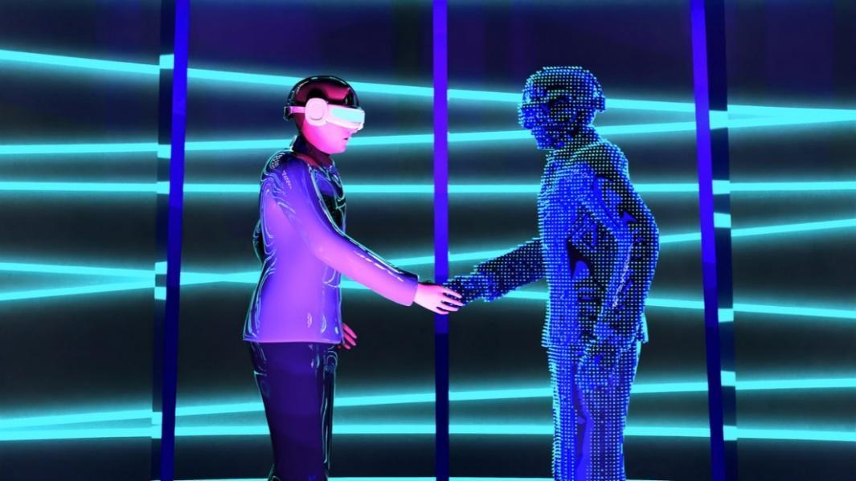
Picture 11: Avatars meeting in a digital virtual reality world

What is the difference between VR and 360° technology?

VR and 360° technology differ first of all in the type of experience. While with VR you are completely immersed in a new world that is operated in real time, 360° technology shows us a “snapshot” from a specific moment.

However, both technologies can be viewed with VR glasses (see picture above). 360° technology is a wonderful introduction to the topic of digitalisation and can be used with simple tools. It is therefore ideal for working with young people.

Different examples of devices

As already mentioned, 360° technology can be played through various devices (=hardware):
- PC screens (laptops or stand PC)
- Tablets
- Smartphones
- Handhelds (e.g., portable/mobile consoles)
- VR glasses or cardboards

For example, 360° videos can be easily viewed on a smartphone, tablet or laptop. You can move the screen or navigate through the scenario by actively clicking on it.

The best option to experience the immersive feeling of virtual reality these days is with VR glasses.

There are many different brands and manufacturers of VR glasses on the market. There is also a wide range of models that have different functions and capacities. This means that the prices of the different models also differ.

So before you buy VR glasses, you first have to analyse what the glasses will be used for and what performance they should contain. Here, too, it is always worth considering which project is to be implemented in concrete terms and which technology actually reflects the project. Often several devices come into question. This can prevent the need to purchase expensive hardware, for example.
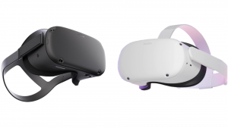
Picture 12: Example two different provider (Oculus Quest and Pico)

VR headsets

VR glasses are all almost identically constructed at the current time. They have:
- A "helmet" (see picture above), which includes
  - several cameras, which serve as sensors and for processing the data in real time
  - a disk drive
  - loudspeakers
  - Buttons for operation
- Two controllers to operate the functions

Some VR goggles nowadays use "eye" or "hand" tracking, which replaces the controllers.

As already mentioned, there are different brands that produce VR glasses. However, the operation and the first steps of use are - so far - very similar for all of them:

Step 1: Put on the VR headsets comfortably and in a manner suitable for use
Step 2: Switch on VR headsets
Step 3: Activate the controller
Step 4: Select "play area”
Step 5: Start the desired application in the main menu.

VR glasses can be used both offline and online. For example, an internet connection must be established to watch videos (e.g. on YouTube) or to call up other browser websites. However, there are also applications that are installed or downloaded once that also work offline. When using VR glasses, it is therefore important to first check which application/function you want to use and whether it requires internet access.

Hint

Every supplier now has very simple videos that explain how to start the glasses and how to use them. So it's always worth checking out the manufacturer's website! One example is:
https://www.youtube.com/watch?v=pVFcsedWsKE

Caution

Some people may experience dizziness when wearing the VR glasses. It is therefore advisable to support or supervise people when using the glasses.

Alternative to VR glasses: the cardboard

VR glasses can vary in price depending on the model, but there are many expensive models. A good, more sustainable and affordable alternative is a "cardboard".

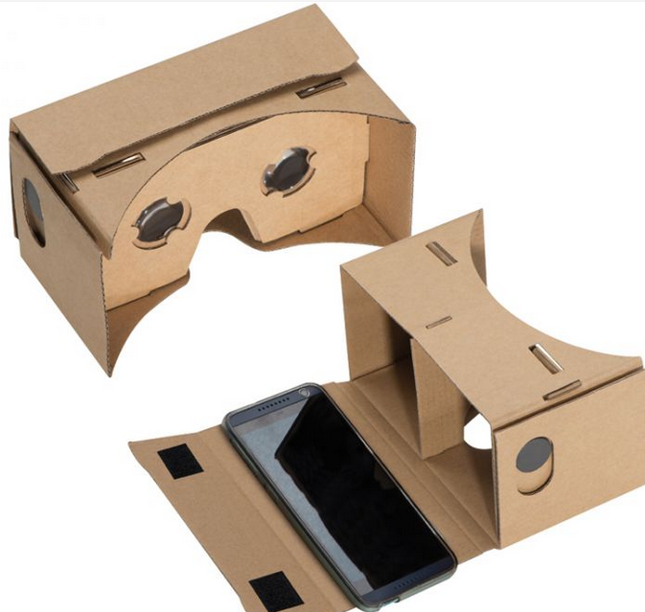
Picture 13: Example cardboard

A cardboard is a frame made of carton or plastic where you can hold a smartphone and immerse into virtual reality with the help of special lenses. This method can be used to play simple VR applications without any problems, such as 360° clips or virtual tours. Ready-made frames usually cost between 10-30€ and differ in their material and screen size.

Important: To view material in 360° on cardboard, you should always look for the sign of a pair of glasses and click on them (see picture below, top right). By pressing this application, the screen splits into two identical parts so that the lenses create a common image for the eyes.

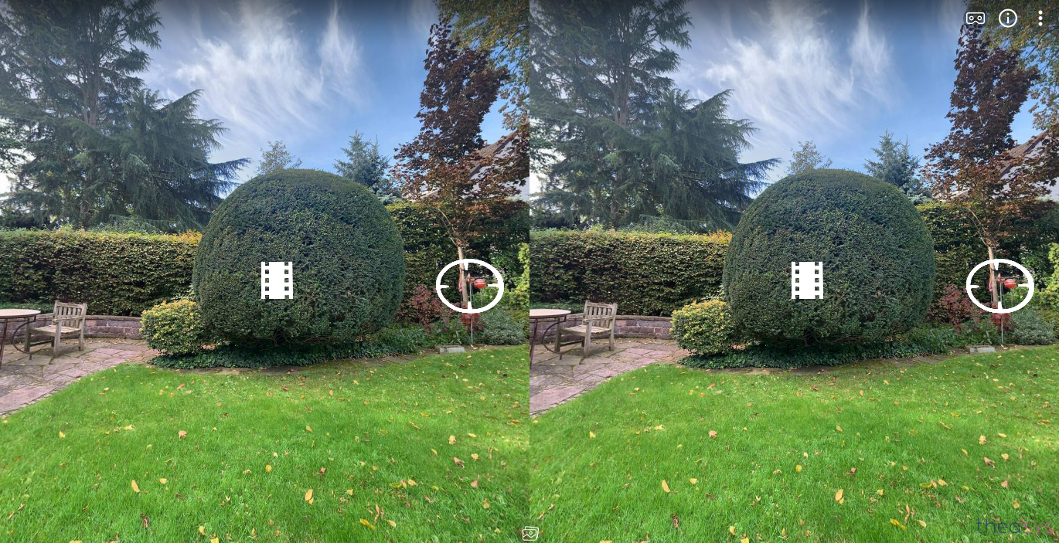
Picture 14: Screenshot virtual tour in Theasys

Hint

Take a look here for more information about cardboards:
https://arvr.google.com/intl/de_de/cardboard/get-cardboard/

Short summary

360° and Virtual Reality are the same technologies, but they are based on each other and influence each other.

Where can you find VR everywhere? In industry, product development, in the health sector, or in gaming.

Analysis: What project do I want to do? What equipment do I need? Is a cardboard or a tablet enough? Or do I need VR glasses?

Creation of 360° content and photo tours

Possibilities for producing 360° pictures and videos

There are different ways to create 360° footage. Depending on your budget and project, you should consider which hardware is most suitable. The following section introduces 360° cameras and good alternatives.

360° cameras
There are also many different models from various manufacturers in the field of 360° cameras. These cameras differ in their resolution, size, weight, functions and price. Here one example of a camera will be shown. For this example, we will take a closer look at the Insta360 ONE X2, as it has been one of the most popular cameras worldwide for years. One of the reasons for this is that it is one of the cheapest cameras at around 490€ and has a high resolution.
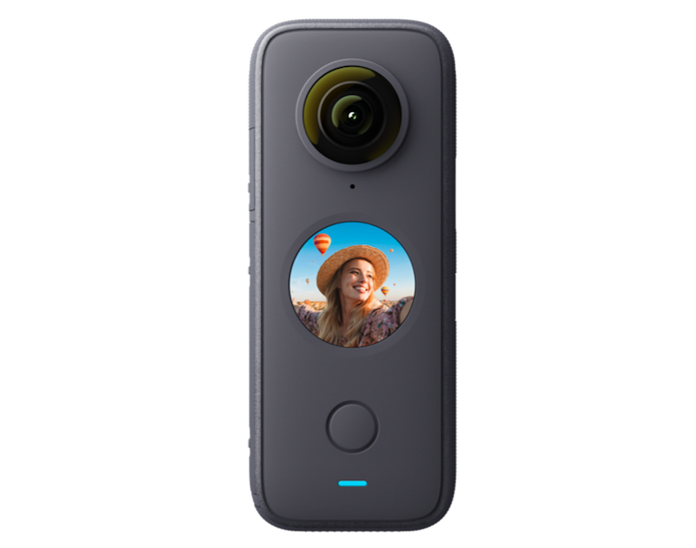
Picture 15: Example 360° Camera (Insta360 ONE X2)

As you can see, this example has two lenses, is flat and quite small (4.62 x 11.30 x 2.98 cm) and also light (149g). Cameras like the Insta360 ONE X2 have several functions and effects, such as time-lapse or the "tiny planet" view. With a resolution of up to 5K and integrated microphones, such high-quality cameras are best suited for 360° videos.

For good recordings, you should always use tripods or selfie sticks. The hardware works with specially developed software that can be installed on smartphones or tablets to control the camera or edit the recordings. Other examples of 360° cameras are: GoPro Fusion, RICOH THETA Z1 (e.g. for photos only).

Note

Before you buy a 360° camera, make sure you know what additional devices or accessories are needed to use the technology (e.g. additional SD card or mounts, etc.).

Smartphones and tablets
As already mentioned in the first part, however, good recordings (primarily photos) can also be made with cheaper alternatives.

Two good alternatives that are common nowadays are smartphones and tablets. Of course, the higher the quality of the camera, the better the photos will be afterwards.
It is also important to check whether the hardware has enough memory to download the application (app) and store the media (photos, videos, etc.).

Google developed a function in the Google Street View app that makes it possible to create 360° images with tablets and smartphones. This way, people all over the world can upload pictures on the app. The map service Google Street View uses this for their own advantage, because in this way the amount of data increases independently. People upload pictures and help ensure more insights from different places. In this way, Google Maps becomes more accurate and comprehensive.

Google Street View thus allows 360° images to be created without paying for them. How this works is explained in the next chapter step by step.

Instructions for creating 360° images with google street view

Taking 360° pictures
    - Install Google Street View on your smartphone or tablet
      - Search for "Google Street View" in the App Store or Play Store.
      - Make sure you have enough memory on your device.
    - Take 360° pictures
      - Open the downloaded app on your device.
      - Within the clickable app you will see a yellow/orange/white camera with a plus sign. Use this symbol to activate your camera. When you click on the camera you will see three different options: connect external 360° camera, import 360° photos and 360° photos.
      - Click on a 360° photo.
      - Now you will see a section of the picture. Around this section you will find orange dots in all directions:
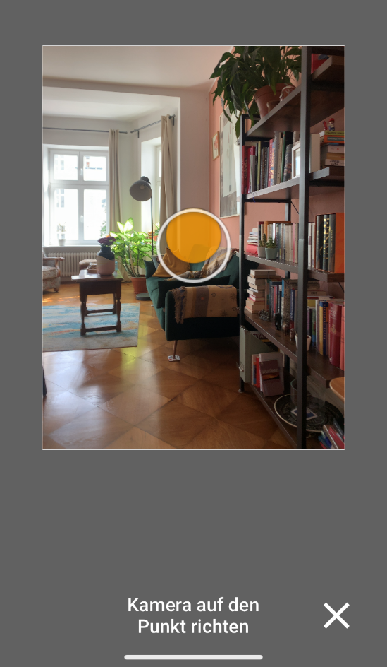
Picture 16: Screenshot Google Street View example 1

      - Concentrate on one of the orange dots. Stand still. The app automatically takes the first picture.
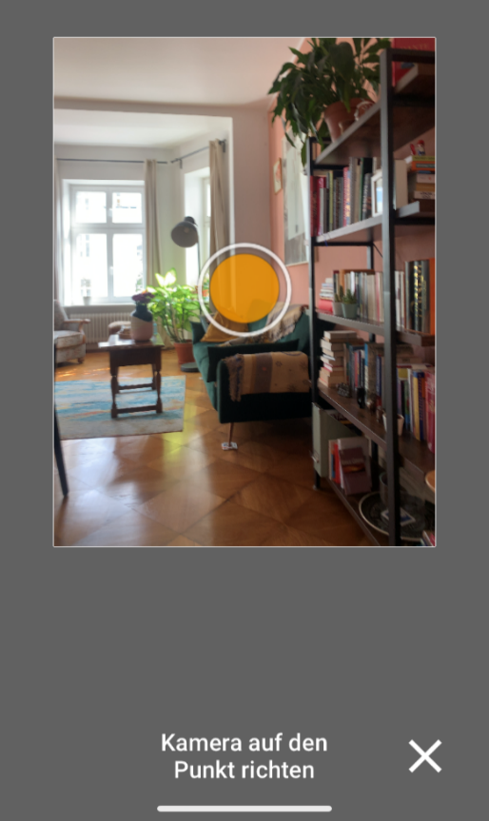
Picture 17: Screenshot Google Street View example 2

      - Wait until the picture is taken. You can see this by the orange tick at the bottom. If you like the picture, you can click on the tick, otherwise you can take the picture again with the arrow.
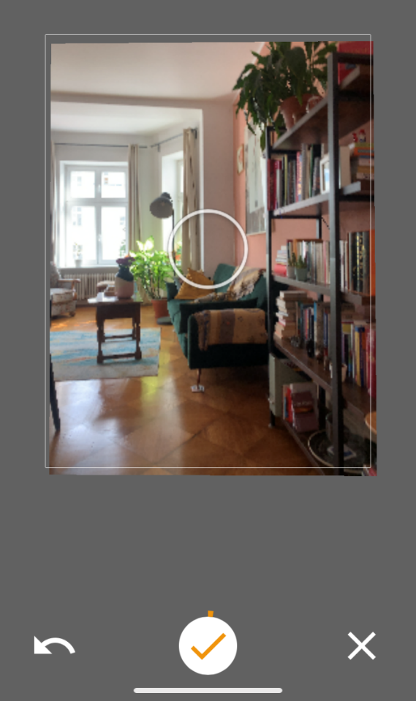
Picture 18: Screenshot Google Street View example 3

      - When you are happy with your image, focus on the next orange point. Fill in the 360° view by shooting one point after the other. Note: There are also points in the sky/ceiling and on the ground that you should capture. So be sure that you have photographed all the orange points.
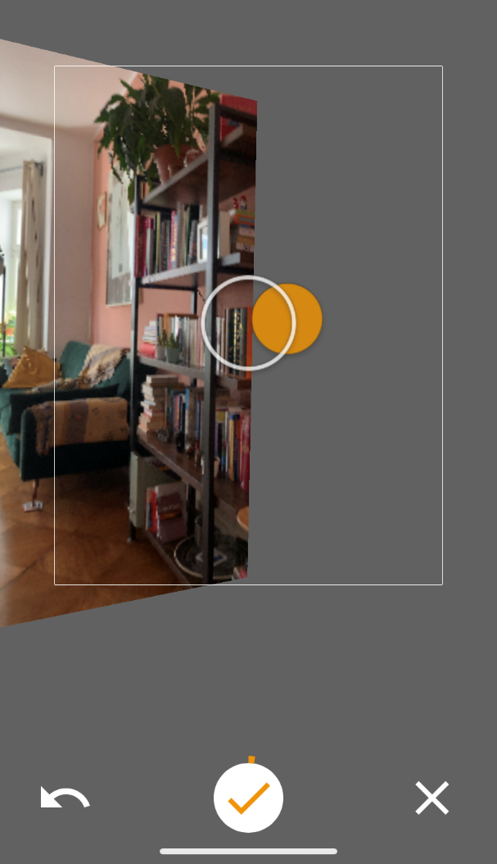
Picture 19: Screenshot Google Street View example 4

      - After you have taken the last picture, the app automatically saves the picture.
      - Attention: Your finished picture looks like a normal panorama picture on your smartphone, tablet and PC. However, when you upload it to a software, it automatically becomes a 360° image.

Transfer the 360° image to a tablet or computer
Option 1: Transfer by email
- Take the smartphone/tablet on which the images are stored.
- Press the "Gallery" button on your smartphone/tablet.
- Select the picture.
- Now press the "share button" (the sign for "share").
- Select "Gmail" (or the desired messenger/provider) from the options - now you can send the picture from your Google email address to your private email address.

Option 2: Transfer via a cable (USB)
- Connect the smartphone/tablet to your computer using a USB cable.
- On the computer, open the digital folder with the data from your smartphone/tablet. In this digital folder you should find the pictures.
- Copy the 360° pictures you took. Paste them into another digital folder on your computer where you (ideally) collect all the material for the photo tour.
- Now you can use the images as material for your photo tour.

Create photo tours in 360°

There are different types and providers of software for creating a 360° photo tour. On the one hand, there is software that can be downloaded as conventional programmes. Examples are the programmes 3dvista (https://www.3dvista.com/en/) or Pano2VR (https://ggnome.com/pano2vr/). These programmes can create very high-quality products and are mostly used for professional purposes.

On the other hand, nowadays there are many online softwares that do not need to be downloaded. They differ in their operation, price and functions. Most have a monthly subscription and a free version.

Softwares that offer free versions are for example:
- Theasys https://www.theasys.io/
- Obirx360 https://orbix360.com/
- Klapty https://www.klapty.com/
- Kuula https://kuula.co/

The free versions are usually limited in their functions (e.g. by the number of panoramic images you can upload), but can create photo tours of just as high quality as the paid ones. Here, it is worthwhile to first plan what you want to show in the photo tour in order to consider whether paid access is necessary at all. To visualise the ideas, there are methods such as writing a script, which has already been presented.

Important

For the creation of 360° images, as well as for the production of a virtual tour, you should make sure that you have permanent access to the internet.

Introduction/manual for using theasys
In the following, the online software Theasys is explained in more detail. The explanation serves on the one hand to give a practical introduction with which you can immediately start a photo tour, and on the other hand to give an insight/example of how such a software can be structured.
If one of the above-mentioned software is more suitable for your project, you are welcome to search the internet for instructional videos that explain how to use it. Most of the videos are very simple and well visualised, so you don't need any previous knowledge.

Take a look beforehand at what a possible tour at Theasys might look like: https://ths.li/2Z2Qe

Login to Theasys

- Go to the website: https://www.theasys.io
- In the upper right corner you will find the button "Register".
- Enter your data in the fields and confirm everything.
- Now you will receive an email with a link that you have to click on.
- As soon as you have done this, you can use Theasys.

Start a new tour
Click on "Upload Panoramas & Build a Virtual Tour" in the middle of the web page.

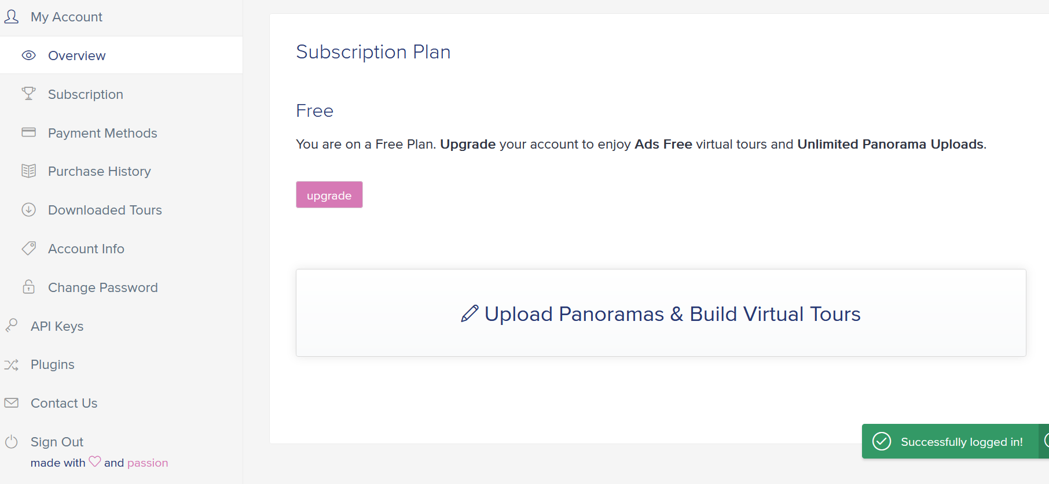
Picture 20: Screenshot on Theasys overview

- Click on "Add a new tour" in the upper right-hand corner.
- A window opens. There you can enter the title of your tour.
- Press the plus sign (+add).
- You will get to an overview page where you can change or adjust various things about your photo tour (e.g. title and description, etc.).
- In the upper area you will see the function "Upload Panoramas & Build Virtual Tours", which is marked with a pencil.
- After that, your browser view changes and you should have reached the editing mode, which you can recognise by the black background:

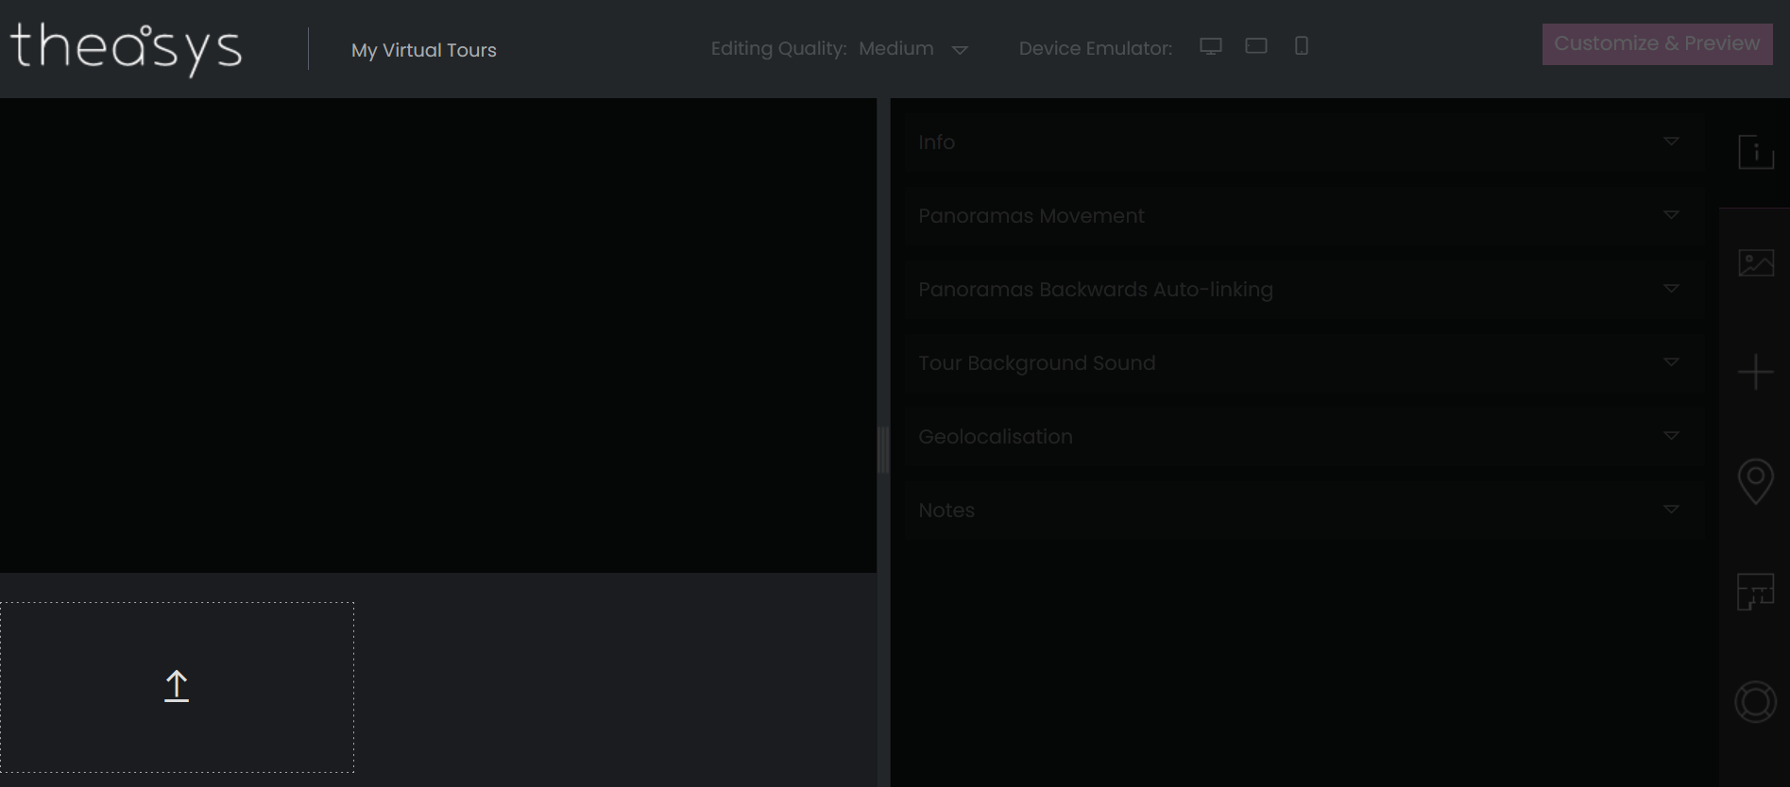
Picture 21: Screenshot on Theasys editor example 1

The structure of the editing mode
In the upper right corner you will find the buttons:

Info → Basic settings of the tour (name/background music/...)
Panorama properties → Settings for the images (set a special view as default / ...)
Hotspot properties → Settings for the hotspots (include icons / hotspots / ...)

What is a hotspot? This is a point that you can click on and either a graphic, text, etc. is linked or where you can switch to another room/scenario.

Upload 360° images
You will see an arrow pointing upwards in the lower left area. Click there to upload a picture.
When you click on it, a window will open where you can view your folder. There you should be able to see your picture and upload it.
Alternative: You can also upload the pictures by "Drag & Drop".
Attention: The pictures must be < 20 Megabyte (MB)! (If they are too big, you can format them and make them smaller).

Linking 360° images
In the free version of Theasys you can currently insert up to five panoramic images (=360° images) and link them together. In this way you create scenarios that are connected and that create the effect of "moving" around. For example, your first scenario of the photo tour can be in front of a house. On the entrance door there is a hotspot that you can click on and this is how you get into the house. The entrance area of the house would be the second scenario or panorama picture in this example. You could then add three more pictures to create a tour of the house. How to add the scenarios is explained here:

Step 1: Insert an arrow
In general, you will find various functions that you can select in the right margin:
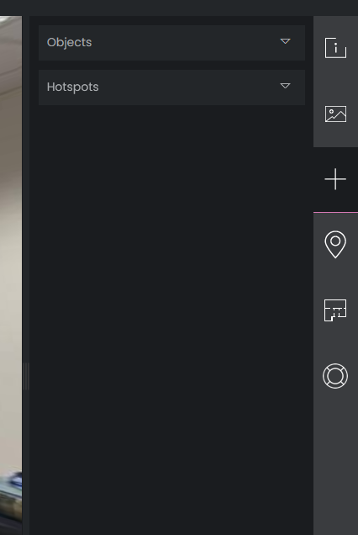
Picture 22: Screenshot on Theasys editor example 2

Click on the plus sign to insert an object or a hotspot, then click through as follows: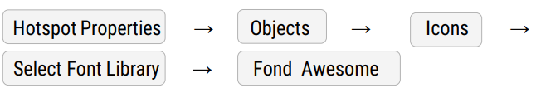

In the search field under "Fond Awesome" you can enter different words (in English), such as "arrow" or "point". Depending on how you want your connection to the next panorama picture to be.

Advice

It makes sense to choose hotspots that make sense to everyone and are intuitively understood. For example, an arrow indicating that you can click there to go to another room.

Step 2: Link the hotspot to an action (e.g. another panoramic image or a web page).

Many different actions or media can be linked behind hotspots. With Theasys it is possible, for example, to add more panoramic images, a link to a website, videos, 2D images, presentations, texts, etc. So you can be very creative when creating hotspots.

Click the following for this:

Your screen should now look like this on the right-hand side:

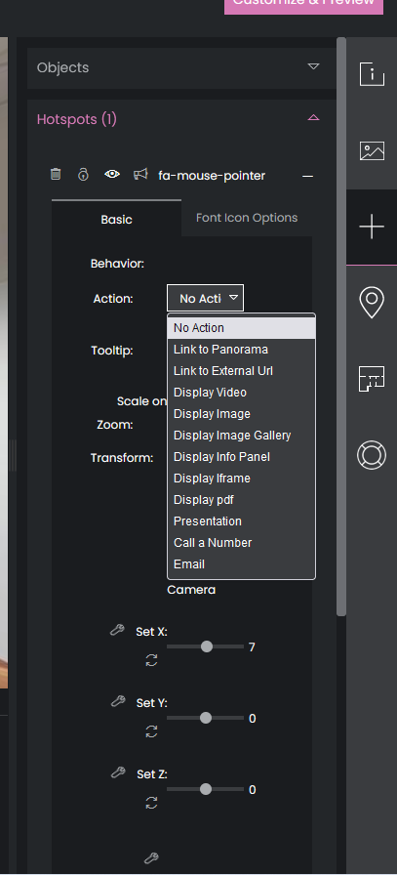
Picture 23: Screenshot on Theasys editor example 3

Under "Action" you can now select what you want to link behind your hotspot.

Next to "Tooltip" you can enter a text that is displayed when you move over the hotspot (example here: "click").
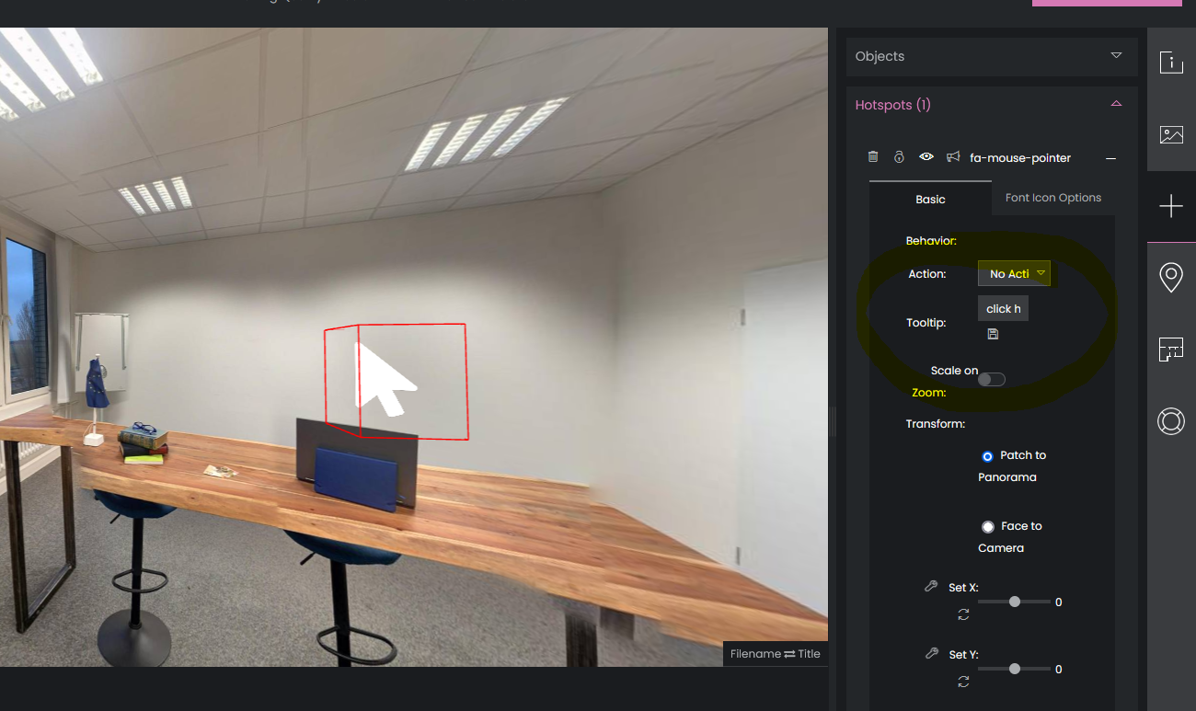
Picture 24: Screenshot on Theasys editor example 4

Step 3 (optional): Change the shape of the hotspot
You may want to change the orientation, size, colour or similar of your hotspot or delete it completely. In general, you will find several options for making changes under "Basics" (see picture above). Try out a few of the functions here.

Click for this:

If you want to delete the hotspot, you can click on the bin above the "Basics" selection (far left).

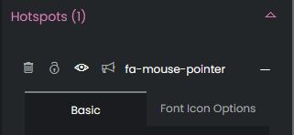
Picture 25: Screenshot on Theasys editor example 5

Plan a photo tour (technically) and implement it successfully

Plan for the use of technology:
- First of all, it should be clear which media are to be seen in the photo tour:
  - Are several 360° images to be integrated? Are videos or 2D images to be taken for it?
- Once these questions have been answered, it can be decided which software and hardware is needed for the photo tour. Often the free versions (such as Google Street View and Theasys) are sufficient and no additional (expensive) equipment needs to be purchased.
- Adapt scenarios with the technology:
- Consider beforehand whether a scenario can be implemented well with the technology. For example, Google Street View has difficulties in smaller rooms and the images often overlap so that it does not look uniform and natural. Here it is worthwhile to photograph large areas.
- If videos are to be shot by oneself, one can consider what technology is necessary for this, e.g. is a smartphone camera sufficient? If so, is a tripod necessary, for example?
- Familiarise yourself with the technical implementation:
- Especially the software for composing the photo tour contains many different functions. Try to integrate different elements beforehand, such as background music.
- If you don't understand something, search the internet for the answers. There are many blogs or videos where functions are explained step by step.
- Combine tools and online software:
- There are other tools that process e.g. videos or pictures to make these media look more valuable. For example, with software like Canva (https://www.canva.com/) you can cut short videos and insert elements.
- Combine virtual reality and photo tours by using cardboard or VR glasses.
- Be brave and creative:
- Technology evolves and can be exciting but also frustrating. That is normal! So one should always bring patience and be forgiving.
- There are many ways to use the presented technology and to create photo tours with it. People should be creative here and brave to try new things!
- Think outside the box!

Tips and Tricks

There are different ways to organise the process of creating a 360°-photo tour. The following section provides some tools to manage the process and help organise group work. There is also a list of tips and tricks that can be useful. Check it out with your participants before they run off to create the tour so it can provide inspiration and difficulties, or insecurities can be avoided.

Milestone plan

As soon as you have a concrete idea of how you want to tackle your project, then it’s time for the milestones. Milestones are important points in time in your project when it is worthwhile to take stock for a moment.

We recommend this method for every project. It makes sense to divide the work into several sections, especially if your project takes longer than a few weeks. It is sensible to determine this when the project starts so that you get a feeling for how much time is available and for what, when it becomes stressful etc.

Who? | Does what? | By what date/ time? | Check?
Kim | Organising a meeting | 13.12.
Kim, Nidal, Tom | Creating the storyline | 15.12.
Tom | Scouting locations | 5.1.
Nidal | Uploading photos | 3.4. | t
Kim, Tom and Nidal | Researching information about SDG 3 | 2.5.

Plan of measures

In a team that has multifarious tasks to perform, organisation is key. Especially if you consider yourselves to be more the creative-chaotic kind of people then this method is a must-have for you!

The plan of measures is the core planning instrument of your project. You enter everything here that has to be dealt with so that nothing is forgotten. Watch out that you always enter the person responsible, and set a date by which the to-do has to be finalised. The smaller you make the measures, the better you can follow the progress of your project.

So that all tasks are performed, the best would be to appoint a person who checks the plan of measures and reminds everyone in the project group about their tasks. Take time at regular intervals to revise the plan of measures and to add the new tasks. What’s really good fun is ticking the task boxes! Don’t hesitate to give each other a pat on the back for that occasionally!

Example:
Who? | Does what? | By what date/ time? | Check?
Lisa | Organising a meeting | 15.12.
Joy | Creating the storyline | 5.1.
Joy and Lisa | Scouting locations | 3.4.
Joy and Lisa | Uploading photos | 2.5.

RCI Matrix

Transparent working in project teams is important. To finish off, there is a little tool which helps you to keep the overview of who has to get which results. When working in big teams, it often happens that someone is forgotten or that all the information is always sent to everyone.

The RCI matrix is one possible way to avoid both. The results from the single work areas are entered into this table and you can read off who is working / collaborating on a sub-project, who is responsible and who has to be informed.

There are three categories thereby:
R= this person is responsible
C = consultant, i.e. the person who supports the respective work process
I = this person must be informed

Example:
What? | Who? | Who? | Who? | Who?
Organising a meeting | Kim | Tom | Nidal | Joy
Creating the storyline | C | R
Scouting locations | I | I |  | R
Uploading photos |  | C | R
Researching information about SDG 15  to include in picture 1 |  |  | R | I

Tips and tricks list
This list is useful for you as a trainer to go through with your group before they are starting their work. Creating a photo tour can be challenging in different aspects. For some it may be difficult to get to know the technical parts and for others, it’s not easy to find serious information regarding the sustainable development goals. To make the process a little bit less challenging this chapter gives an overview of some tricks and tips for having a great 360° photo tour experience!
General tips
- Do not be afraid to be funny! Use humour in your 360° -tour and connect to your audience by pointing out curious facts in a humorous way.
- Designing a tour is a process of trial and error: If your plan does not work out the way you intended to feel free to just change it!
- Stay open for changes, development, and new input from others.
- Focus on your own interest: Often it’s easier to create something about aspects you’re personally interested in.
- Address your audience directly when they enter the digital tour. Guide them through your pictures asking questions that make them reflect the information you provide.
  - e.g., ask where this phenomena can be found in their own surroundings
- Group work can be fun! Get honest and in depth feedback by someone and incorporate it into your tour.
- Questions to evaluate your tour:
  - Is the tour easy to operate?
  - Are the SDGs represented?
  - Can a regional problem be identified?
  - Are different materials used, such as links, videos, photos?
  - Is there a common thread in the narrative?

Technical tips

- Do not make it too obvious – give the user something to discover, e.g., with using hints/ connected links/ combined information
- The photo you took inside a building/ house doesn’t look satisfying? Search for a place outside, this will help the app.
- Use all 360° to mark your clickable highlights in the photos, use the ground of the sky/ceiling to position your hints.

Conclusion
A train-the-trainer programme provides a standard framework that will allow you to roll out a training in a specific subject by providing trainers the necessary subject matter expertise and the training competences required to deliver the course.

Train-the-trainer programmes are vital as they can provide professional trainers with the ability to familiarise themselves with best practices for designing, organising, planning and delivering training programmes.

By providing practical learning examples and guidance to trainers we will be giving them the opportunity to develop and build on their own style, improve their training technique, and create a positive learning environment.

Being familiar with and understanding the key concepts and steps involved in providing training programs is a good idea, especially for trainers who are taking on the role of a trainer for the first time. Refreshing and updating your knowledge on training techniques and approaches is also crucial if you are already an experienced trainer.

A train-the-trainer programme will walk trainers through all the vital concepts and provide a combination of techniques and approaches that have already been tested.

The train-the-trainer course will additionally cover all areas trainers need in order to be successful, expanding from presenting and facilitating training courses to creating lesson plans and delivering training programmes.

Competent and effective trainers must “own” their whole training course, from developing the agenda, to each and every slide that will include training material and information for learners, and even the setting of the classroom that will enable learners to receive the finest learning experience.

As confidence is key, by making trainers knowledgeable we will support them become more confident and deliver training efficiently and effectively.

Another advantage of train-the-trainer programmes is that they support you to expand your reach as you are not training learners, you are training other trainers who will in turn become experts in your subject. This will have a multiplier effect and support you to reach many learners with lower cost but with a consistent quality.

Image directory

Module 1

Picture 1: all SDGs, https://sdgs.un.org
Picture 2: SDG examples, https://sdgs.un.org

Module 2

Picture 3: Landscape photo tour sample, https://www.theasys.io/samples/
Picture 4: Real estate photo tour sample, https://www.theasys.io/samples/
Picture 5: Commercial photo tour sample, https://www.theasys.io/samples/
Picture 6: Panorama shore 360° photo, https://pixexid.com/image/sb0criu-360-panorama-shore
Picture 7: Spaceship 360° photo, https://pixexid.com/image/30g7d8y4-spaceship-on-space-360

Module 3

Picture 8: Example 360° camera: https://www.heise.de/select/ct/2016/14/1467887931564662
Picture 9: Avatars meeting in a digital virtual reality world: https://www.ispo.com/trends/metaverse-die-revolution-der-sportwelt
Picture 10: Example two different provider (Oculus Quest and Pico): https://vr-expert.de/oculus-quest-2-vs-pico-neo-3-pro-vergleich-welches-vr-headset-ist-besser-fuer-unternehmen-geeignet/
Picture 11: Example cardboard: https://www.source-werbeartikel.com/vr-brille-aus-karton-42-2035601?gfeed=1&gclid=Cj0KCQjwyOuYBhCGARIsAIdGQROnKVMNdE3yl3hZavFLM5XwZzGObvCjq0kDA6p1nODB-wFxX_r-TN8aAoYMEALw_wcB
Picture 12: Screenshot virtual tour in theasys: https://www.theasys.io/dashboard/virtual-tours/edit/CLgYKKqjJxAysmL/
Picture 13: Example 360° Camera (Insta360 ONE X2) https://store.insta360.com/product/one_x2?utm_source=website&utm_medium=product_page_button&utm_campaign=one_x2&_gl=1*10swet4*_ga*MTc3MDQzMDgwNi4xNjYyMzc0MTc5*_ga_7TV2BE92TS*MTY2MjM3NDE3OS4xLjEuMTY2MjM3NDkzMi4wLjAuMA..&_ga=2.83565910.1991753932.16623741
Picture 14: Screenshot Google Street View example 1
Picture 15: Screenshot Google Street View example 2
Picture 16: Screenshot Google Street View example 3
Picture 17: Screenshot Google Street View example 4
Picture 18: Screenshot theasys overview: https://www.theasys.io/dashboard/account/overview/
Picture 19: Screenshot theasys editor example 1: https://www.theasys.io/app/CLgYKKqjJxAysmL/
Picture 20: Screenshot theasys editor example 2: https://www.theasys.io/app/CLgYKKqjJxAysmL/
Picture 21: Screenshot theasys editor example 3: https://www.theasys.io/app/CLgYKKqjJxAysmL/
Picture 22: Screenshot theasys editor example 4: https://www.theasys.io/app/CLgYKKqjJxAysmL/
Picture 23: Screenshot theasys editor example 5: https://www.theasys.io/app/CLgYKKqjJxAysmL/

Sources

Module 1

https://www.investopedia.com/terms/s/sustainability.asp#citation-1
https://sdgs.un.org

Module 2

https://www.wikihow.com/Write-a-Script
https://boords.com/how-to-write-a-script
https://burtsdrama.com/script-writing-lessons/
https://www.studiobinder.com/blog/what-is-script-writing/
https://www.theasys.io/

Module 3

https://www.bbc.com/academy-guides/how-do-i-make-360-videos
https://training.npr.org/2017/12/18/a-beginners-guide-to-spatial-audio-in-360-degree-video/
https://training.npr.org/2018/11/27/360-audio/

Annex

https://upload.wikimedia.org/wikipedia/commons/d/df/Sustainable_Development_Goals.png

Annex: Puzzle Sdgs and targets

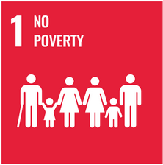 | End poverty in all its forms  everywhere
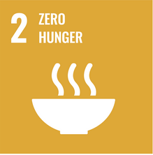 | End hunger, achieve food security and improved nutrition and  promote sustainable agriculture
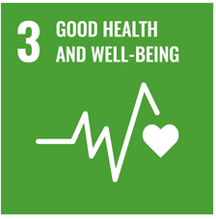 | Ensure healthy lives and promote well-being for all at all ages
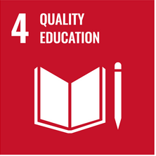 | Ensure inclusive and equitable quality education and promote lifelong learning opportunities for all
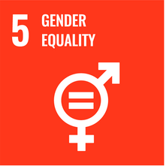 | Achieve gender equality and empower all women and girls
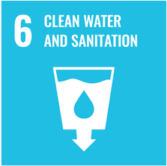 | Ensure availability and sustainable management of water and sanitation for all
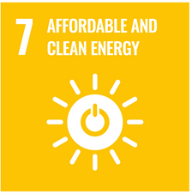 | Ensure access to affordable, reliable, sustainable and modern energy for all
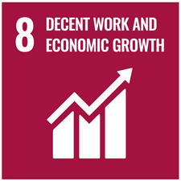 | Promote sustained, inclusive and sustainable economic growth, full and productive employment and decent work for all
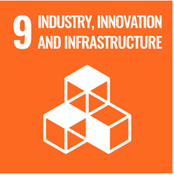 | Build resilient infrastructure, promote inclusive and sustainable industrialization and foster innovation
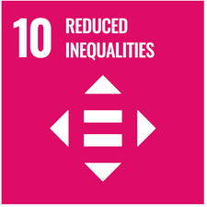 | Reduce inequality within and among countries
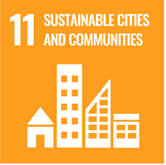 | Reduce inequality within and among countries
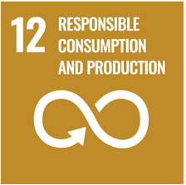 | Ensure sustainable consumption and production patterns
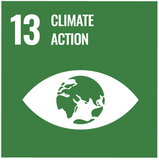 | Take urgent action to combat climate change and its impacts
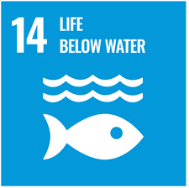 | Conserve and sustainably use the oceans, seas and marine resources for sustainable development
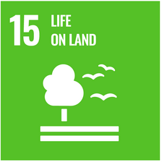 | Protect, restore and promote sustainable use of terrestrial ecosystems, sustainably manage forests, combat desertification, and halt and reverse land degradation and halt biodiversity loss
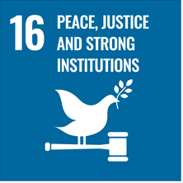 | Promote peaceful and inclusive societies for sustainable development, provide access to justice for all and build effective, accountable and inclusive institutions at all levels
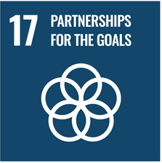 | Strengthen the means of implementation and revitalize the Global Partnership for Sustainable Development

Grant, Mitchell, „What is Sustainability? How Sustainabilities Work, Benefits, and Example“, Investopedia, accessed 27 September 2022, https://www.investopedia.com/terms/s/sustainability.asp#citation-1..
https://www.studiobinder.com/blog/what-is-script-writing/
https://www.cio.de/a/was-ist-das-metaverse,3683446

